# Communication Networks Introduction

##### DR.Eslami

Department of Electrical Engineering [Islamic Azad University،Science And Research Branch](https://srb.iau.ir/en)

* The course introduces the underlying concepts and principles of Communication Networkss.
* It presents different components of a network and how

these components fit together.

* The layers of functionalities implemented in network nodes are investigated and the underlying design concepts are discussed.
* The course is designed at a graduate level with practical assignments and short projects
* Required Textbook
  + Andrew Tanenbaum. Computer Networks, Sixth Edition, Prentice Hall
* Additional textbooks and References
  + A. Leon-Garcia & I. Widjaja, Communication Networks, McGraw Hill
  + W. Stallings. Data and Computer Communications. Prentice Hall.
  + J. Walrand. Communication Networks: First Course. Aksen Associates.
  + D. Comer. Internetworking with TCP/IP, Volume I, Prentice Hall.
  + W. Stevens. TCP/IP Illustrated: The Protocols, Vol 1. Addison-Wesley.
  + D. Comer. Computer Networks and Internets. Prentice Hall.
  + L. Peterson and B. Davie. Computer Networks: A Systems Approach.

Morgan Kaufman.

* Some of the course material are presented from other sources
* Introduction.
* The Physical Layer.
* The Data Link Layer.
* The Multiple Access Sub-Layer.
* The Network Layer.
* The Transport Layer.
* The Application Layer.

Communication Networkss

* 1961-1964 Idea of store and forward distributed communication in packet

networks by L. Kleinrock, D. Watts and P. Baran

* + More suitable for computer communication
  + More resilient to node failure
* Creation of ARPANET in late 1960’s
  + To build a network that withstands destruction of some of its nodes
  + 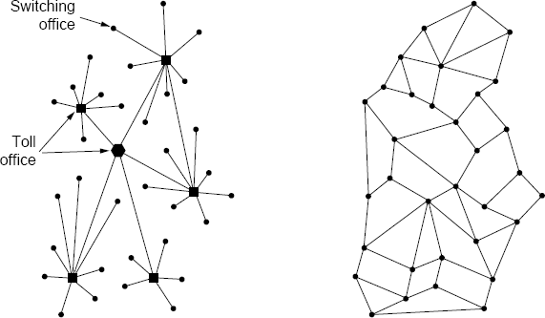First Network started operation in 1969
* ARPANET, the precursor to the modern internet, was an academic research project funded by the Advanced Research Projects Agency, a branch of the military known for funding ambitious research projects without immediate commercial or military applications

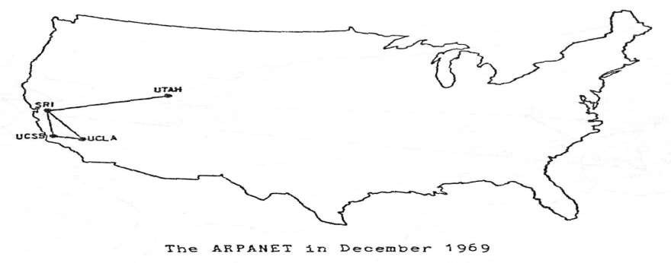

https:/[/w](http://www.vox.com/a/internet-maps)w[w.vox.com/a/internet-maps](http://www.vox.com/a/internet-maps)

* By the end of 1970, ARPANET had grown to 13 nodes

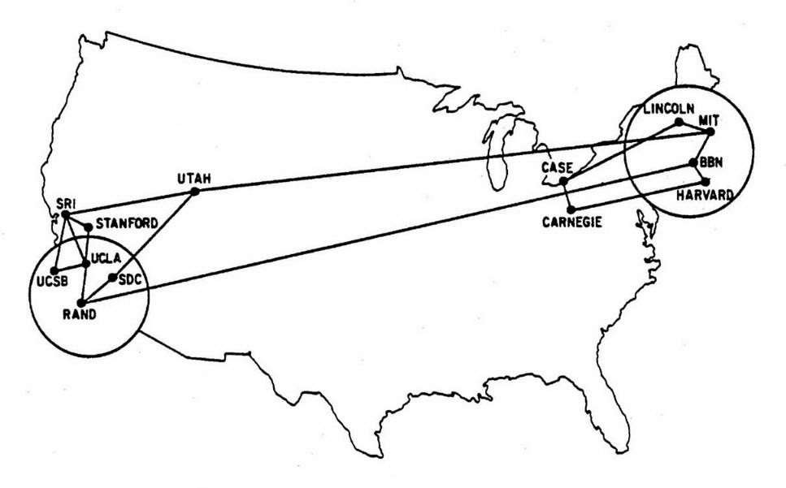

* In 1973, the ARPANET became international, with a satellite link connecting Norway and London to the other nodes in the United States. Hawaii also joined the network by satellite. At this point, the network had around 40 nodes.

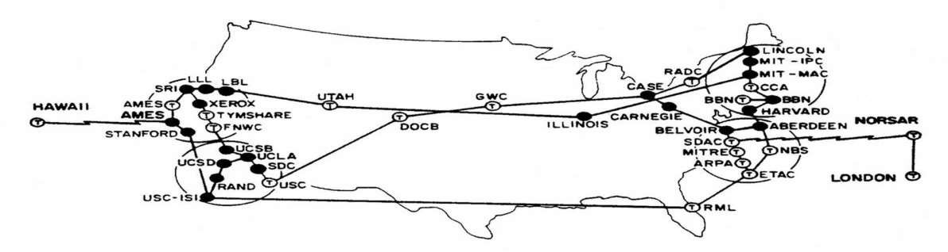

* 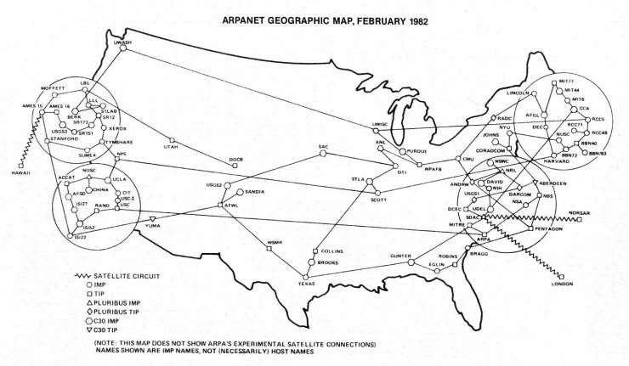By 1982, the network had about 100 nodes.
* In 1984, ARPANET network operators decided that the network should be reorganized as a decentralized "network of networks."
* Under this scheme, different networks would be controlled by different organizations, but all the networks able to communicate using shared standards, forming a shared "internet."

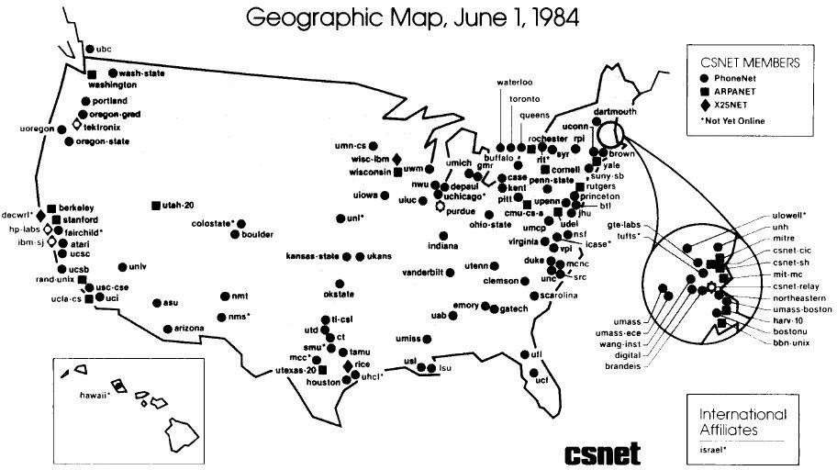

* A set of standards known as TCP/IP was developed.
* On January 1, 1983, the ARPANET switched to using TCP/IP, marking the birth of the modern internet.



* In 1986, the US National Science foundation agency created a TCP/IP-based network called NSFNET to link supercomputing centers together and allow researchers across the country to use them.
* The NSFNET became the internet's "backbone," the high-speed, long-distance network that allowed different parts of the internet to communicate.

Communicati 12

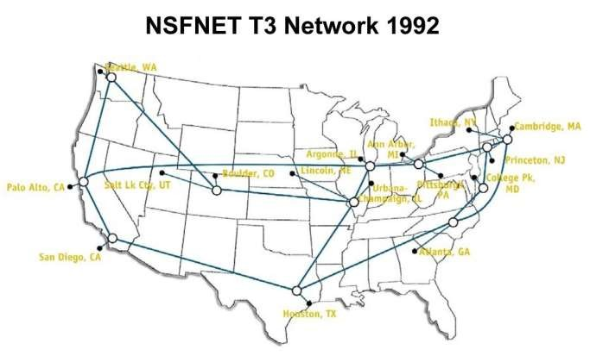

on

* In 1993, the internet was still dominated by the United States, but it was becoming a truly global network. This is a map of information flow on Usenet, a bulletin board application.

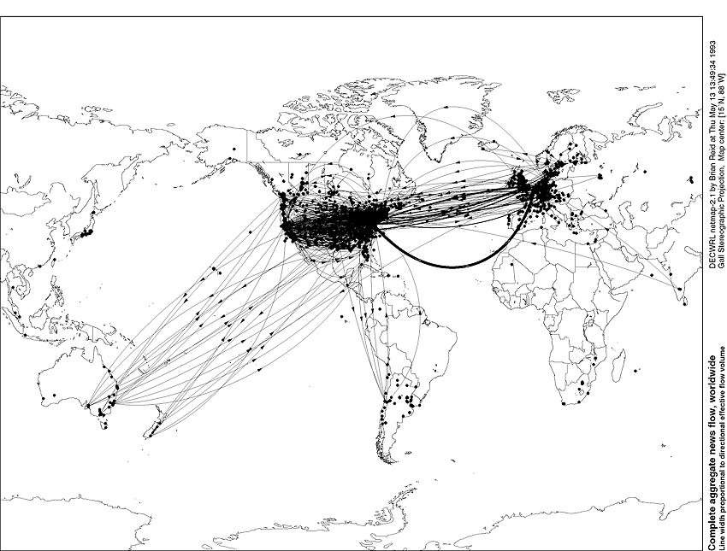

Communicati 13

on

## backbone

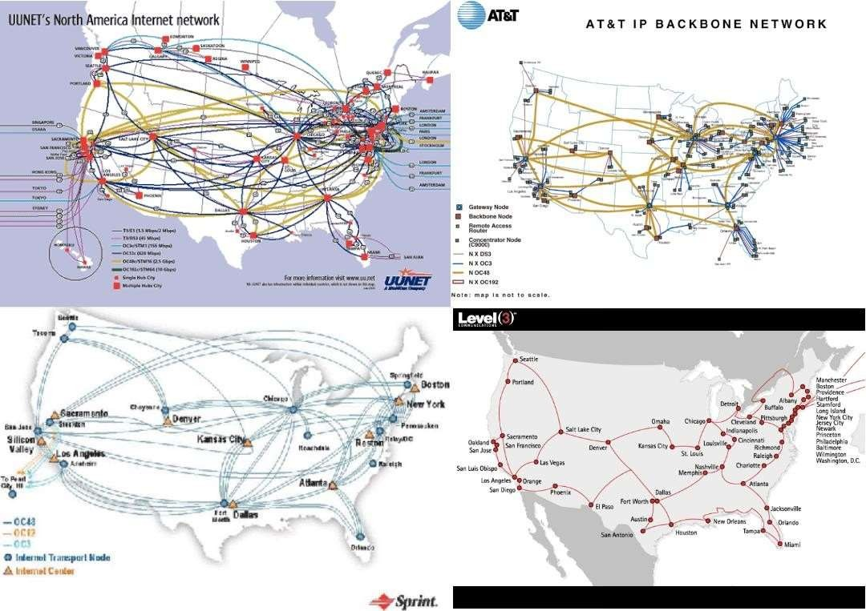

* In 1994, the internet backbone was privatized to several competitive service providers.

Communicati 14

on

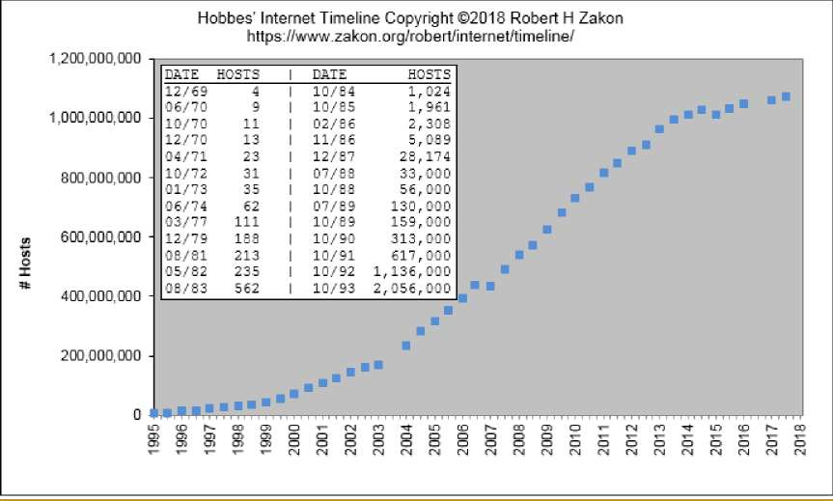

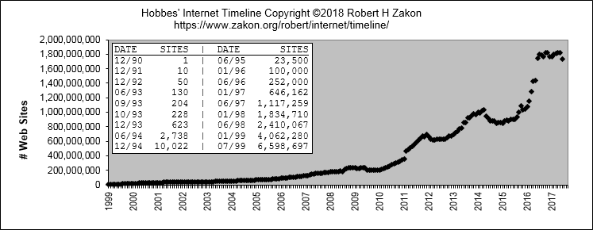

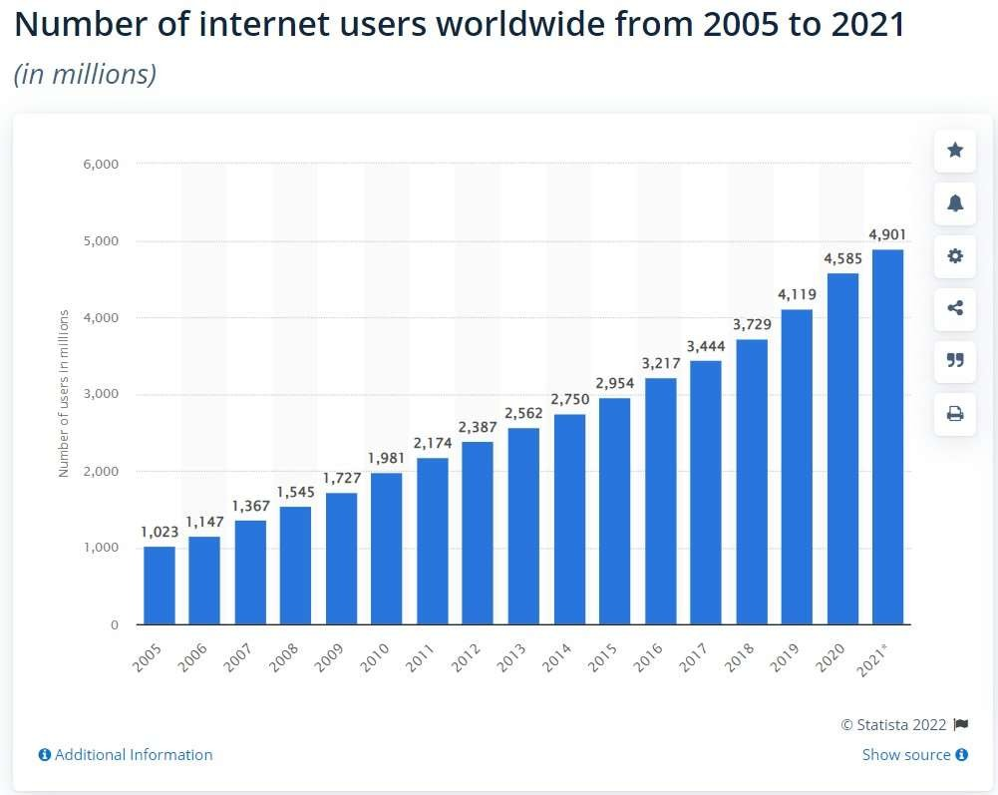

Communicati 17

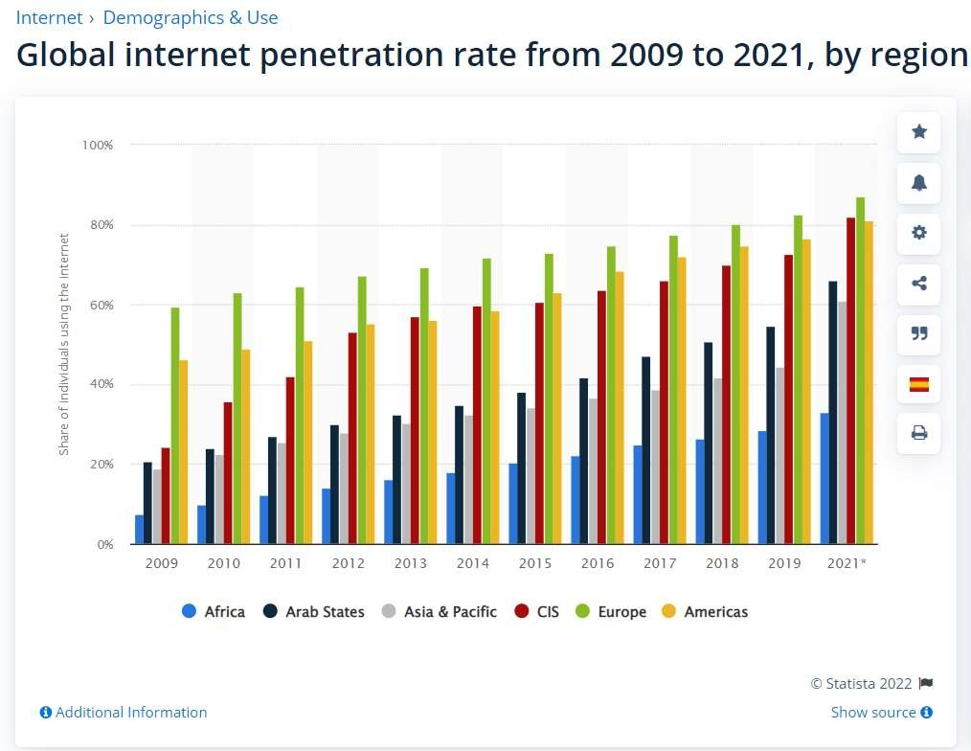

Communicati 18

* Old: Single powerful computer, many local terminals for interaction
* Now: Many autonomous computers interconnected to do the job

Communicati 19

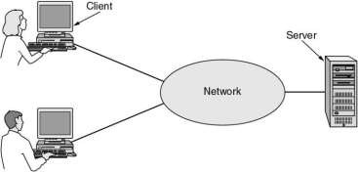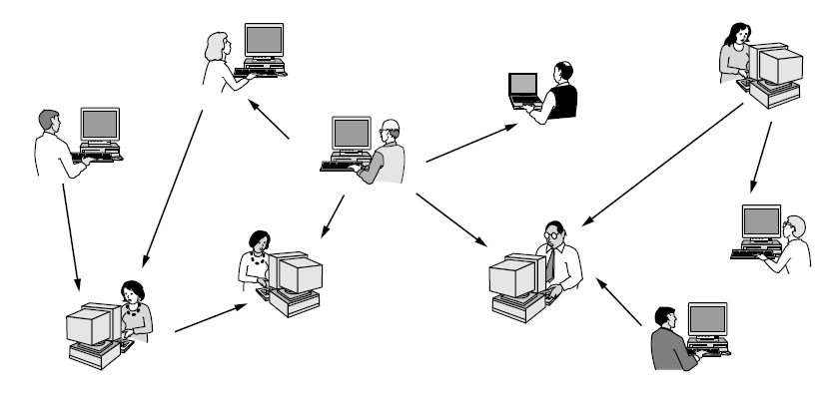

on

* Access to Information
  + Web Browsing
  + Online navigation
* Person to Person Communication
  + Instant Messaging
  + Social Networks
  + Video Calling
* Electronic Commerce
  + Business to Consumer (B2C)
  + Business to Business (B2B)
  + Government to consumer (G2C)
* Entertainment
  + IPTV
* Internet of Things

## Communication

N BertowaodbraknsdsAccess Networks

* Mobile and Wireless Access Networks
* Content Provider Networks
* Transit Networks
* Enterprise Networks
* PAN (Personal Area Network)
  + Network with a short range
  + Example: Bluetooth connections

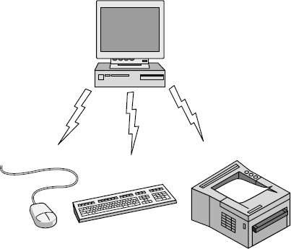

* LAN (Local Area Network)
  + Network usually within a building
  + Restricted Size, delay
  + Rate: 10Mbps to 10Gbps
  + Channel allocation: Static or dynamic
  + Examples: Ethernet (IEEE 802.3),

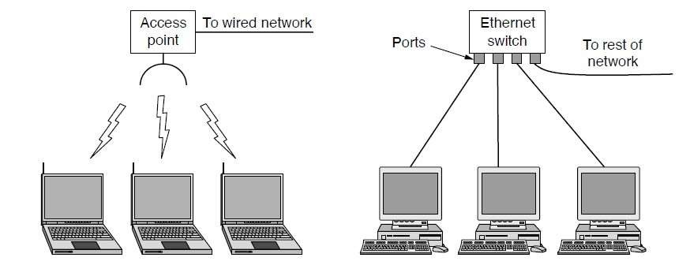

* MAN (Metropolitan Area Network)
  + A network within a city

Communicati 24

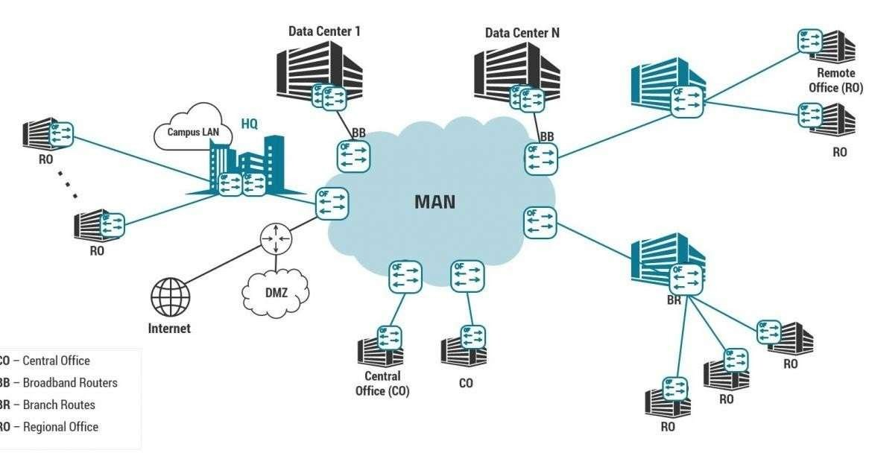

on

* WAN (Wide Area Network)
  + A network with large area
  + A WAN can span a country, several countries or a it can have a global

coverage

* + Example:
    - FLAG Network (Global)
    - See: https:/[/w](http://www.submarinecablemap.com/)w[w.submarinecablemap.com/](http://www.submarinecablemap.com/)

Communicati 25

on

■ WAN (Wide Area Network)

❑ A network with large area

❑ A WAN can span a country, several countries or a it can have a global

coverage

❑ Example:

■ TIC Network (One Country)

■ FLAG Network (Global)

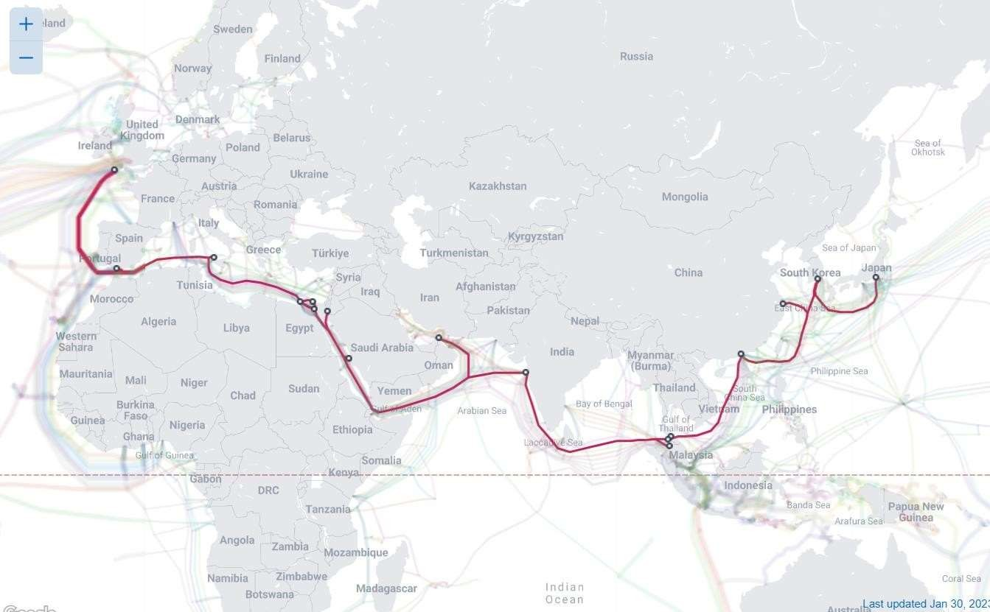

Communicati 26

on

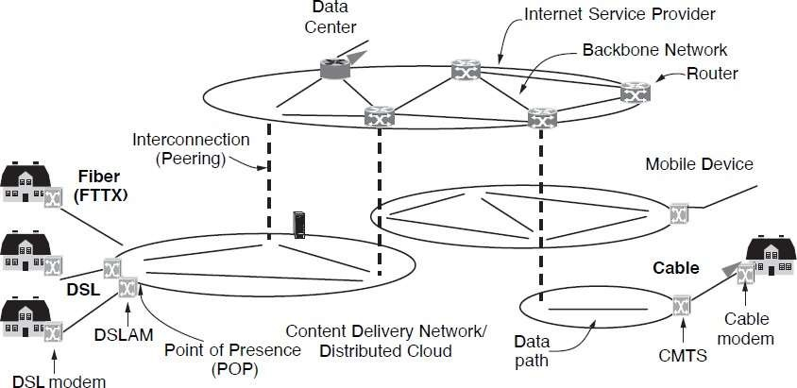

Communication Networks



Reliability

* Resist bit errors
* Find a path to destination

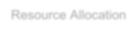

Resource Allocation

* Properly share resources
* Flow control
* Manage the quality of service



Evolvability

* Cope with growth

Security

* Confidentiality
* Authentication

Communicati 28

* Functionality of most networks are organized as a series of layers
* Each layer is implemented by an entity
* Peers: two communicating entities (within the same layer)

Communicati 29

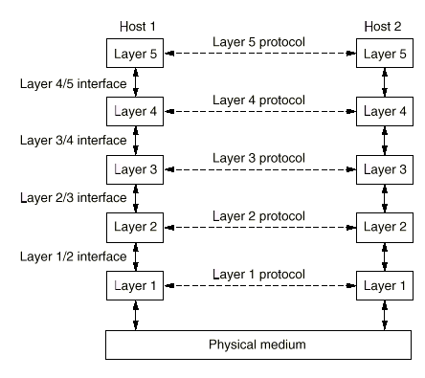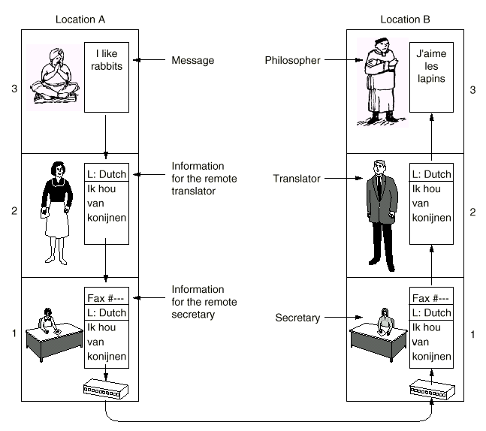

Communicati 30

* Protocol: An agreement on rules and procedures between two communicating parties on how the communications is to proceed.
* Service: set of primitives (operations) that a layer provides to the

above layer

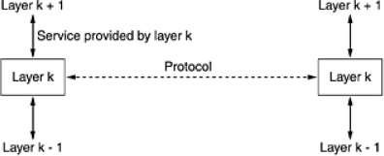

* Headers/Trailers may be needed to allow implementation of a protocols

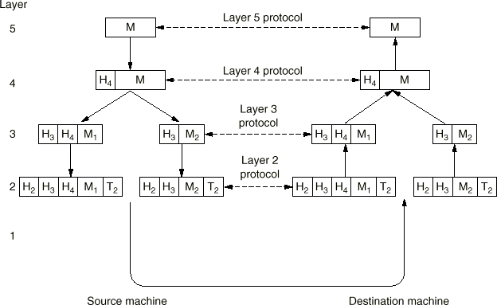

* Service Categories:

Communicat

ion

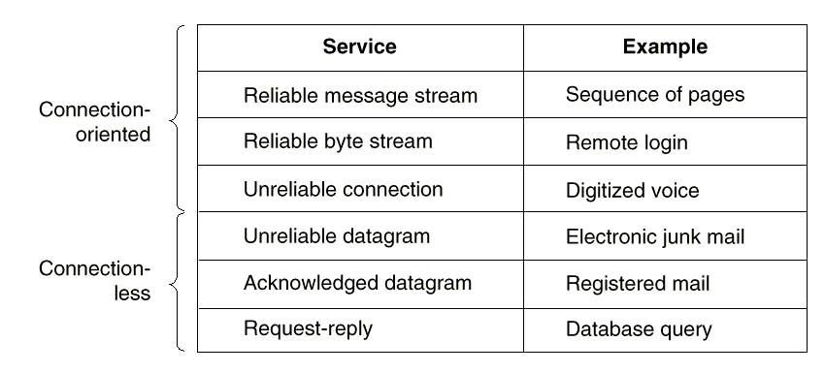

* + Connection oriented
    - Phone conversation
    - Telnet / remote login / FTP
  + Connectionless
    - Postal system
    - Email
* Service Reliability
  + Reliable: never loose data
    - Acknowledgements /

retransmission

* + Unreliable: data may be lost
    - No acknowledgements
    - Datagram service

## Reference Model

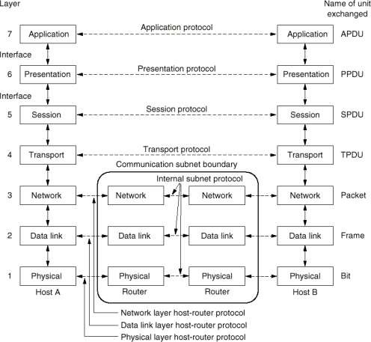

* Originated from ARPANET

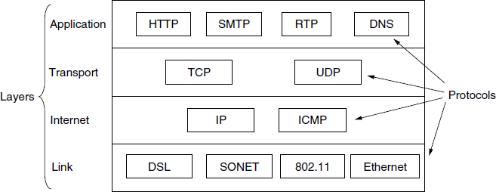

* Link Layer: Move packets from one node to the next.



* 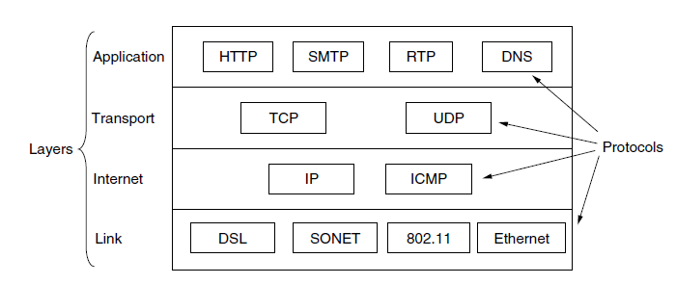Internet Layer: Find the best path for packets to reach their destination.

Communicati 37

* Transport Layer: It is designed to allow peer entities on the source and destination hosts to carry on a conversation.
* Transport of data can be “Reliable” or “Un-Reliable”.



Communicati

38

* Application Layer: E-mail, Web, Remote Connection and many other protocols.



Communicati

39

Networks 43

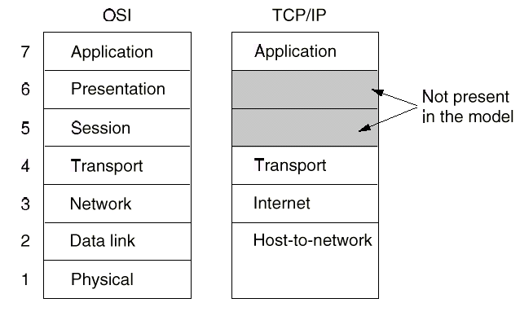

* TCP / IP
  + Bottom-up approach;

grew out of practice

* + Not a general protocol stack
  + Host-to-network layer is actually an interface description

Data

* OSI:
  + Top-down design methodology
  + The concepts clearly distinguishes
    - Services (specification)
    - Interfaces
    - Protocols (implementation)
  + Network layer supports both connectionless and connection-oriented

communication

* + Transport layer supports only connection-oriented service !!
* 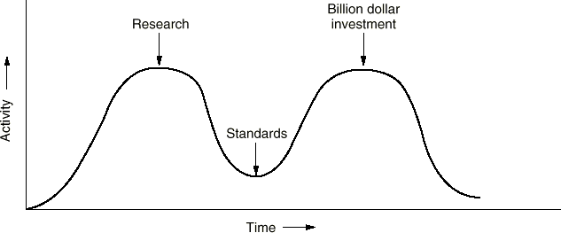Bad timing.
* Bad technology.
  + Too many layers (Competition

with 7 layer IBM SNA! stack)

* + Overloaded (L2, L1) and

empty (L5, L6) layers

* + Too difficult to understand and implement
  + Initially ignored connectionless protocols
* Bad implementations.
  + Early implementations were huge, unwieldy, and slow.
* Bad politics
  + TCP/IP as part of UNIX, widely available, useful and open
  + OSI as a creature of telecom ministers/big telecom companies
* We will follow a hybrid, 5-layer model in this course
* Data Link Layer includes Multiple Access Control (MAC) functionalities, but noting the importance of MAC, we will devote a special section to it.

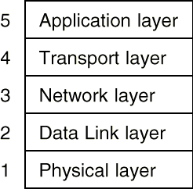

* Telecommunication world
  + ITU: International Telecommunication Union
* International standards
  + ISO: Int. Organization for Standardization (1946)
  + ANSI: American National Standards Institute
  + IEEE: Inst. of Electrical and Electronic Engineers
* Internet
  + IAB: Internet Activities Board
  + IETF: Internet Engineering Task Force
  + IRTF: Internet Research Task Force

Communication Networkss Physical Layer

##### DR.Eslami

Department of Electrical Engineering [Islamic Azad University،Science And Research Branch](https://srb.iau.ir/en)

* Physical Layer is responsible for delivering a stream of symbols (usually a

stream of 1’s and 0’s) from a source over a channel to a destination.

* Information theory shows that there are limitation for delivering information over a channel
* Maximum Data Rate of a band limited noiseless channel:

C=2W*log2(V) bits/sec

where V is number of discrete signal levels, W is channel bandwidth

* For Noisy channels: C=Wlog2(1+SNR) bits/sec
* Example: A channel with a bandwidth of 4kHz and SNR=30dB can carry

40kbps at most

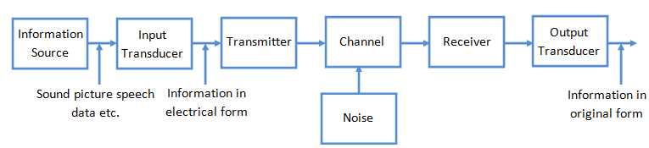

* Important communication Media:
  + Guided Transmission Media
    - Twisted Pair
    - Coaxial Cable
    - Power Lines
    - Fiber Optics
  + Wireless Transmission
    - Radio/Microwave Transmission
    - Millimeter Wave Transmission
    - Light wave Transmission
    - Satellite Communication
      * Geostationary
      * Medium Orbit Satellites
      * Low Earth Orbit Satellites
* Twisted Pair cable is used in telephone networks and

Communication Networkss

* Attenuation depends on distance, frequency and cable type

Communicatio 4

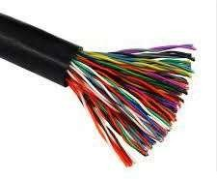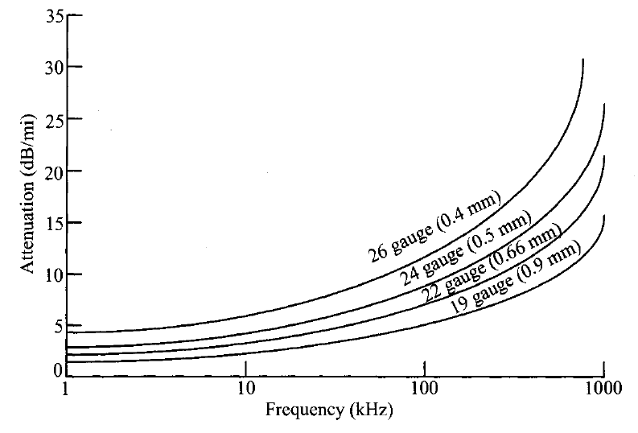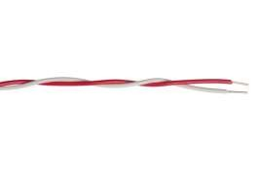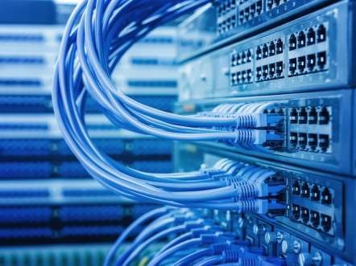

Twisted Pair

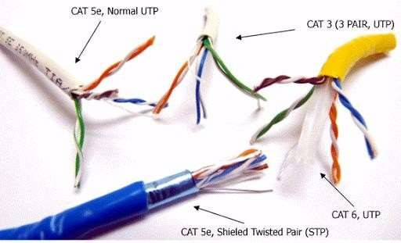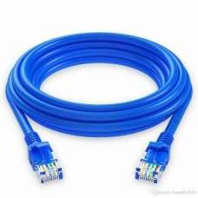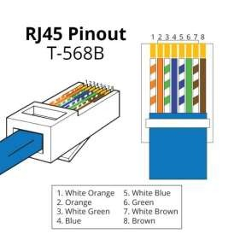

* Twisted Pair is also used for LAN cabling

Twisted Pair

* Twisted pair cables are standardized and used in Communication Networkss

|  |  |  |  |  |
| --- | --- | --- | --- | --- |
| **ategory** | **Max. Data Rate** | **Bandwidth** | **Max. Distance** | **Usage** |
| Category 1 | 1 Mbps | 0.4 MHz |  | Telephone and modem lines |
| Category 2 | 4 Mbps | 4 MHz |  | LocalTalk & Telephone |
| Category 3 | 10 Mbps | 16 MHz | 100 m | 10BaseT Ethernet |
| Category 4 | 16 Mbps | 20 MHz | 100 m | Token Ring |
| Category 5 | 100 Mbps | 100 MHz | 100 m | 100BaseT Ethernet |
| Category 5e | 1 Gbps | 100 MHz | 100 m | 100BaseT Ethernet, residential homes |
| Category 6 | 1 Gbps | 250 MHz | 100 m (10Gb at 37 m) | Gigabit Ethernet, commercial buildings |
| Category 6a | 10 Gbps | 500 MHz | 100 m | Gigabit Ethernet, commercial buildings |
| Category 7 | 10 Gbps | 600 MHz | 100 m | 10 Gbps Core Infrastructure |
| Category 7a | 10 Gbps | 1000 MHz | 100 m (40Gb at 50 m) | 10 Gbps Core Infrastructure |
| Category 8 | 25 Gbps (Cat8.1)  40 Gbps (Cat8.2) | 2000 MHz | 30 m | 25 Gbps/40 Gbps Core Infrastructure |

Coaxial Cable

* 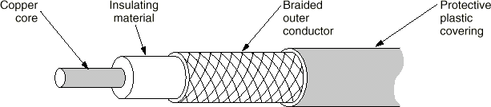Better shielding than twisted pair
* Lower attenuation & cross talk
* Can carry 1~2 Gbps in 1 km
* Telco’s used it for their backbone communication. It is replaced by fiber optics.
* Cable TV companies use it for TV and data delivery services.

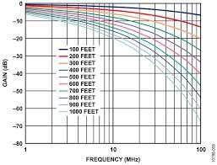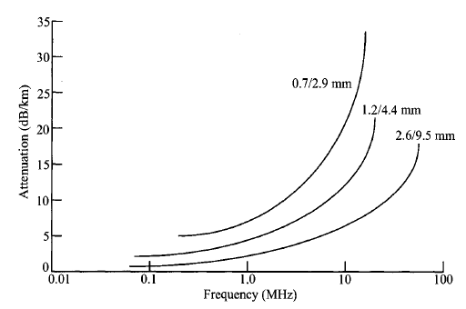

Communicatio

n Networkss

5

0

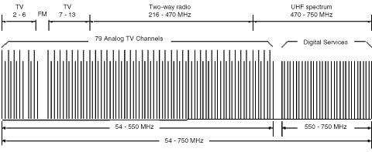

Communicatio

5

Cable TV Networks

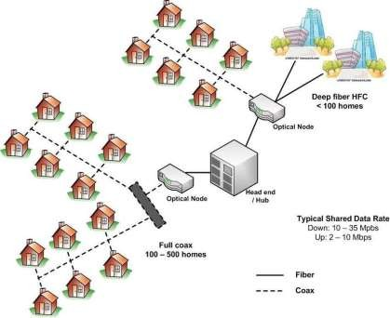

Hybrid Fiber Coax Architecture

* Combination of fibers and coaxes used to deliver the service
* Lasers are intensity modulated using the analogue RF signal
* Data Over Cable Service Interface Specification (DOCSIS) series of standards were developed to allow data service delivery over the TV cable network.
* DOCSIS 3.0 is the latest version of the standard (2007) which also supports QoS

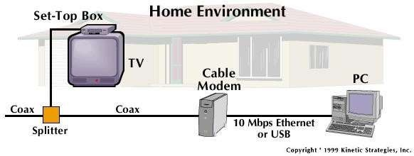

* Power Lines Carrier Communication Systems are used by Electric companies for transmission of control and dispatching data over power lines.

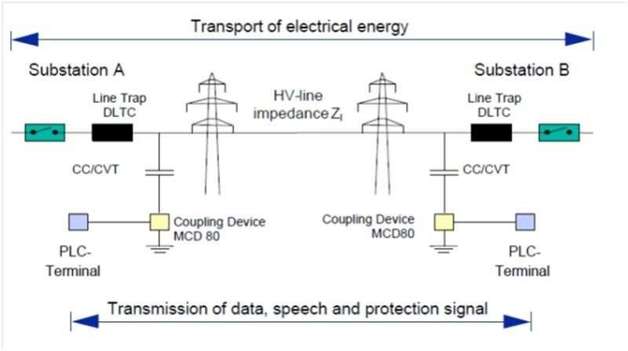

* Power Lines can be used for broadband data communication inside home.
* HomePlug AV2 standard supports up to 1Gbps

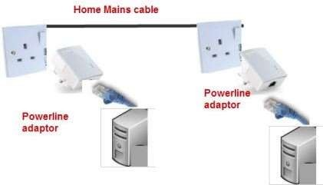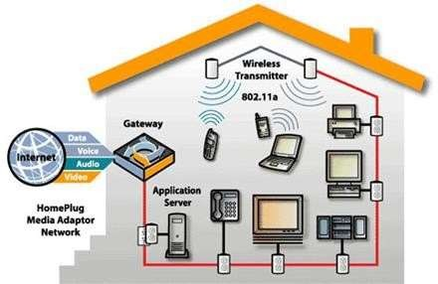

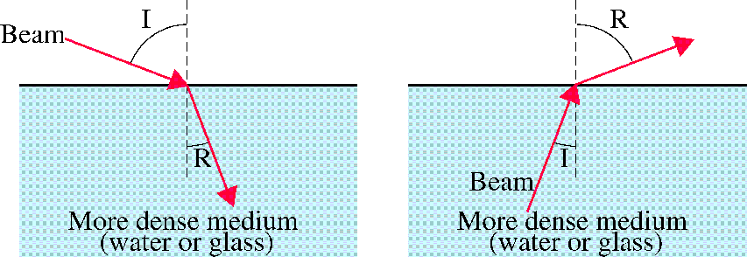

From less dense to more dense medium

From more dense to less dense medium

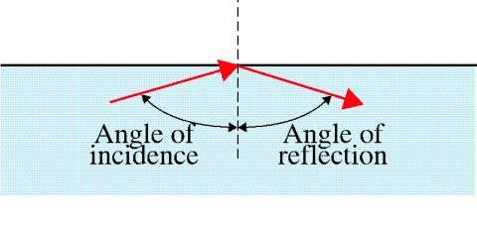

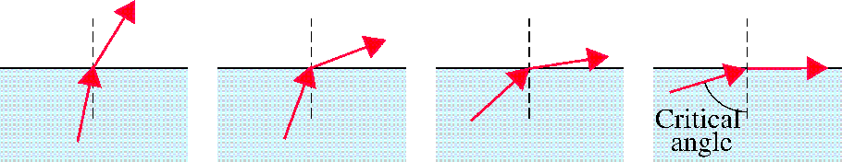

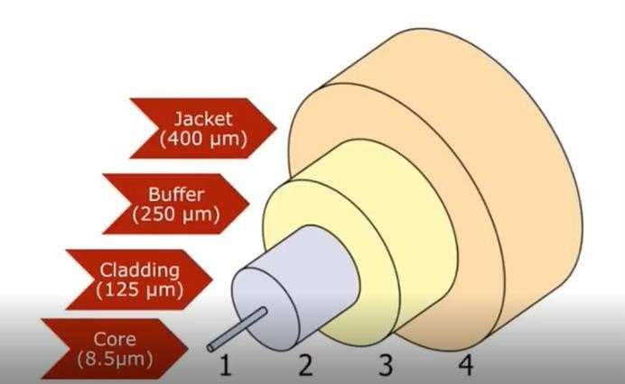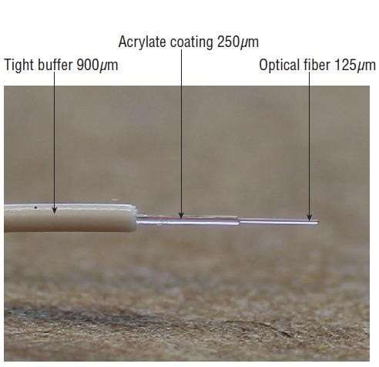

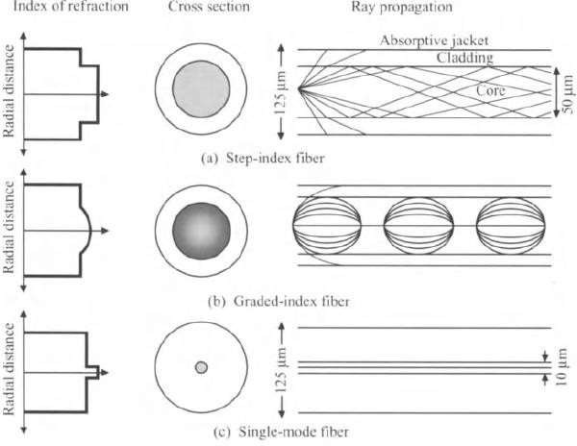Communicatio

Multi-mode

Fiber

Single-mode

Fiber

58

## Single Mode and Multi Mode

Communicatio 59

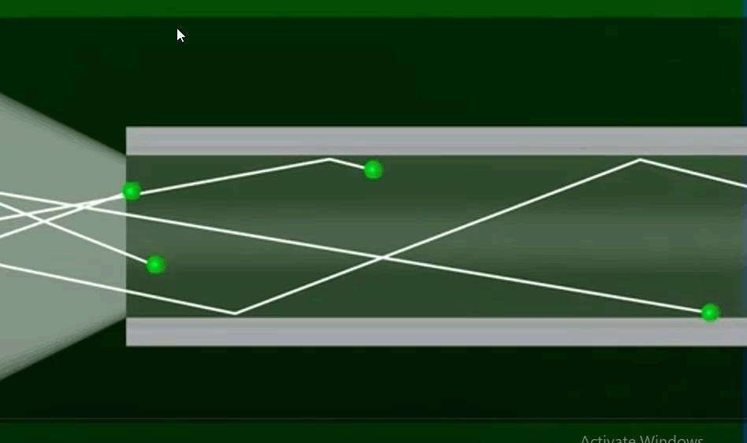

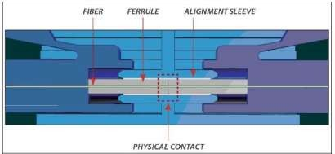

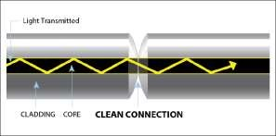

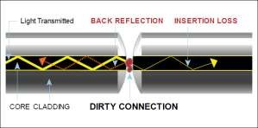LC Adaptor

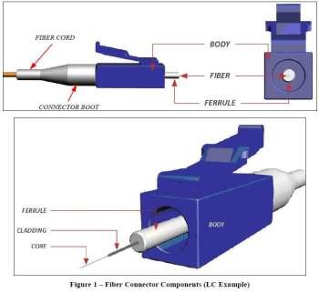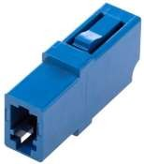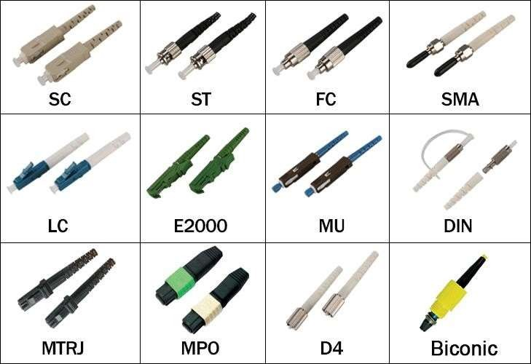

Communicatio 61

* Typical Attenuation for Multimode fiber:
  + 3 dB/km @ 850 nm
  + 1 dB/km @ 1300 nm

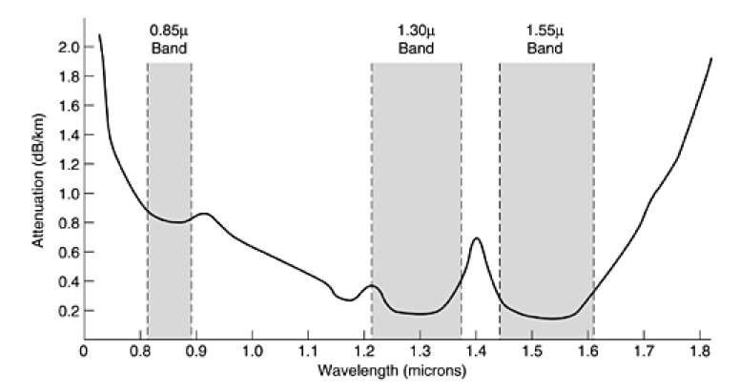

Communicatio

62

* Typical Attenuation for Single mode fiber:
  + 0.4 dB/km @ 1310 nm
  + 0.25 dB/km @ 1550 nm
* Fiber can handle much higher data rates than copper
  + C-Band: 1530-1565 nm
  + Frequency Range: 191 THz to 196 THz => 5 THz of bandwidth
* Fiber has low loss of signal power (attenuation), so fewer repeaters are needed for fiber optic links compared to copper based links
* Fibers are difficult to tap and therefore excellent for security
* Fiber is not affected by power surges, electromagnetic interference or power failure, or corrosive chemicals in the air
  + Photons of light in a fiber do not affect each other as they have no electrical charge, and they are not affected by stray photons outside the fiber
  + In the case of copper, electrons move through the cable and these are

affected by each other and by electromagnetic fields outside the cable

* Fibers are thin and lightweight, allowing more cables to fit into a

given area

* + 1000 twisted pair cables 1 km long = 800kg
  + 2 optical fiber cables 1km long = 100kg (allows transfer of much more

data)

* 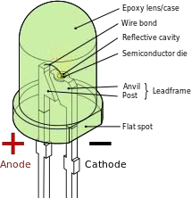Sending device called “light source”
* Light source
  + Light-emitting diode (LED)
    - Cheap but unfocused

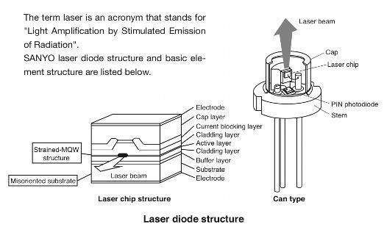

* Short distance
* Laser diode (LD)
  + More expensive than LEDs but focused
  + Preserve the signal (long

distance)

* + Most communication

systems use LD

* Lasers produce light in a more confined region of spectrum

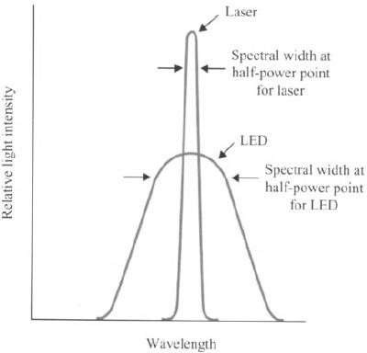

* 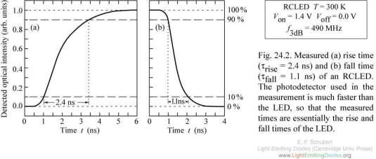Lasers can generate pulses with shorter duration in time. Therefore, higher modulation rates can be achieved with lasers.

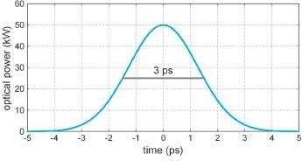

* Receiving device called “photosensitive cell” (photodiode)
* Photodiode converts optical signal to electrical signal

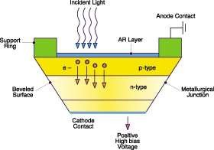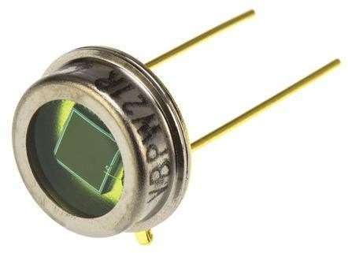

Light wave transmission system - overview

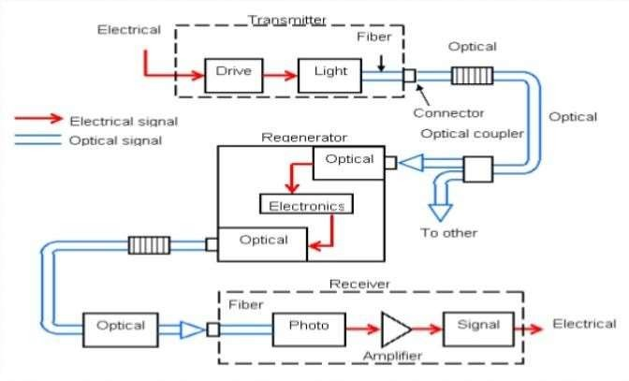

* Main Drivers
  + Communication without a physical attachment such as wires or fibers.
  + Mobility of users
  + Ease of deployment

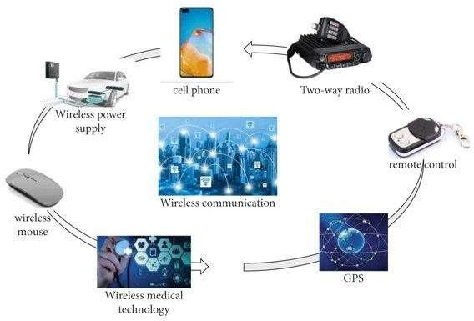

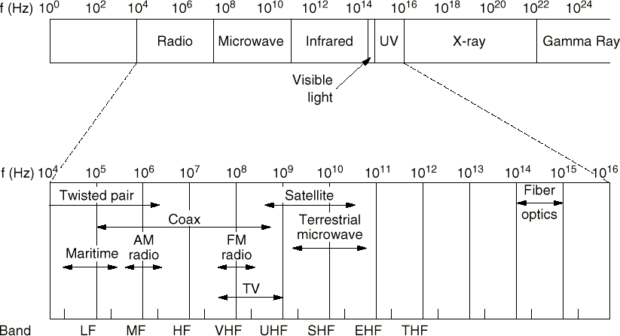

Communicatio 71

* Radio range of frequencies (10KHz to 10MHz) usually used for broadcast

communication

* + Long range, low attenuation, reflection from ionosphere
* Microwave range of frequencies (10MHz to 10GHz) usually used for point to point long distance transmission and local two-way communications
  + Medium range, affected by rain and weather conditions. Subject to multipath

fading.

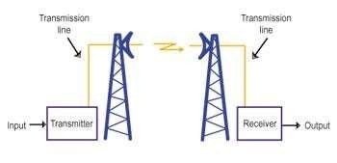

Communicatio

72

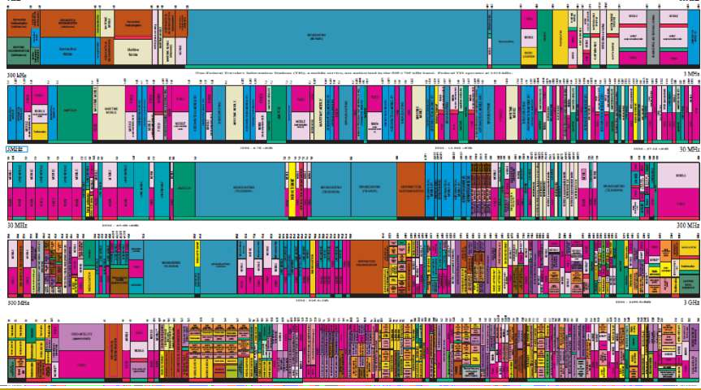

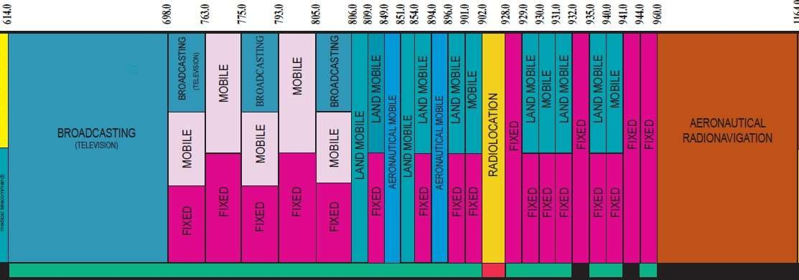

Communicatio 74

* Most radio frequency bands are regulated. Using frequency spectrum for commercial purposes is usually subject to a regulatory fee.
* There are license free bands available in most countries (ISM bands)

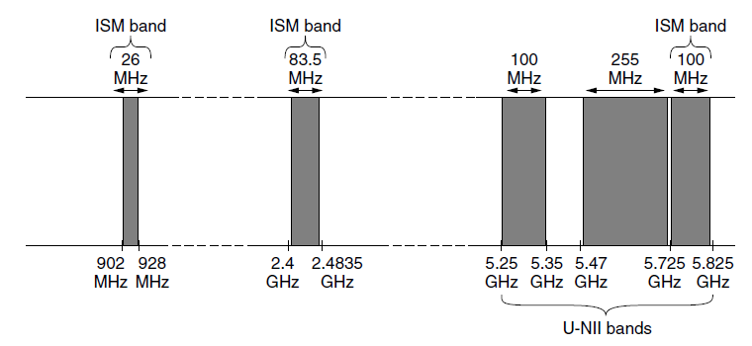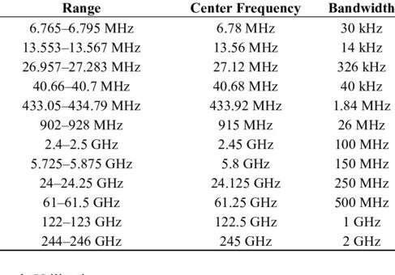

Communicatio

75

* Idea: Light as the information carrier for free space communication

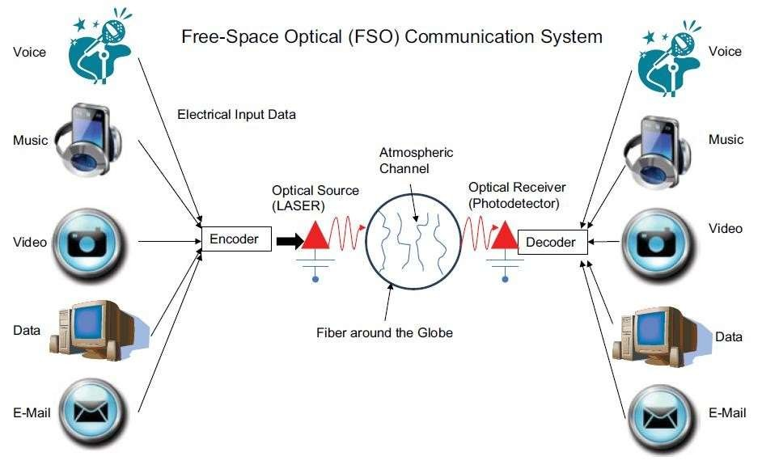

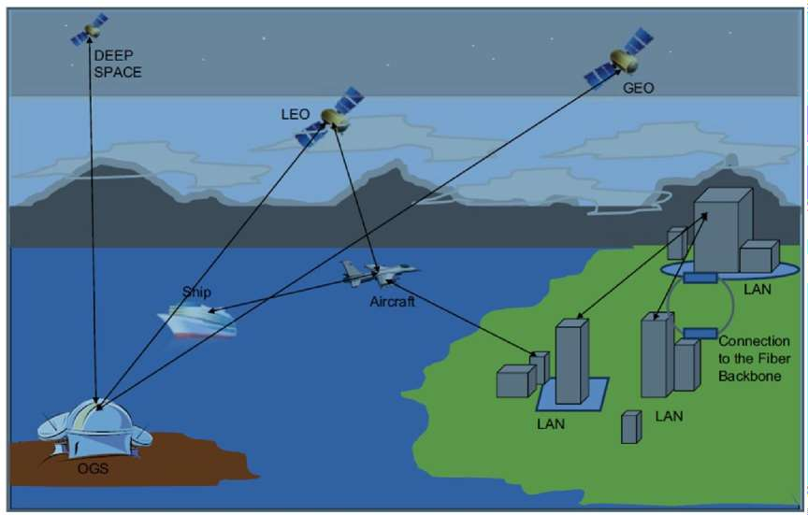

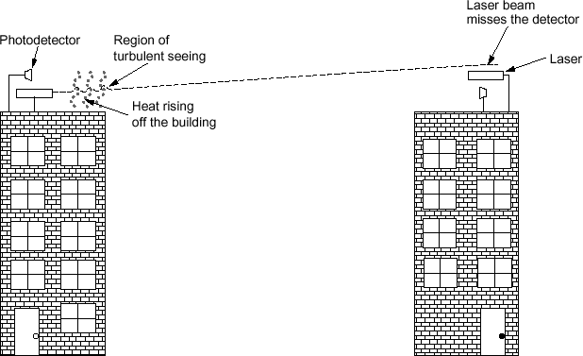

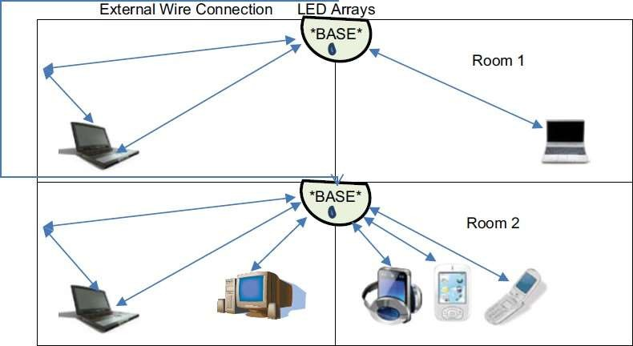

* Visible Light Communication (VLC)

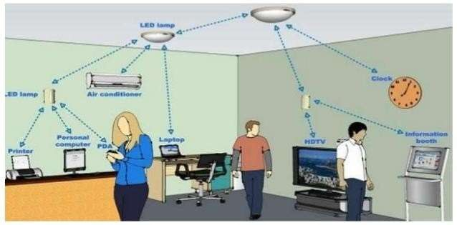

Communicatio 80

* Satellites can be used as a wireless node in the sky that can receive, amplify, process and transmit communication signals
* They are mainly used in three orbit ranges and therefore have different rotation period around earth.

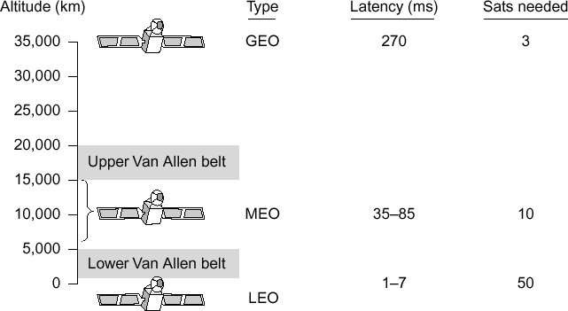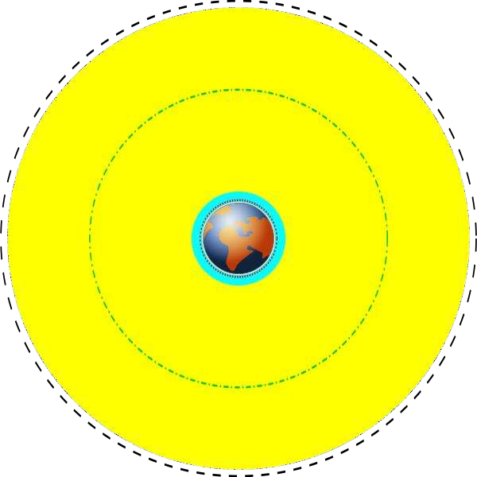

Communicatio 81

* Satellites generally have multiple transponders each with a given

bandwidth/capacity for data transport

* They usually use “spot-beams” to focus their transmission on a given region.
* Most communication satellites are at Geostationary orbit
* Satellite operational frequency ranges:

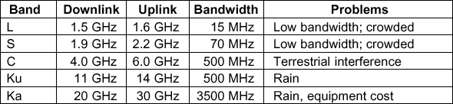

* Very Small Aperture Terminals (VSAT)
  + Small terminals that communicate to each other through a Geostationary satellite and a HUB.
  + VSAT can be used to provide voice and data connectivity to remote locations with no land-based telecommunication infrastructure
  + 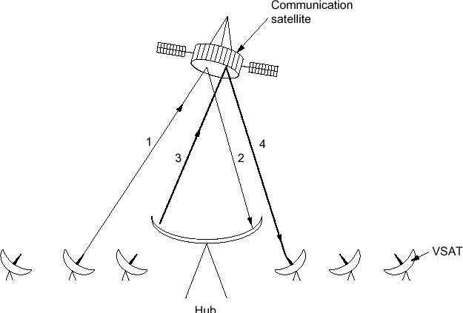Data rate of links ranges from 4 kb/s to 100 Mb/s

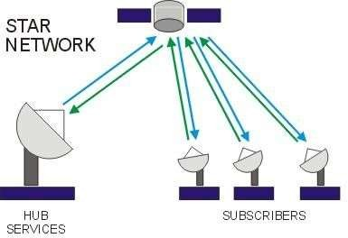 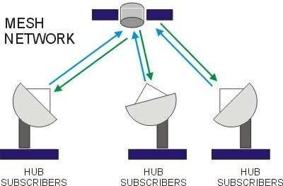

* Rotate at 6 hours or less around earth
* Global Positioning using 31 Satellites at about 20,000 km

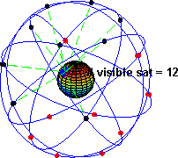

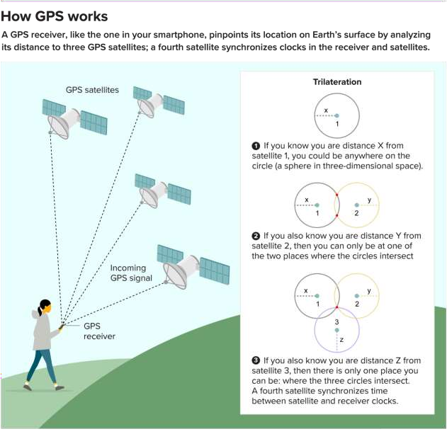

Communicatio 86

n Networkss

Low Earth Orbit Satellites (LEO)

* Satellites orbiting earth below 2000 km with a rotation time of 128 minutes or less
* Many satellites are needed to cover the earth for providing communication services (Mobile phone, Internet access)
* Starlink, Telesat, and Oneweb/Airtel are some of the companies that have satellite systems to provide global voice and data services.

Communicatio 87

* In some LEO satellite systems such as Iridium, satellites are relaying and switching the data from source to destination
* In some other satellite systems such as Globalstar, satellites relay the signal to their ground station and switching is done by a terrestrial network. The advantage is that much of the complexity is on the ground and satellites are simpler.

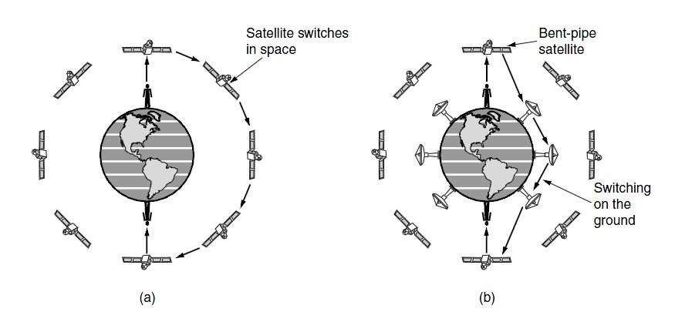

Communicatio

88

##### Starlink currently has more than 3500 satellites

Communicatio 89

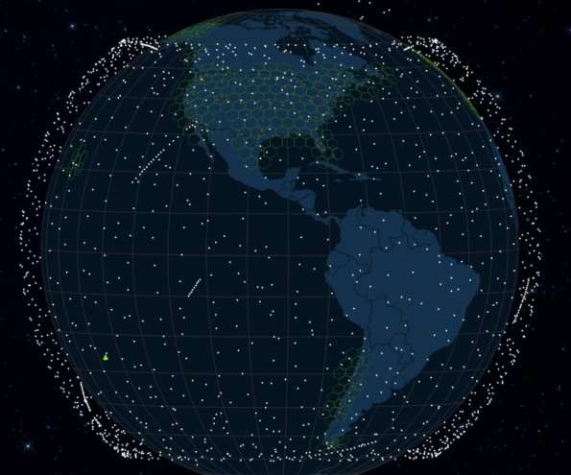

n Networkss

* Optical communication is the dominant technology for transmission of voice and data.
* From office LANs to intercontinental communication networks, optical communication systems are used as a cost effective solution.
* Satellite communication serves some key demands
  + Networks that require rapid deployment (disaster recovery, military

applications)

* + Communication in places where terrestrial networks are not well

developed (jungles, countries with many islands, oil stations in the sea)

* + Broadcasting (TV, Radio)

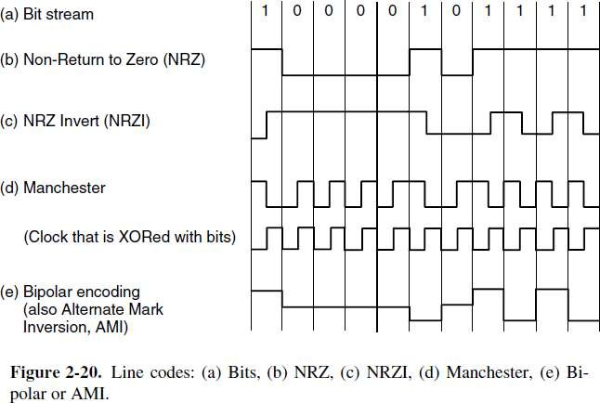

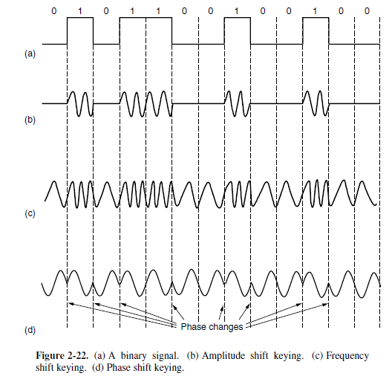

* 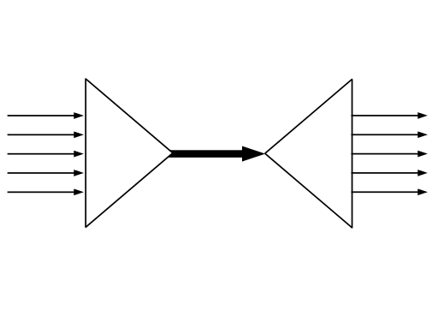In telecommunications and computer networks, multiplexing (sometimes contracted to muxing) is a method by which multiple analog message signals or digital data streams are combined into one signal over a shared medium.
* The aim is to share an expensive resource.
* Multiplexing originated in telegraphy in the 1870s, and is now widely applied in communications..
* The multiplexed signal is transmitted over a communication channel, which

may be a physical transmission medium.

* The multiplexing divides the capacity of the high-level communication channel into several low-level logical channels, one for each message signal or data stream to be transferred.
* A reverse process, known as demultiplexing, can extract the original channels on the receiver side.
* A device that performs the multiplexing is called a multiplexer (MUX), and a device that performs the reverse process is called a demultiplexer (DEMUX).
* 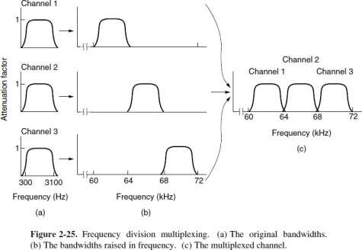Information from multiple sources can be multiplexed in frequency domain by assigning different carriers to different sources.
* Usually there is a guard band

between different frequency bands

* Orthogonal Frequency Division Multiplexing (OFDM) allows us to use different frequency bands for transmission of data in a more efficient way

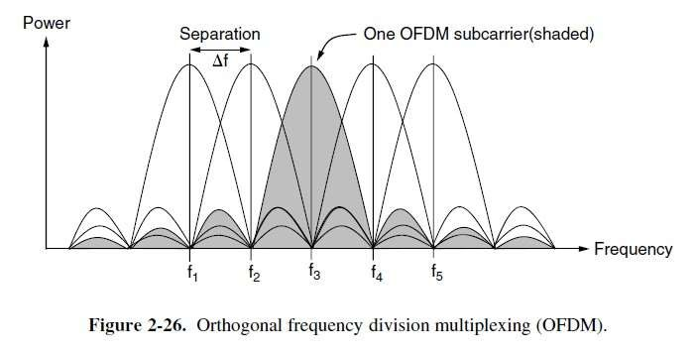

* OFDM is used in wireless networks, cable networks and twisted pair networks.

Communicatio 94

n Networkss

* Several independent streams of data each carried in a different wavelength can be multiplexed in optical domain and transmitted over a single fiber.
* This technology has drastically increased the capacity and lowered to cost of transmission networks

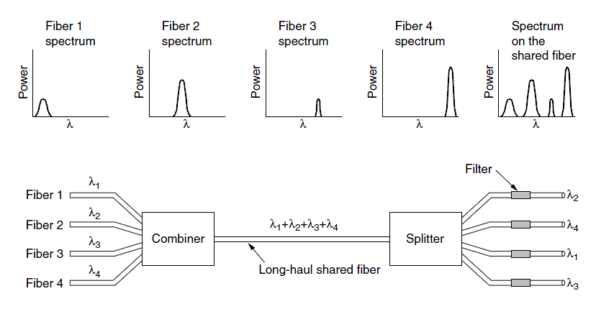

Communicatio

n Networkss

95

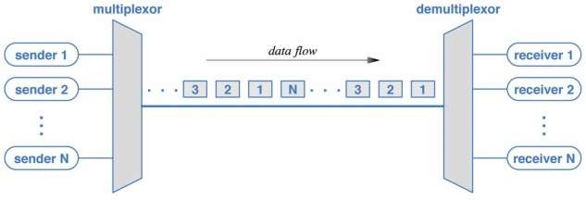

* Different sources of data can be transmitted by dividing time into different slots and using each slot for a stream of data
* TDM is widely used in optical networks and wireless networks.

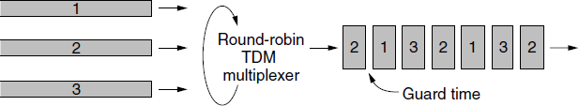

* A techniques which allows for a new multiple access mechanism and is proving to be very effective for mobile communication. (Used in 2G and 3G mobile systems)
* Time division: TDM
  + each speaker gets its turn
* Frequency division: FDM
  + concurrent speakers separated far enough
* Code Division Multiplexing (CDM)
  + every speaker speaks a different language ***at the same time***
* Key idea:
  + Each station uses the entire frequency band but uses a different code.

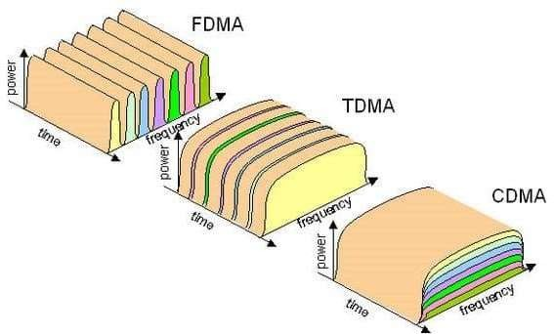

https://networkencyclopedia.com/code-division-multiple-access-cdma/

* Each bit time interval is divided into m slots called chips
* Each transmitter uses a unique chip sequence to send 1 and its inverse to send 0.
  + Send 1 as: 1 1 -1 -1 1 -1 1 -1
  + Send 0 as: -1 -1 1 1 -1 1 -1 1
* Chips are chosen to have these properties:

*m*

*S* •*T*  1  *s t*  0

*i i*

*m*

*i*1

*m*

*S* • *S*  1  *s*2  1

*i*

*m i*1

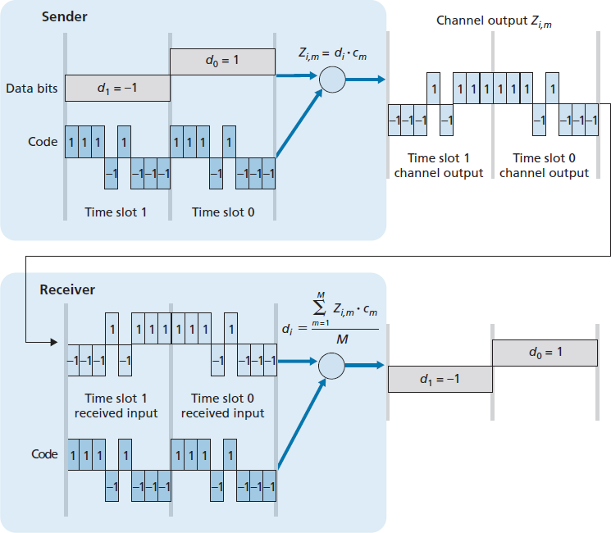

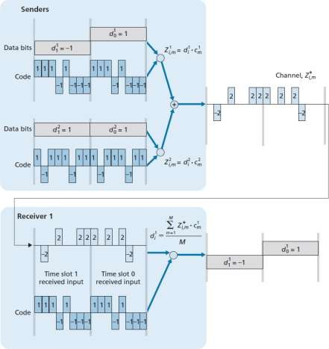

* Example:

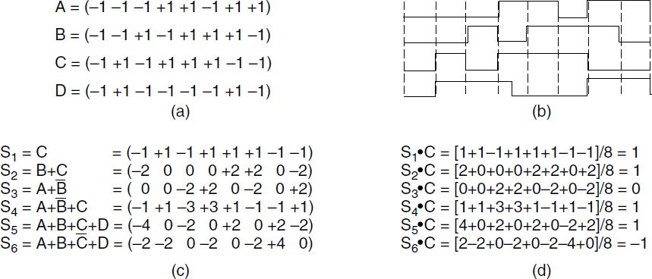

* CDMA Spectrum

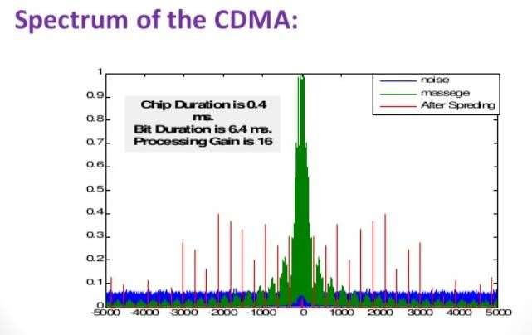

* Practical issues:
  + Keys should be known in advance
  + Power Control:
    - Senders should be received with same power
    - Send with inverse power of received signal strength
  + Synchronization: what if senders are not synchronized:
    - Lock into the ‘wanted’ channel
    - Other channels will be received as background noise
* Public Switched Telephone Network (PSTN)
  + A complex network that spans the globe and enables voice and data

communication.

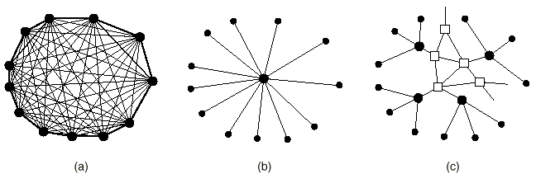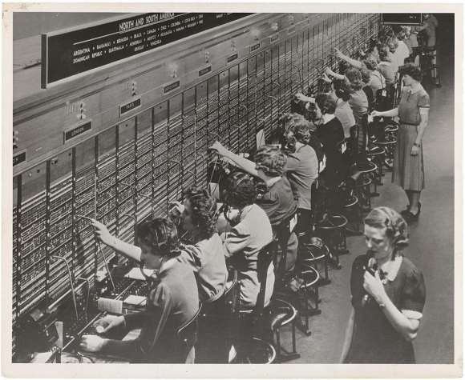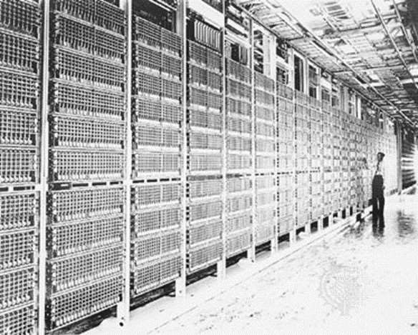

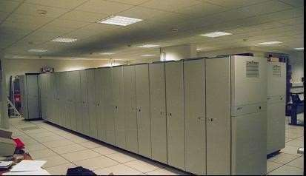

* Telephone system organization: hierarchical network with three important components:
  + Local loops:
  + Switching centers:
  + Trunks: connecting switching offices using various transmission technologies

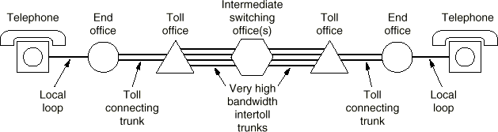

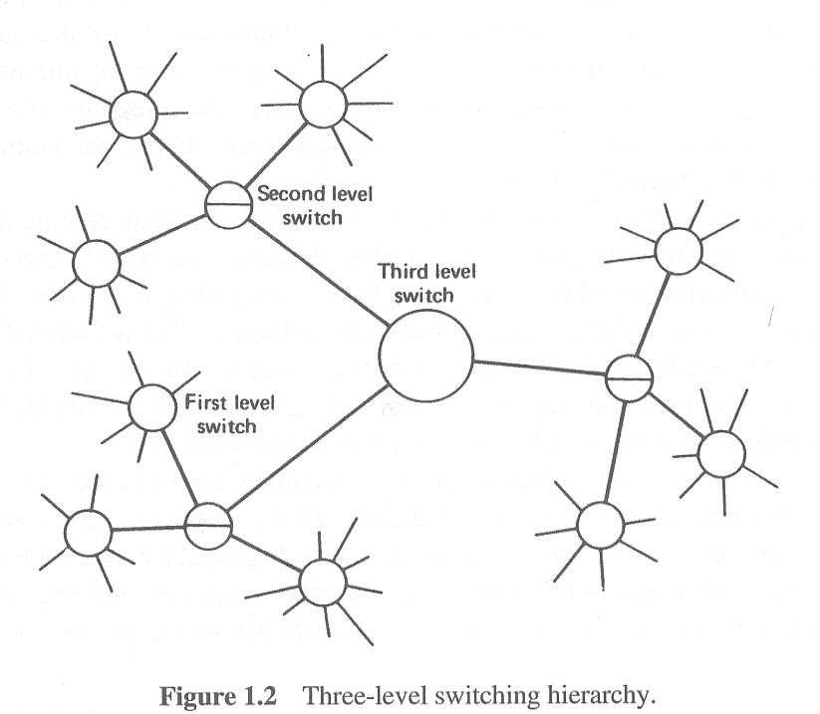

Switch Hierarchy, an example

SLIC

Timing Unit

SLIC

Telephone Switch

SLIC

SLIC

SLIC

E1 Mux

TDM Switch

SLIC

SLIC

Control Unit

SLIC

SLIC

SLIC

Dual-Tone Multi-Frequency Signaling

* DTMF is a telecommunication signaling system using the voice- frequency band over telephone lines between telephone equipment and other communications devices and switching centers.
* Pressing a key sends a combination of the row and column frequencies.
* Telephone switching centers detect the received tones to extract the pressed key.

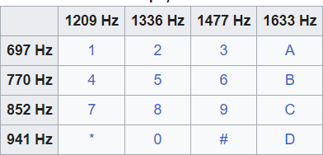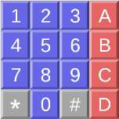

* Important User Side Functions
  + Battery supply to subscriber

line

* + Overvoltage protection
  + Off/On hook detection
  + Ring Generation

n

* Important Network Side Function
  + PCM Coder/Decoder
  + Filtering and Amplification
  + Compression/Decompression

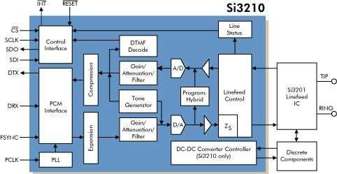

* Tone Detection
* Tone Generatio
* Hybrid
* Testing

Communicatio

n Networkss

11

3

* Modem: A device that receives a stream of digital bits and sends/receives it

properly from the transmission medium (such as twisted pair)

* Transmission problems:
  + Attenuation and Delays which are frequency dependent
  + Noise (Thermal Noise, Impulse Noise, etc)
  + Cross talk, caused by inductive coupling of wires
* For voice band modems, data rate is limited by PSTN sampling process and

loop conditions

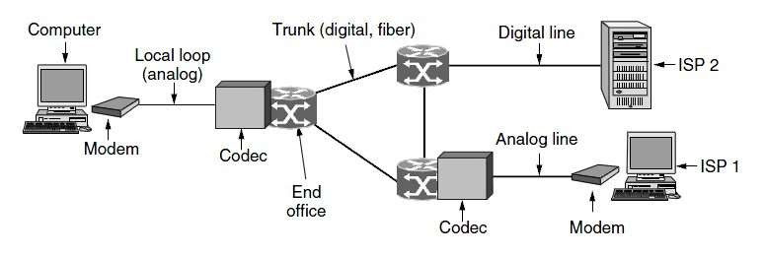

Communicatio

11

* Important voice band modem standard:
  + V.32: 9600 bps : 4 bits / baud
  + V.32 bis: 14.4 kbps : 6 bits / baud
  + V.34: 28.8 kbps (Using QAM Constellation)
  + V.90: 56 kbps DS, 33.6 kbps US
  + V.92: 56 kbps DS, 48 kbps US
* Maximum modem data rate for connection over normal PSTN networks:

33.6kbps (limited by quantization noise)

* Rates achieved by V.90 and V.92 standards is achieved when connecting to

ISPs with digital network connection

* Compression schemes:
  + MNPs : run-length encoding (runs of zero’s may be very common)
  + V.42 bis : Ziv-Lempel compression

(ADSL)

* 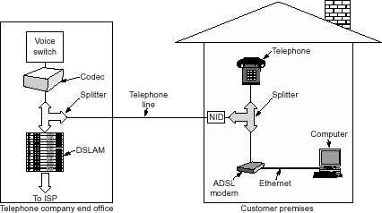Objective: Offering data services without impacting the voice service on twisted pair
* Central Office (CO) side:
  + Use splitter to feed low pass part to the voice switch while the higher frequencies to the feed the DSLAM
* Customer Premise End (CPE)
  + Use splitter or in-line filters to feed the low pass part of the spectrum to the telephone and the high pass part to the CPE ADSL modem
* ADSL signal power spectrum is defined carefully to reduce cross talk into other services
* Uses Discrete Multi tone technique (DMT) as the modulation scheme.
* Idea: Divide frequency into small bins each carrying a separate QAM

constellation

* + Better use of channel capacity
  + More resistance to noise
  + Rate adaptability

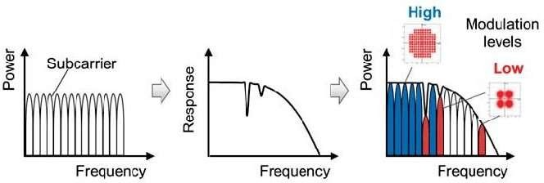

* ADSL Spectrum is designed to:
  + Allow higher download rate and lower upload rate at home
  + Co-exist with telephone service
* Most common mode of operation: Frequency Division Mode
  + Upstream (US) 25kHz to 130 kHz providing up to 3.5 Mbps
  + Downstream (DS) 140 kHz to 2.2 MHz providing up to 24 Mbps

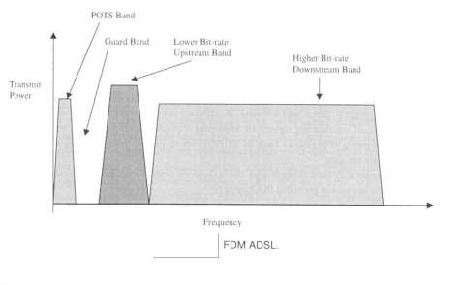

Communicatio

11

* ADSL downlink and uplink rate decrease with the distance between home and local exchange

Communicatio 11

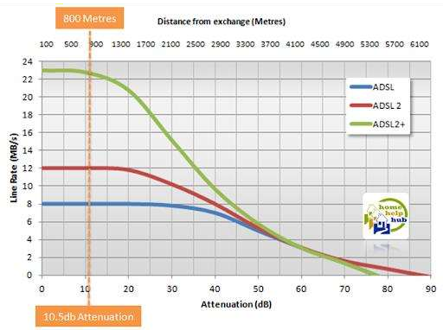

n Networkss 9

* Fiber optic can provide a medium for providing very high speed data services.
* Bringing fiber deployment closer to the homes and businesses facilitates the deployment of higher speed data services for end
* Passive Optical Networks (PON) are becoming very popular and can run at around gigabits per second to provide different services such as
  + Ethernet PONs (EPON)
  + Gigabit capable PONs (GPON)

Communicatio 12

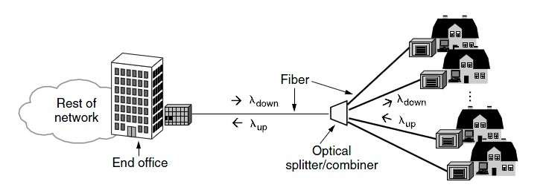

n Networkss 0

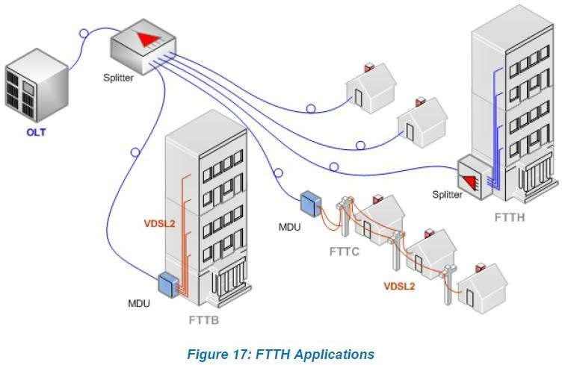Source: FTTH Handbook

FTTH Council Europe

Faculty of EE, Sharif U of Tech Advanced 78

Communication

* TDM: time division multiplexing

(can only be used in the digital domain)

* + Pulse Coded Modulation (PCM): Analog voice signals coming from local loop are sampled at 8000 samples/sec. Each sample is represented by 8 bits.

⇒ 64 kbps representation of the voice signal

* + Several voice channels can be multiplexed in time to carry voice info between Telco offices.

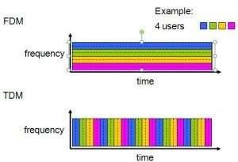

* 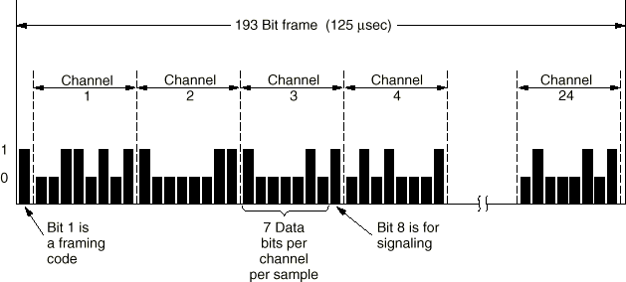N. America : T1 carrier
  + 1.544 Mbps
  + 24 x 8 + 1 = 193 bits per frame
  + 1 frame per 125 microseconds
  + 8000 x 8 = 64 kbits/second per channel
  + 24 analog channels
  + AD-conversion: PCM 8-bit sampling

at 8000 Hz

* Outside N. America : E1 carrier
  + 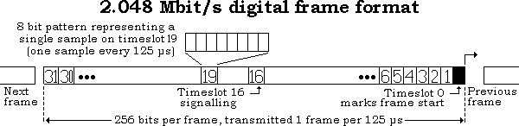2.048 Mbps
  + 32 channels
  + 32 x 8 bits per frame
  + 30 data and 2 signaling channels
* Higher order rates are derived from

multiplexing T1 or E1 signal streams

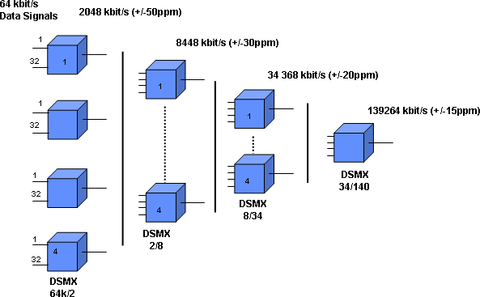

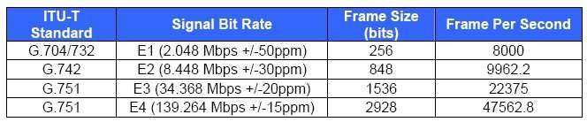

Communicatio

12

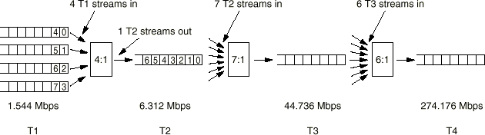

Communicatio 12

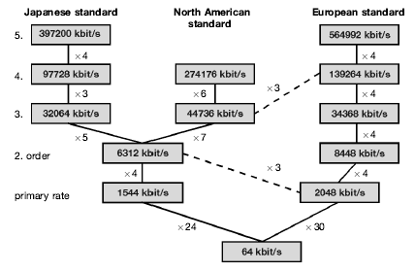

Communicatio

n Networkss

12

6

* SONET (Synchronous Optical Network) and SDH (Synchronous Digital Hierarchy) are the primary standards for all types of metro and long-haul transport of traffic over fiber networks.
* Design objectives:
  + Unify the US, European and Japanese digital transmission systems
  + Provide a multiplexing scheme or digital hierarchy
  + Provide OAM support
  + Direct access to low-level tributaries without the need to de-multiplex the entire

signal

**140 Mbit/s 140 Mbit/s**

**main**

**1,2 ................. 64**

**2 - 8**

**8 - 34**

**34 - 140**

**OLTU**

**2 - 8**

**8 - 34**

**34 - 140**

**OLTU**

**2 - 8**

**8 - 34**

**34 - 140**

**OLTU**

**2 - 8**

**8 - 34**

**34 - 140**

**OLTU**

**stand-by**

**Drop & Insert Station Line Terminating Unit**

■ PDH has some disadvantages.

❑ Inability to identify individual channels in a higher order bit stream.

❑ Insufficient capacity for network management.

❑ There are different hierarchies in use around the world.

❑ Specialized interface equipment is required to inter-work the two hierarchies.

■ SDH has some advantages over PDH networks.

❑ High transmission rates.

❑ Simplified add & drop function.

❑ Defined easy standard interconnection.

❑ Reliability.

❑ Future-proof platform for new services.

* SDH Rate and signaling
  + 155 Mbps or multiples
  + 270 x 9 x 8 bits per frame of 125 microseconds
* SDH multiplexing
  + 261 x 8 x 9 bits for synchronous payload envelope (SPE)
  + Payloads can carry many different types of traffic
  + Header bytes are used for framing, parity, voice channels, error monitoring, IDs, clocking

and synchronization

* Standards: Multiples of 4nxSTM-1
  + STM-1: 155.52 Mbps
  + 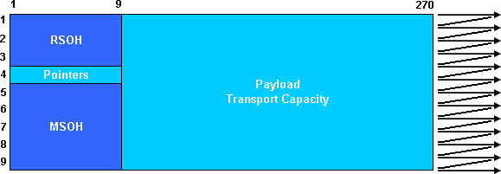STM-4: 622.08 Mbps
  + STM-16: 2.5 Gbps
  + STM-64: 10 Gbps
  + STM-256: 40 Gbps

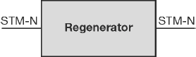 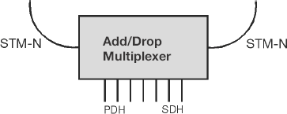

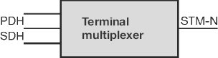 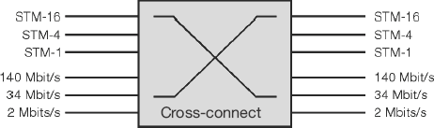

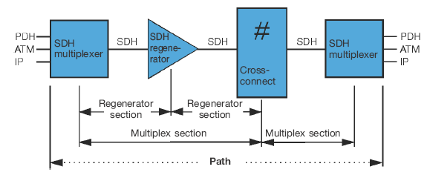

Communicatio

n Networkss

13

0

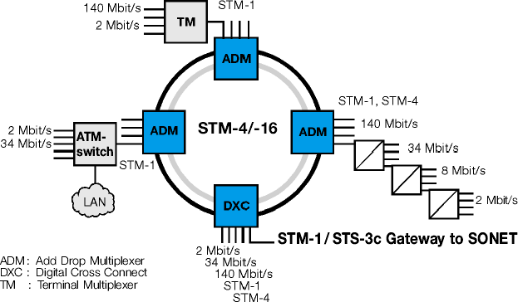

Communicatio 13

n Networkss 1

❸

Terminal Mux

Terminal Mux Linear Add/Drop Muxe

TM ADM ADM

s

❶ Linear Add/Drop Mux

PDH Tributaries

Standard

ADM

STM-4/OC-12

RING

ADM

CCW

PDH Tributaries

Dual-Ring Add/Drop Muxes

CW

Terminal Mux

STM-1/OC-3 Link

Linear Add/Drop Muxes

ADM

Ring Bridge

PDH

Tributaries

❹ 1+1 APS

Terminal Mux

1+1

TM

1+1

ADM

PDH Tributaries

1+1

ADM

Linear 1+1 APS

ADM

CCW

STM-1/OC-3 RING

ADM

CW

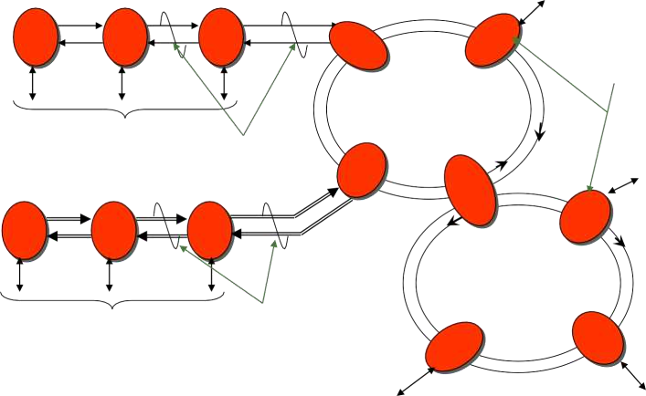

Typical Network Nodes

STM-1/OC-3 Link

Communicatio

PDH

Tributaries

ADM

ADM

PDH Tributaries

❷ Dual Ring (UPSR)

Add/Drop Mux

89

Communication Networkss 91

* **Circuit switching**
  + Dedicated path established between source and destination
  + Long set-up time: O(10 sec)
  + No congestion change: guaranteed bandwidth
  + No extra random delay while call is established.

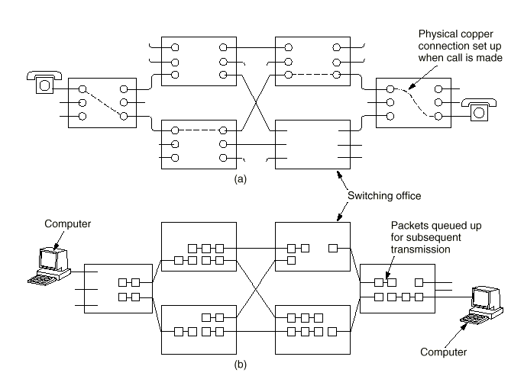

Only transport delay

* + Unused bandwidth is wasted
  + Transparent to data format and framing mode. (road vs. railroad)

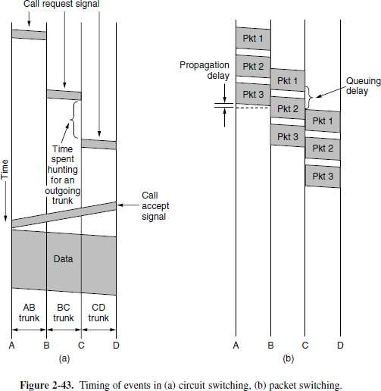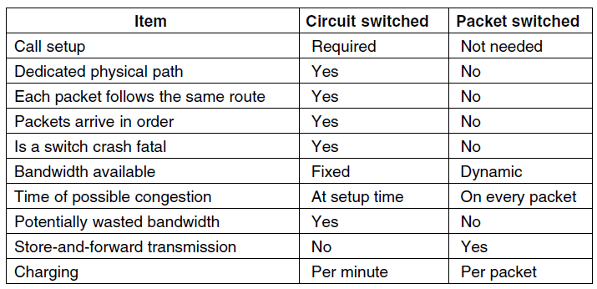

* **Packet switching**
  + Store-and-forward technique used
  + No dedicated path
  + Packet size should be limited in order not to block switches and/or overflow buffers
  + First packet is forwarded while

second is received.

* + Rate conversion is easy
  + Delivery order may not be

guaranteed

Communicatio 92

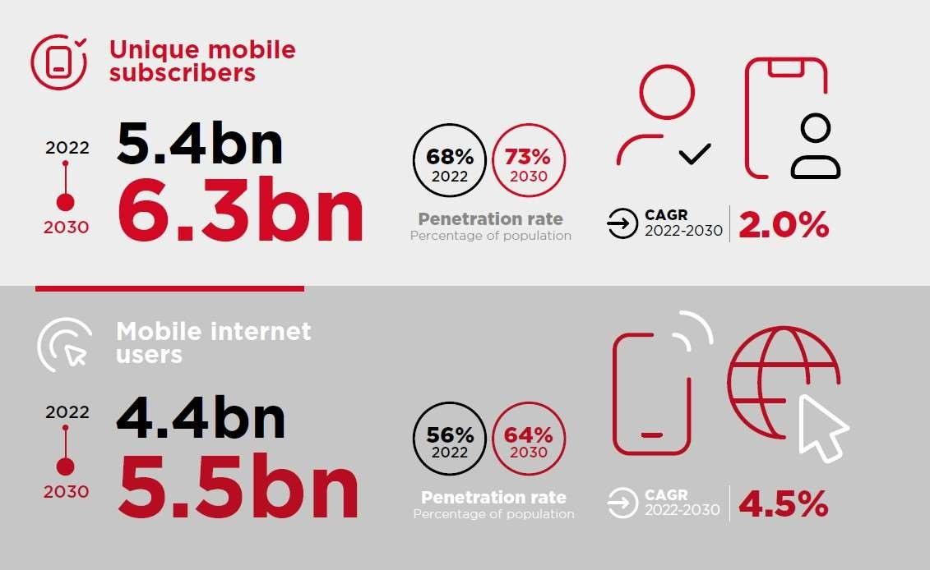

Communicatio 93

n Networkss

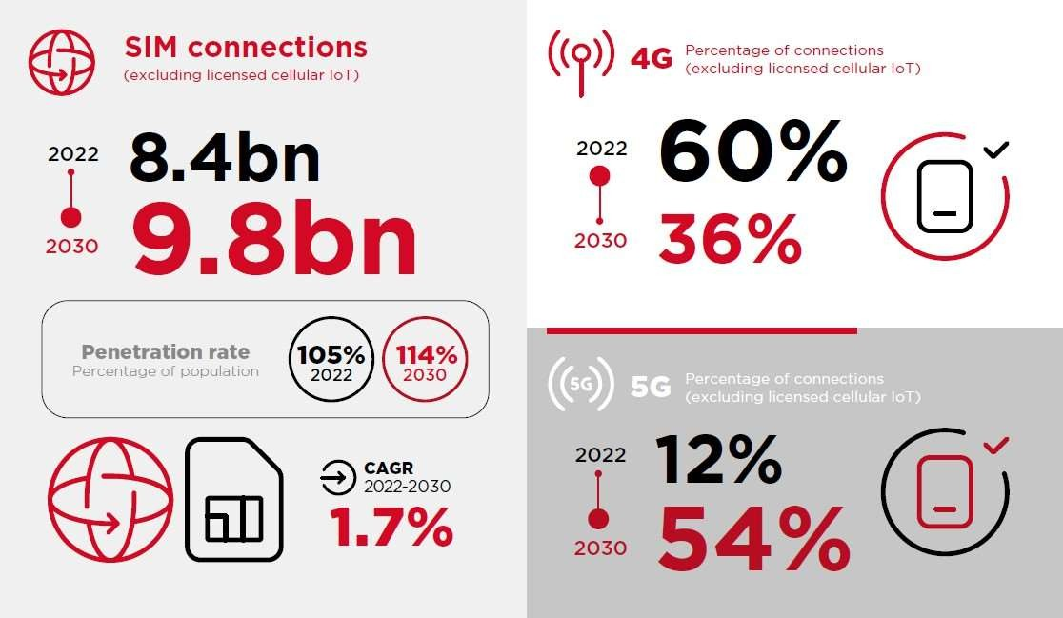

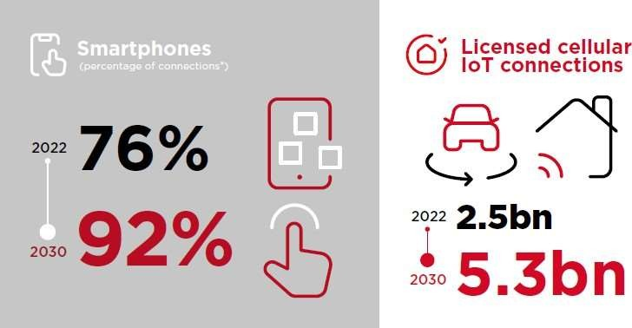

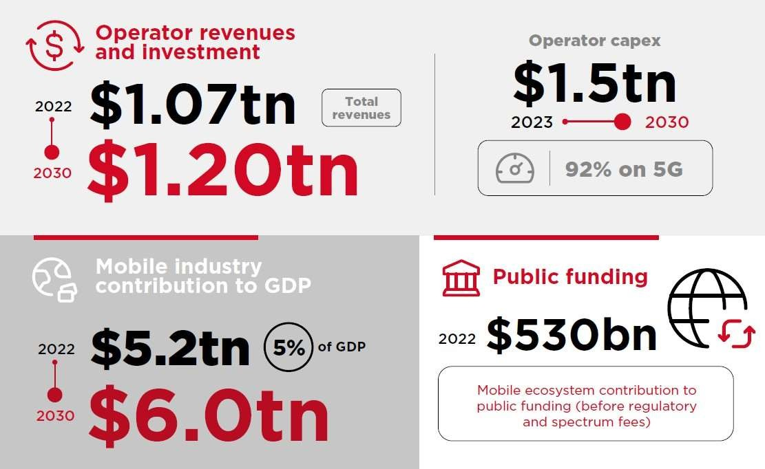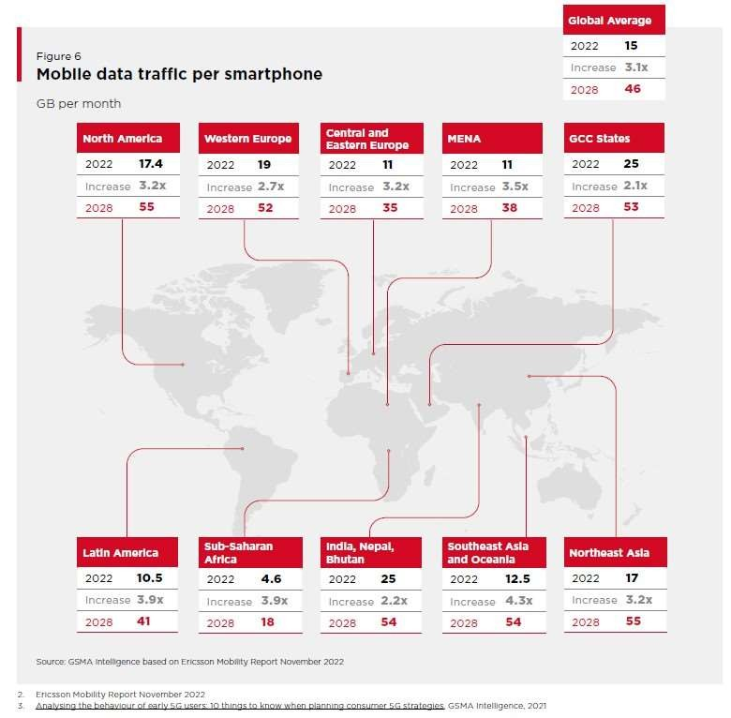

Communicatio 97

n Networkss

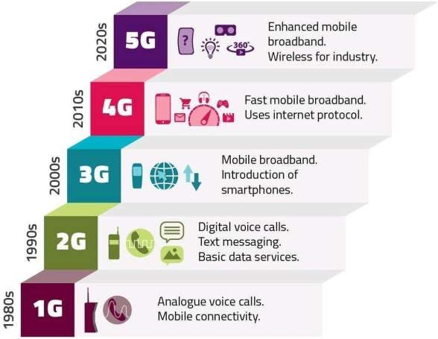

* First Generation:
  + Started from push to talk one to many systems (Police, Taxi’s)
  + In 1960, Improved Mobile Telephone System (IMTS) was installed with

separate US and DS channels

* + Had a high power transmitter with 23 channels from 150 MHz to 450MHz
  + Problems with channel capacity (Low number of channels) and

interference

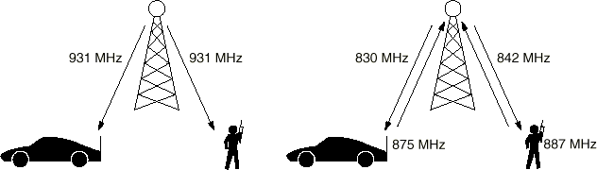

* Single hop wireless connectivity to the wired world
  + Space divided into cells
  + A base station is responsible to communicate with hosts in its cell
  + Mobile hosts can change cells while communicating
  + Hand-off occurs when a mobile host starts communicating via a new base station
* 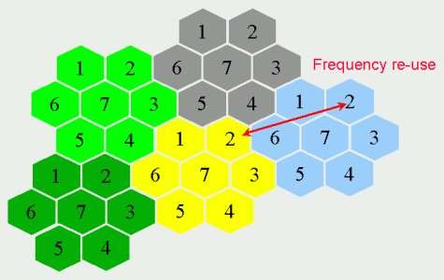Factors for determining cell size
  + No. of users to be support
  + Multiplexing and transmission

technologies

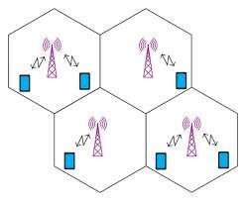



* Advanced Mobile Phone System (AMPS) (1982)
  + Divide area into radio cells to avoid interference and allow frequency re-use
  + Cells are around 10 km wide
  + Multiple base stations talk to a Base station switching center (BSC)
  + Multiple BSC’s talk to a Mobile Switching Center (MSC) and then to the PSTN network
  + 832 upstream channels from 829-849 MHz, 832 downstream channels from

869-894 MHz each 30 kHz wide

* Channels are used for
  + Control (Base to Mobile) to

manage the system (21 channels)

* + Paging (Base to Mobile) to alert

mobile users for a call

* + Access (Bi-directional) for call setup and channel assignment
  + Data (Bi-directional) for voice, fax and data (usually around 45 channels due to frequency re-use)
* Call handling
  + When handset is powered on, it scans control channels to find the most powerful signal
  + It then broadcasts its 32 bit serial number

and phone number in digital format

* + BTS reports to MSC and it will decide if the

user should be accepted for service

* + When mobile is dialing, MSC decides upon the channel and service availability and connects the call
  + MSC should also handle roaming and

handoff

* + For incoming call, handset should continuously monitor the paging channel and respond through the control channel when a call request comes in
    - 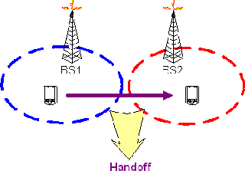Hand-off necessary when mobile moves from area of one BS into another
    - BS initiated:
      * BS monitors the signal level of the mobile
      * Handoff occurs if signal level falls below threshold
      * Increases load on BS
      * Monitor signal level of each mobile
      * Determine target BS for handoff
    - Mobile assisted:
      * Each BS periodically transmits beacon
      * Mobile, on hearing stronger beacon from a new BS, sends it a greeting
      * changes routing tables to make new BS its default gateway
      * sends new BS identity of the old BS
      * New BS acknowledges the greeting and begins to route mobile’s call
    - Intersystem:
      * Mobile moves across areas controlled by different MSC’s
      * Handled similar to mobile assisted case with additional HLR/VLR effort

Communicatio 103

* + - D-AMPS
      * IS-54, IS-135, backward compatible with AMPS.
      * Uses the same 30 kHz channels as AMPS. Therefore, D-AMPS

(Sometimes call PCS) and AMPS can coexist in the same network.

* + - * A new band was opened for D-AMPS:
        + 1850-1910 MHz for US
        + 1930-1990 MHz for DS
      * Systems with much smaller phone size and longer battery life were

developed

* + - * D-AMPS Vocoder can compress the voice down to 8kbps or less

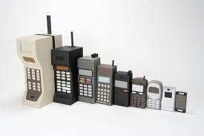

* Mobile Monitors the Rx quality and requests a handover to another base if there is a need

Communicatio

104

* + - GSM: Global system for mobile communication
      * Developed in Europe in 1990s
      * Second generation mobile system
      * Can offer voice and data

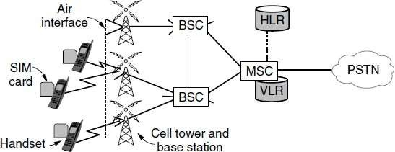

**Core Network**

* + - Main tasks of core network
      * Call control
      * Routing
      * 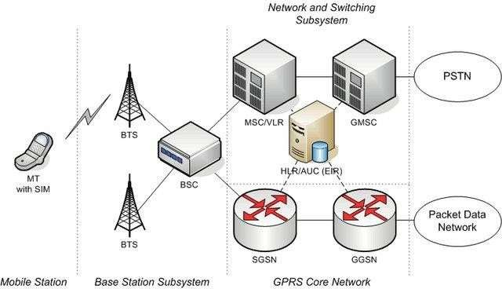Locating
      * Mobility management
      * Signaling to other networks
    - 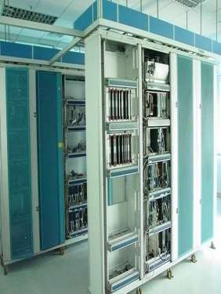Specific functions of a MSC
      * Switching of 64 kbit/s channels
      * Paging and call forwarding
      * Termination of SS7 (signaling system no. 7)
      * Mobility specific signaling
      * Location registration and forwarding of location

information

* + - * Support of short message service (SMS)
      * Generation and forwarding of accounting and

billing information

* + - Switching functions
      * Additional functions for mobility support
      * Interworking functions via Gateway MSC (GMSC)

❑ Integration of several databases

* + - Central master database that contains data from every user that has subscribed to the operator, includes:
      * Subscriber data
      * IMSI - International Mobile Subscriber Identity
      * List of subscribed services with parameters and restrictions
      * Location data
      * Current MSC/VLR address
    - Responsibilities of the HLR include:
      * Management of service profiles
      * Mapping of subscriber identities (MSISDN, IMSI)
      * Supplementary service control and profile updates
      * Execution of supplementary service logic e.g. incoming calls barred.
      * Passing subscription records to VLR
    - Local database:
      * Data about all users currently in the domain of the VLR
      * Includes roamers and non-roamers
      * Associated to each MSC
    - Responsibilities of the VLR include:
      * Executing supplementary service programs (outgoing calls

barred)

* + - * Initiating authentication and ciphering
      * Initiating paging
      * Passing location information to HLR
    - SMSC: stores and forwards messages to and from the SME (Short Message Entity)
    - On receiving the short message from the short message center, MSC uses VLR (Visitor Location Register) which contains temporary information about the mobile, (mobile identification and the cell where the mobile is currently situated)
    - Using information form the VLR the MSC is able to switch the information (short message) to the corresponding BSS (Base Station System, BSC + BTSs), which transmits the short message to the mobile.
    - If the receiving mobile is not available, the message is stored in SMSC (based on operator policies) and will be delivered when it becomes available.

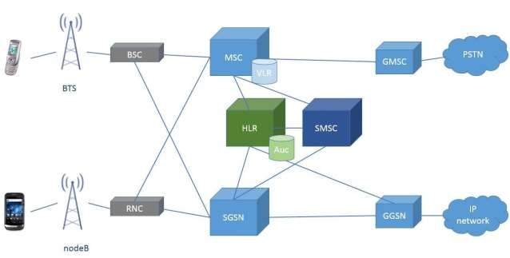

Communicatio

n Networkss

110

* + - 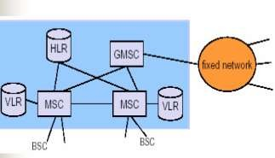Gateway MSC
      * Connects mobile network to a fixed network
      * Request routing information from the HLR

and routes the connection to the local MSC

* + - Authentication Center (AuC) (Associated to HLR)
      * Supports authentication and encryption mechanisms
      * Ki - subscriber secret authentication key
      * A3 - authentication algorithm
      * A8 - cipher key generation algorithm
    - Equipment Identity Register (EIR)
      * Stores mobile stations IMEI (International Mobile Equipment Identity)
      * White-list - mobile stations allowed to connect without restrictions
      * Black-list - mobile stations locked (stolen or not type approved)
      * Gray-list - mobile stations under observation for possible problems
* GSM Channels:
  + Traffic Channels
  + Signaling Channels
* Signaling Channels:
  + Broadcast channel for:
    - Outputting identity of base station
    - Each mobile checks its signal strength to see if it has moved to another cell
  + Dedicated channel for:
    - Location updating
    - Registration
    - Call setup
  + Common Control channel for:
    - Paging (of incoming calls); each mobile

monitors this channel

* + - Random access channel, using slotted Aloha to request a slot on the dedicated channel, to set up a new call
    - Access grant channel
* Setting up a call:
  + Mobile requests a dedicated access channel# using random access channel; this is the only channel where we can get collisions; so it is used very shortly
  + Base grants channel# on access grant channel
  + Setup the call on dedicated channel
  + Start the conversation on one of the

agreed regular channels

* The demand for data connectivity in mobiles increased. Several steps were taken to define standards to support Communication Networksing in 2G networks.
* General Packet Radio Service (GPRS)
  + A packet oriented mobile data service on the 2G networks
  + GPRS provides data rates of 56–114 kbit/second by using unused time

slots of GSM system.

* + Slots are reserved for IP data traffic based on demand.
  + GPRS is a best-effort service, implying variable throughput and latency that depend on the number of other users sharing the service concurrently
* Enhanced Data Rate for Global Evolution (EDGE)
  + EDGE is a digital mobile phone technology that allows improved data

transmission rates as a backward-compatible extension of GSM

* + Peak bit-rates of up to 1 Mbit/s and typical bit-rates of 400 kbit/s can be

expected.

Third Generation Mobile Systems (3G)

* Initial Objectives:
  + High quality voice
  + High speed data for messaging, multimedia and internet access.
  + Up to 2 Mbps rate to fixed users and up to 384 kbps to mobile users
* Three main standards:
  + Wideband CDMA
    - Developed mostly in Europe
    - Runs in a 5 MHz band
    - Can inter-work with GSM but not backward compatible
  + CDMA2000
    - Developed mostly in USA
    - Uses 5 MHz bandwidth
    - Designed to interwork with IS-95 which is a 2G CDMA standard used in North

America

* + TD-SCDMA
    - Chinese version of 3G systems

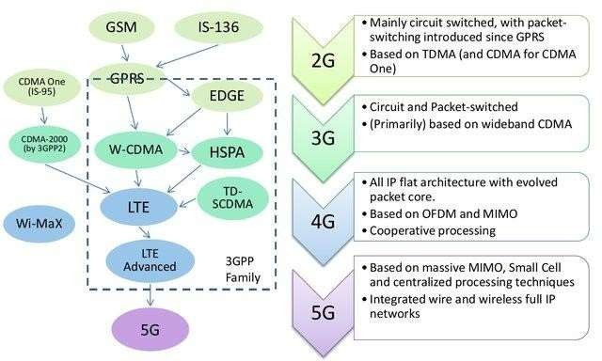

* The LTE specification:
  + Downlink peak rates of at least 100 Mbit/s for a single antenna, Peak download rates of 326.4 Mbit/s for 4x4 antennae, and 172.8 Mbit/s for 2x2 antennae (utilizing 20 MHz of spectrum)
  + Peak upload rates of 86.4 Mbit/s for every 20 MHz of spectrum using a

single antenna

* + RAN round-trip times of less than 10 ms. Sub-5 ms latency for small IP

packets

* + Scalable carrier bandwidths, from 1.4 MHz to 20 MHz
  + Five different terminal classes have been defined from a voice centric class up to a high end terminal that supports the peak data rates. All terminals will be able to process 20 MHz bandwidth
  + Supports both frequency division duplexing (FDD) and time division

duplexing (TDD).

❑ Simpler core network architecture resulting in low operating cost

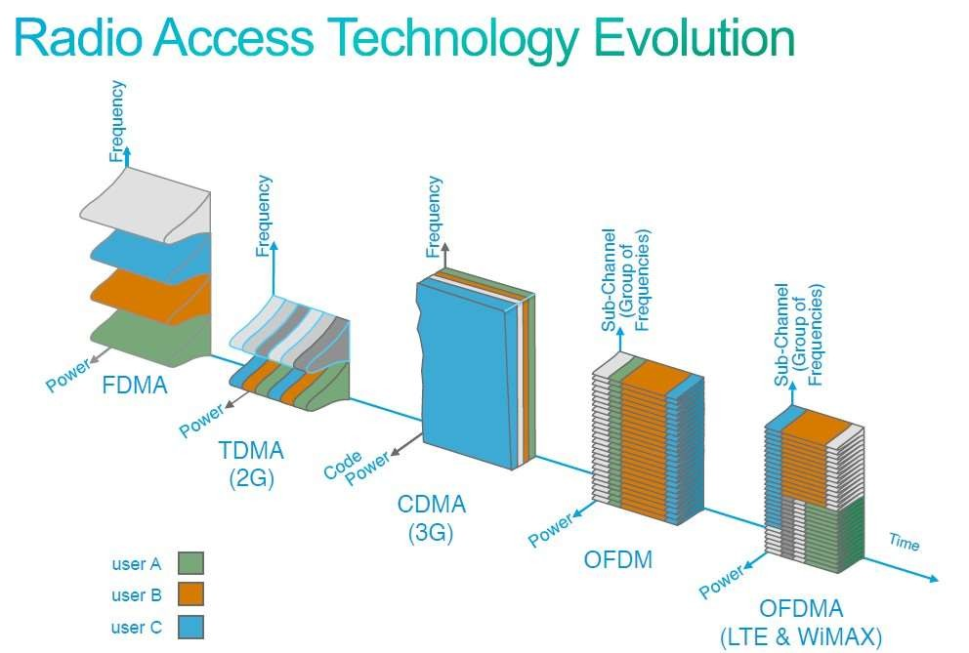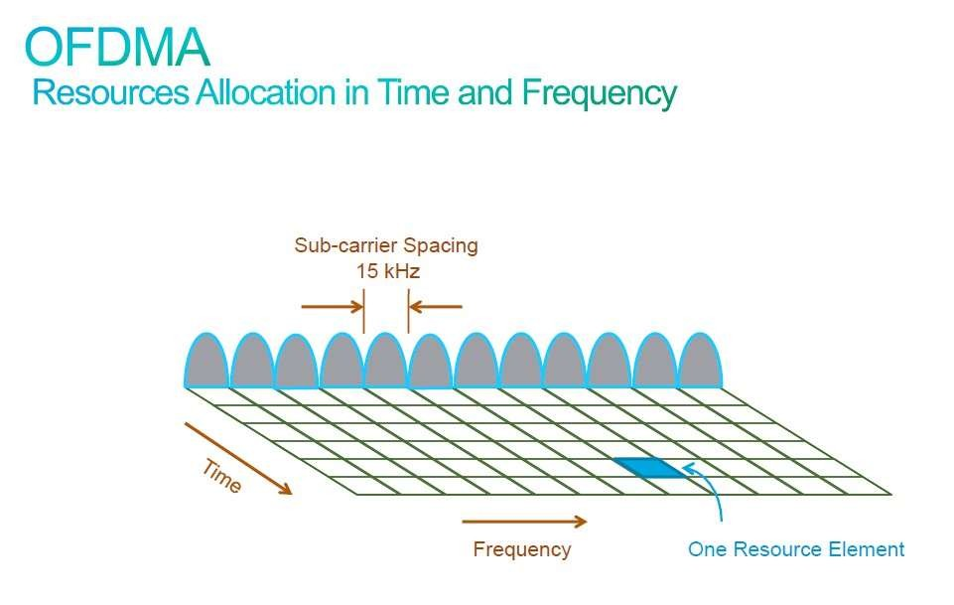

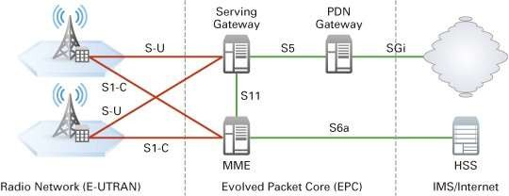

##### The MME is an important controller node in the LTE network. It is responsible for:

* + Idle mode UE (User Equipment) tracking
  + Paging procedure such as re-transmissions
  + Bearer activation and deactivation process
  + S-GW selection for a UE at the initial attach
  + Intra-LTE handover with Core Network node relocation
  + User authentication with HSS
* Main functions of the Serving Gateway:
  + Routing and forwarding of user data packets.
  + Inter-eNB handovers in the U-plane
  + Mobility between LTE and other types of networks, such as

between 2G/3G and P-GW.

* + Replicating user traffic for lawful interception.
* The DL data from the UEs in idle state is terminated at the SGW, and arrival of DL data triggers paging for the UE.
* The SGW keeps context information such as parameters of the IP bearer and routing information, and stores the UE contexts when paging happens.
* The PDN Gateway is the connecting node between UEs and external networks. It is the entry point of data traffic for UEs.
* In order to access multiple PDNs, UEs can connect to several PGWs at the same time.
* The functions of the PGW include:
  + Policy enforcement
  + Packet filtering
  + Charging support
  + Lawful interception
  + Packet screening
  + Mobility between 3GPP and non-3GPP networks

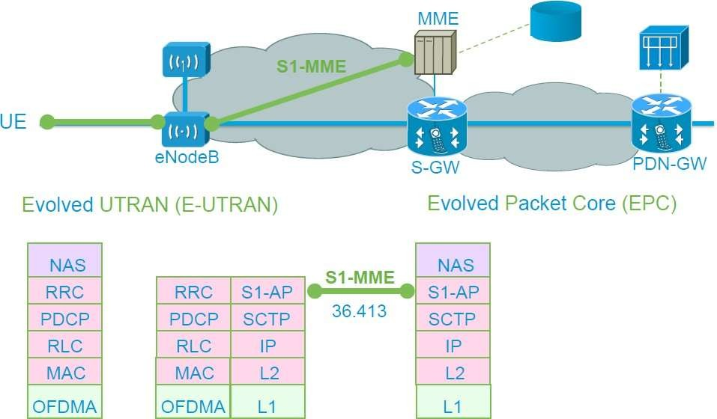

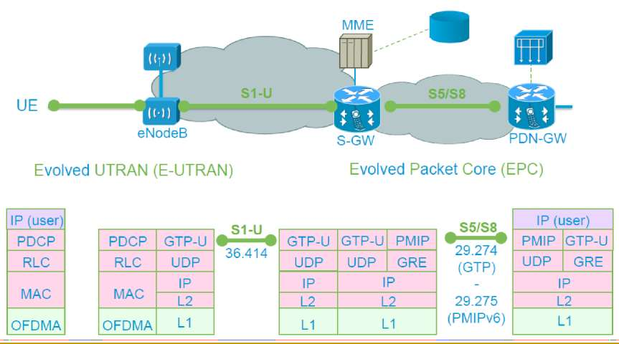

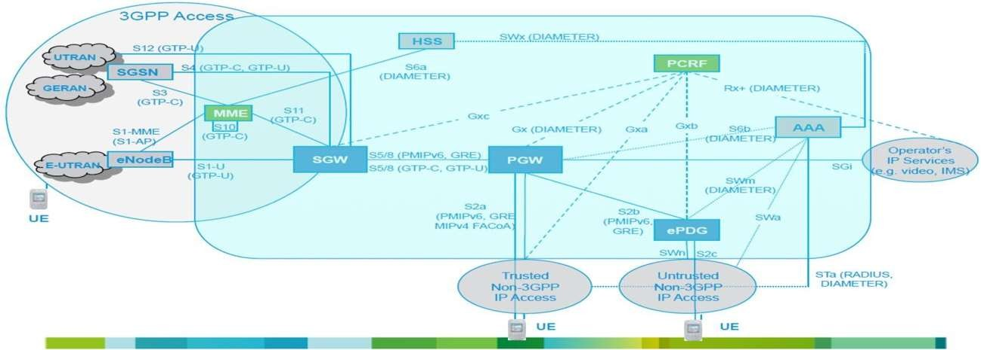

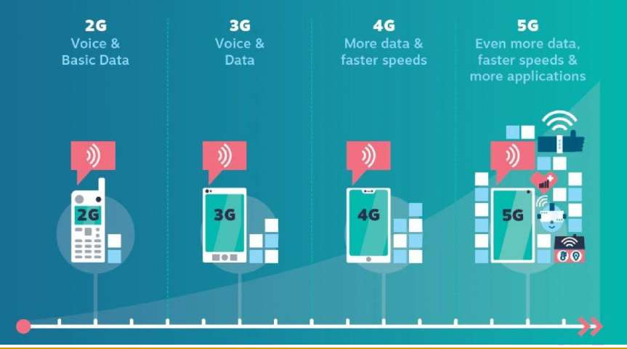

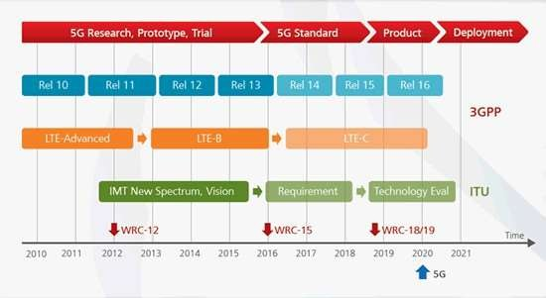

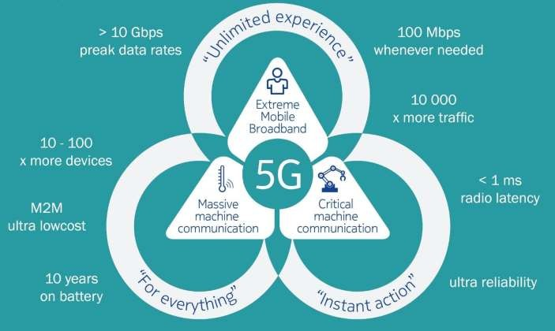

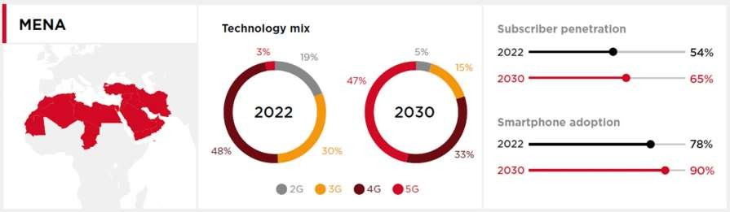

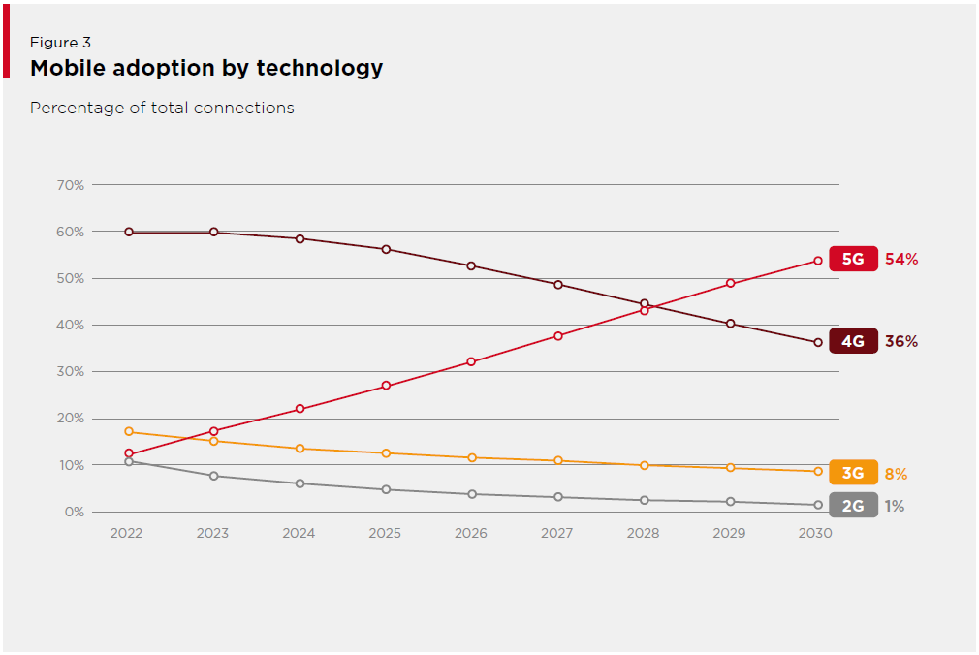

Source:

Communicatio

130

# Data Communication Networks Data Link Layer

DR.Eslami

Department of ElectricalEngineering [Islamic Azad University،Science And Research Branch](https://srb.iau.ir/en)

Communicatio 1

* Data Link Layer Purpose:
  + Ensure reliable, efficient communication between neighbor nodes
* Four specific functions:
  + Provide *services* to network layer
  + Framing
  + Error handling
  + Flow control
* Overview
  + Design issues
  + Error detection and correction
  + Elementary protocols
  + Sliding window protocols
  + Example protocols
* Operation Perspective

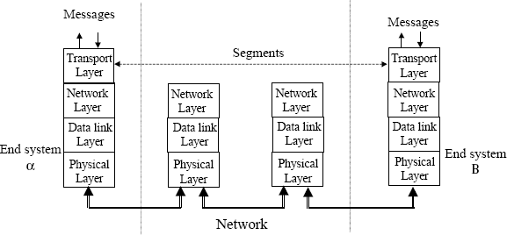

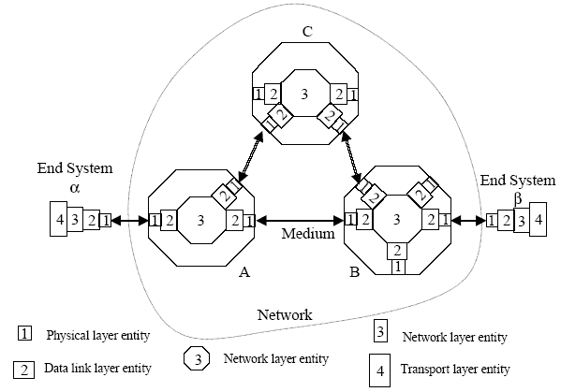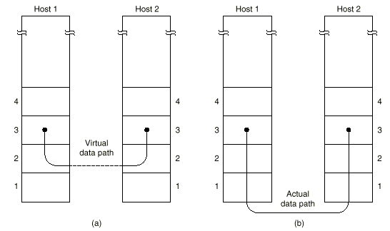

* Data Link operation in a network

1

Communicati

on Networkss 7

###### Services provided to Network Layer:

* + Unacknowledged Connectionless
  + Acknowledged Connectionless
  + Acknowledged connection oriented

###### Unacknowledged connectionless

* + Just send frames towards the destination
  + No connection is established, No connection released
  + No acknowledge of received frames
  + No attempt to recover lost frames

###### Appropriate in case of:

* + Real-time traffic: speech, video: Short delay more important

than 100% reliability

* + Low error channels: leave error correction to higher layers
  + Most LAN’s are using this service class

###### Example: Ethernet

* Acknowledged connectionless
  + Each frame is acknowledged, but no connection is

established

* + Acknowledgment is a service that can be performed by the

transport layer as well

* + Data link layer provides this service to avoid long delays that could be caused if frames are not acknowledged
  + Specially important over un-reliable channels such as

wireless

###### Example: 802.11 (WiFi)

* Acknowledged Connection Oriented
  + Establishes a connection before sending data
  + Each frame is numbered
  + Data link layer guarantees the delivery of a SINGLE copy of EVERY frame (With acknowledged connectionless, it is possible to receive multiple copies of a frame due to a lost ACK)
  + Releases the connection at the end of conversation (To release software and hardware resources tied up to the connection)
  + Provides a reliable bit stream to NL
* Character stuffing
  + Insert ASCII known characters to specify boundaries (FLAG)
  + Insert ESC before accidental FLAGs or ESCs of binary files. To be

removed by the receiver’s data link layer

* + Choice of marking characters (ESC, FLAG) Depends on 8 bit ASCII

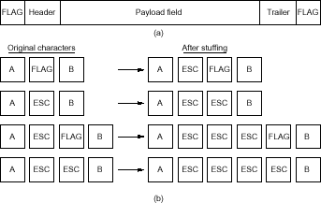character set

* Bit Stuffing
  + Use a flag bit pattern (01111110)
  + Stuff a zero after 5 1’s if it happened in user data
  + Easy to recover the frame if sync is lost

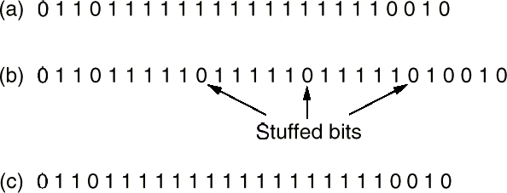

* Coding Violation

|  |  |  |
| --- | --- | --- |
| **Data (Hex)** | **Data (Binary)** | **4B5B Code** |
| 0 | 0000 | 11110 |
| 1 | 0001 | 01001 |
| 2 | 0010 | 10100 |
| 3 | 0011 | 10101 |
| 4 | 0100 | 01010 |
| 5 | 0101 | 01011 |
| 6 | 0110 | 01110 |
| 7 | 0111 | 01111 |
| 8 | 1000 | 10010 |
| 9 | 1001 | 10011 |
| A | 1010 | 10110 |
| B | 1011 | 10111 |
| C | 1100 | 11010 |
| D | 1101 | 11011 |
| E | 1110 | 11100 |
| F | 1111 | 11101 |

* + Send physical layer signals that can not be associated with valid data sets to indicate frame boundaries
* Example: 4B/5B coding
  + Groups of 4 bits are mapped into group of 4 bits such that there is at least two transitions per block of bits
  + Special codes that are not part of the normal pattern (coding violations) can determine start and end of frames.
    - Start Delimeter: 11000 10001
    - End Delimeter: 01101 00111
* Error handling
  + Errors usually occur in bursts
  + Advantage: fewer frames are corrupted
  + Disadvantage: burst errors harder to detect and correct
* Two approaches:
  + Detection
  + Correction
* Both require extra bits per data word or message
* Idea: add r extra bits to frame data
* Not all 2m+r codes are legal (only 2m codes are legal)
* n = m + r bits code word, m bits for data and r bits added for error

control

* Noise and other imperfections can cause errors in symbol detection

Communicatio 18

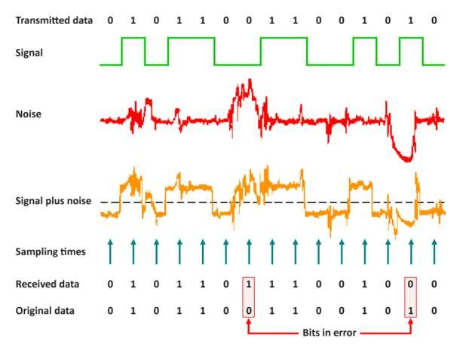

n Networkss 5

###### Error control codes can be used to reduce the chance of error.

Communicatio 18

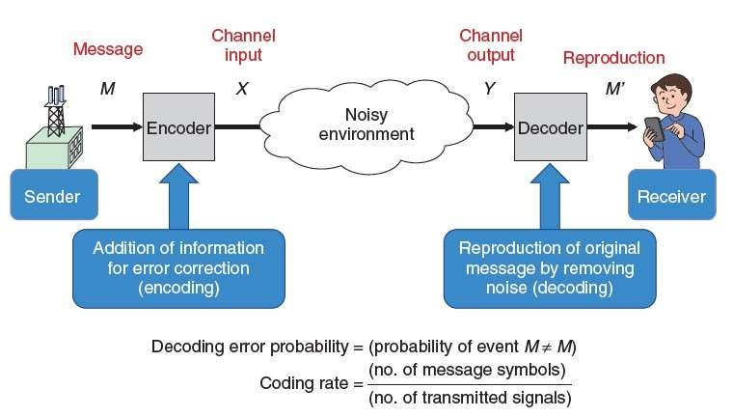

Error Detection

* Detection of errors caused by noise or other impairments during transmission from the transmitter to the receiver.

### Error Correction

##### Detection of errors and reconstruction of the original, error-free data

###### Idea: Add controlled redundancy to the message

Linear Encoder

m

r

m

n=m+r

m

Convolutional

Encoder

n=m+r

* + The Hamming distance (HD) of 2 code words a and b is the number

of bit positions in which a and b are different:

HD (a,b)= Number of ones in (a XOR b)

* + Note that HD (a,b) bit errors are required to convert a into b (or vice versa )

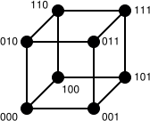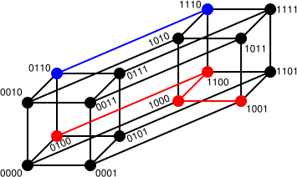

###### To guarantee the detection of up to s errors in all cases, the minimum Hamming distance in a block code must be 𝑑𝑚𝑖𝑛 = 𝑠 + 1

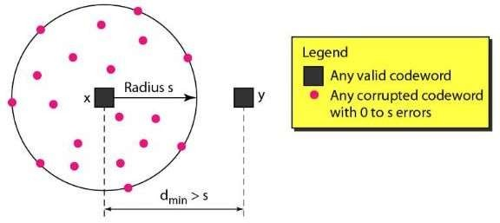

* + Example 1: parity
    - Add (parity) bit to every data word such that total numbers of ones is even (or

odd)

* + - * HDmin = 2
      * Single bit errors are detectable

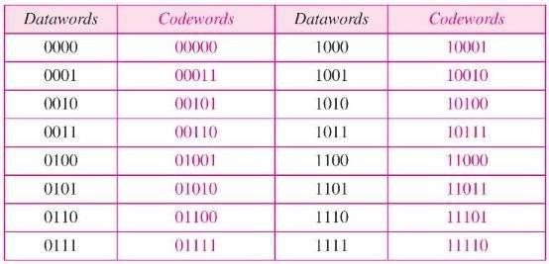

###### To guarantee correction of up to t errors in all cases, the minimum Hamming distance in a block code must be 𝑑𝑚𝑖𝑛 = 2𝑡 + 1

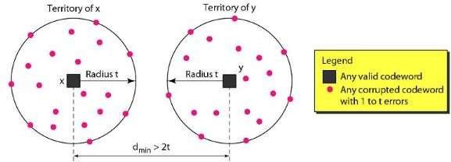

* + Example 2:
    - 4 data words with HDmin = 5
    - If 00000.00111 arrives, what is the original?

|  |  |
| --- | --- |
| **Input** | **Encoded Output** |
| 00 | 00000.00000 |
| 01 | 00000.11111 |
| 10 | 11111.00000 |
| 11 | 11111.11111 |

* + How many redundant (r) bits do we need for a single bit error correction?
    - Assume m bit message with r bits added for single error correction (n = m+r bits)
    - How many legal code-words? 2m
    - How many illegal codes per code-words? n*(2m)
    - (n+1)*(2m)<2n => (m+r+1)<2r
    - This is the minimum number of bits (r) we need to correct a single error in n bits

with r parity bits

* + - Example: M=8 => r>=4 ; M=16 => r>=5 ; M=240 => r>=8

Error Detection

* Encoder adds overhead for error detection
* Decoder detects error and requests re-transmission in case of error (Automatic Repeat request (ARQ))

Forward Error Correction (FEC)

* Encoder adds overhead to enable correction at the decoder
* Avoids delay of ARQ
* More overhead and increased complexity

Hybrid ARQ

* Send messages with FEC and if decoding was not successful, request re- transmission
* Send messages with error detectioin codes and if there was an error, request FEC from source
  + In some scenarios, error detection with retransmission is more

efficient than error correction

* + *Example:*
    - Error rate 10-6 ---- Block size 1000 bits
    - Single bit error correcting requires 10 bits / block
    - Single bit error detection requires 1 bit / block
    - Retransmission of 1 block (= 1001 bits) per 1000 blocks is more efficient

###### In many scenarios, errors are seen as burst of errors

* + FEC codes allow correction of a limited number of errors per block

###### Burst errors may prevent decoders from recovering the correct message

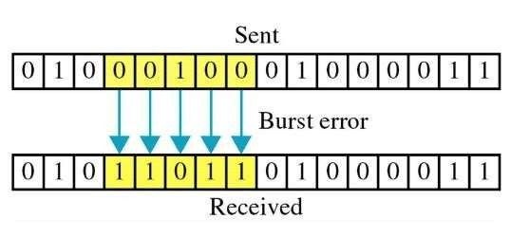

* + We modify the order of symbol transmission at the source and re-order them at the receiver to allow proper operation of FEC

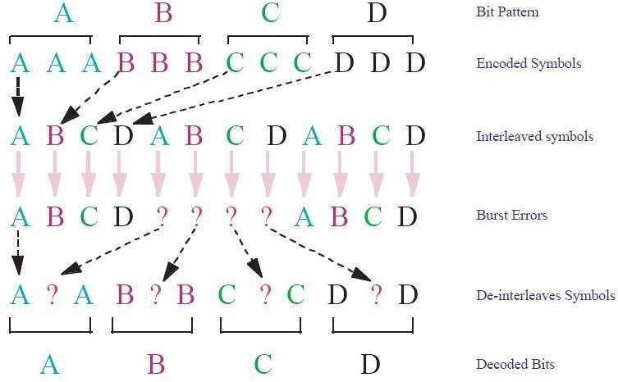

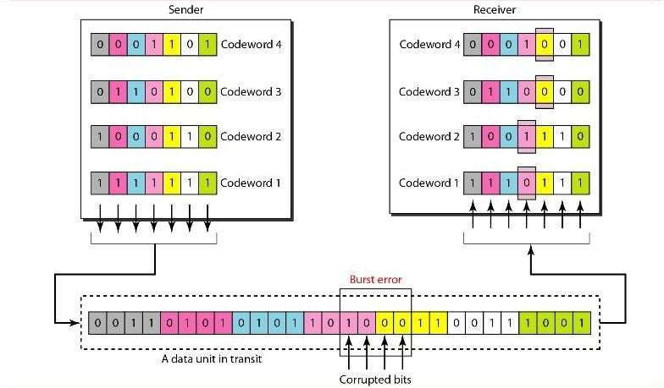

###### Redundancy added to a block of bytes that uses cyclic codes to check and verify the block.

* + Some standardized CRCs

|  |  |  |
| --- | --- | --- |
| **Name** | **Length of CRC** | **Example Application** |
| CRC-8 | 8 | DVB-S2 |
| CRC-16 | 16 | Bluetooth |
| CRC-32 | 32 | Ethernet |

* + Assumptions:
    - Send a long data stream from

sender to receiver

* + - Checksum errors are signaled

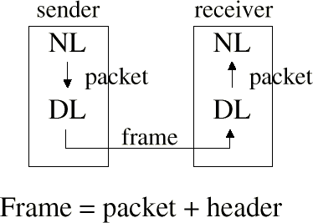by the physical layer

* + - NL, DL, PL are independent processes
    - Connection-oriented, reliable service needed at NL => one and only one copy of each frame and in the exact sequence should be received by NL

###### Data Link layer protocol runs on two different systems with possibly different hardware/software characteristics.

* + If the sender sends its frame at rate 𝑅𝑎 and the receiver can process only at rate 𝑅𝑏 where 𝑅𝑎 > 𝑅𝑏, then the receiver will be overloaded and unable to receive all frames correctly.

###### Therefore, we need to have a flow control mechanism in data link layer

* + The solution: Use Acknowledgment
  + Node A waits for an Ack frame from Node B before sending its next

frame

* + Frame Length in Time: 𝑇𝑓 =

𝑁 𝑓 ( 𝑓 𝑟 𝑎𝑚𝑒 𝑙𝑒𝑛𝑔𝑡ℎ 𝑖𝑛

𝑏𝑖𝑡𝑠)

𝑅𝐴 (𝑇𝑟𝑎𝑛𝑠𝑚𝑖𝑡 𝑅𝑎𝑡𝑒 𝑜 𝑓

Propagation Delay: 𝐿 (𝐷𝑖𝑠𝐴𝑡)𝑎𝑛𝑐𝑒 𝑏𝑒𝑡𝑤𝑒𝑒𝑛 𝑡𝑤𝑜 𝑛𝑜𝑑𝑒𝑠)

𝑇𝑝 = ( )

■

𝑉 𝑠𝑝𝑒𝑒𝑑 𝑜 𝑓 𝑠𝑖𝑔𝑛𝑎𝑙 𝑝𝑟𝑜𝑝𝑎𝑔𝑎𝑡𝑖𝑜𝑛

Tf Tp Tp

1. t
2. t

B receives the frame and then generates an Ack

* + What if a frame is not received correctly?
    - A could wait for the Ack that B has not transmitted (Mutual Locking)
    - Solution: A should have a timer to re-send to lost frame after some time

Ttime-out

Tf Tp

1. t
2. t

B: Frame Error or no Frames Received

* + What if the Ack is lost?
    - A sends the same frame again. Therefore, data link layer in B has two of

the same frame. (Frame duplication)

* + - Solution: We need to use frame numbers to avoid duplication

Ttime-out

Tf Tp Tp

1

1

1. t
2. t

B receives the frame correctly, but the Ack is lost

###### What if the Timers are not set properly?

* + - A receives an Ack after frame#1, so it thinks that frame #1

is delivered correctly to B, but this may not be true!

* + - Solution: We should use Ack Numbers so A knows which

frame was Acked.

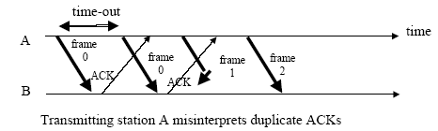

* + A (TX) sends its numbered frames, starts a timer for each frame and

waits for an Ack for that exact same frame

* + B (RX) checks the received frame and sends a Numbered Ack to confirm.
  + 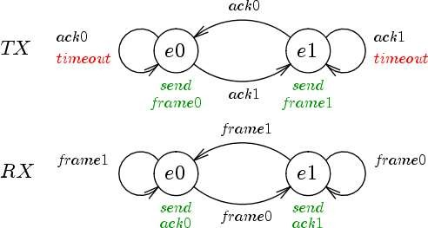A (TX) Stops and Waits for the correct Ack before it continues to the next frame

|  |  |  |  |
| --- | --- | --- | --- |
| Seq# | Ack# | Packet | CRC |

Frame

* + If 𝑎 = 𝑇𝑝/𝑇𝑓 is not very small, then stop and wait is inefficient.

Tf Tp Tp Tf Tp Tp Tf Tp Tp

1. t
2. t
   * Stop and Wait is inefficient when propagation delay is larger than the packet transmission time – Can only send one packet per round- trip time
   * Go Back N allows transmission of new packets before earlier ones are acknowledged
   * Go back N uses a window mechanism where the sender can send packets that are within a “window” (range) of packets – The window advances as acknowledgements for earlier packets are received

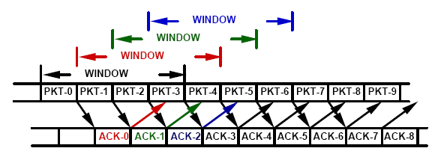

* + Window size = N
  + Sender cannot send packet i+N until it has received the ACK for packet i
  + Receiver operates just like in Stop and Wait
    - Receive packets in order
    - Receiver cannot accept packet out of sequence
    - Send RN = i + 1 => ACK for all packets up to and including i
  + Use of piggybacking
    - When traffic is bi-directional RN’s are piggybacked on packets going in

the other direction

* + - Each packet contains a SN field indicating that packet’s sequence

number and a RN field acknowledging packets in the other direction

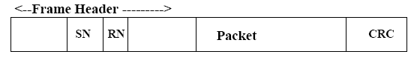

* + The transmitter has a "window" of N packets that can be sent without

acknowledgements

* + This window ranges from the last value of RN obtained from the receiver

(denoted SNmin) to SNmin+N-1

* + When the transmitter reaches the end of its window, or times out, it goes

back and retransmits packet SNmin

* + Let SNmin be the smallest number packet not yet ACKed
  + Let SNmax be the number of the next packet to be accepted from the higher layer (I.e., the next new packet to be transmitted)

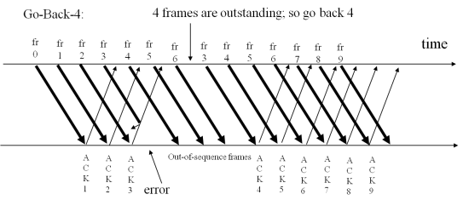

Communicatio

21

* + Sender:
    - k-bit seq # in frame header
    - “window” of up to N, consecutive unACK’ed frames allowed
    - ACK(n): ACKs all frames up to, including seq # n - “cumulative ACK”
    - may receive duplicate ACKs (see receiver)
    - timer for each in-flight frames
    - timeout(n): retransmit frames n and all higher seq # frames in window

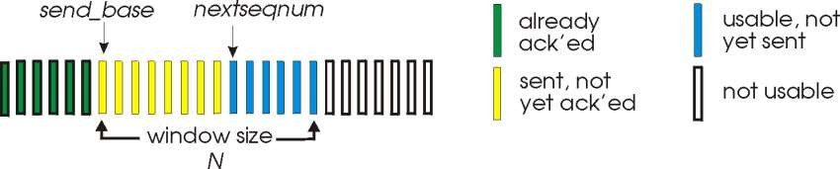

* + SNmin = 0; SNmax = 0
  + Repeat
    - If SNmax < SNmin + N (entire window not yet sent)
      * Send packet SNmax ;
      * SNmax = SNmax + 1;
    - If packet arrives from receiver with RN > SNmin
      * SNmin = RN;
    - If SNmin < SNmax (there are still some unacknowledged packets) and sender

cannot send any new packets

* + - * Choose some packet between SNmin and SNmax and re-send it or do not send anything
  + The last rule says that when you cannot send any new packets you should

re-send an old (not yet ACKed) packet

* + There may be two reasons for not being able to send a new packet
    - Nothing new from higher layer
    - Window expired (SNmax = SNmin + N )
  + No set rule on which packet to re-send
    - Least recently sent
* RN = 0;
* 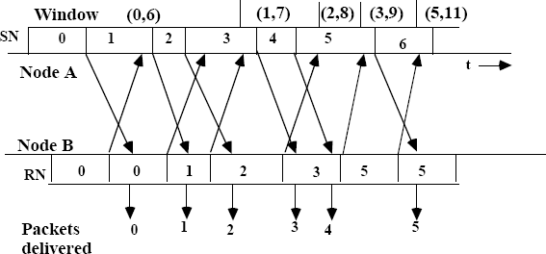Repeat
  + When a good packet arrives,
    - if SN = RN
      * Accept packet
      * Increment RN = RN +1
* At regular intervals send an

ACK packet with RN

* + Most implementations send an ACK whenever they receive a packet from the other direction
  + ACK can be delayed for piggybacking
* Receiver reject all packets with SN not equal RN
  + However, those packets may still contain useful RN numbers
* Note that packet RN-1 must be accepted at B before a frame

containing request RN can start transmission at B

* Requires no buffering of packets at the receiver
* Sender must buffer up to N packets while waiting for their ACK
* Sender must re-send entire window in the event of an error
* Receiver can only accept packets in order
  + Receiver must deliver packets in order to higher layer
  + Cannot accept packet i+1 before packet i
  + This removes the need for buffering
  + This introduces the need to re-send the entire window upon error
* The major problem with Go Back N is this need to re-send the entire

window when an error occurs.

* This is due to the fact that the receiver can only accept packets in

order

* Window Size: N
* Sequence Counter: M different numbers (For example, If the counter has 3 bits, M=23=8)

A

B

7

7

|  |  |  |  |  |  |  |  |
| --- | --- | --- | --- | --- | --- | --- | --- |
| 0 | 1 | 2 | 3 | 4 | 5 | 6 | 7 |

|  |  |  |  |  |  |  |  |
| --- | --- | --- | --- | --- | --- | --- | --- |
| 0 | 1 | 2 | 3 | 4 | 5 | 6 | 7 |

t

t

A

B

7

7

|  |  |  |  |  |  |  |  |
| --- | --- | --- | --- | --- | --- | --- | --- |
| 0 | 1 | 2 | 3 | 4 | 5 | 6 | 7 |

|  |  |  |  |  |  |  |  |
| --- | --- | --- | --- | --- | --- | --- | --- |
| 0 | 1 | 2 | 3 | 4 | 5 | 6 | 7 |

t

t

* Window Size: N
* Sequence Counter: M different numbers (For example, If the counter has 3 bits, M=23=8)
* We should always choose N<M

A

|  |  |  |  |  |  |  |
| --- | --- | --- | --- | --- | --- | --- |
| 0 | 1 | 2 | 3 | 4 | 5 | 6 |

|  |  |  |  |  |  |  |
| --- | --- | --- | --- | --- | --- | --- |
| 7 | 0 | 1 | 2 | 3 | 4 | 5 |

B

B

5

6

t

A t

|  |  |  |  |  |  |  |
| --- | --- | --- | --- | --- | --- | --- |
| 0 | 1 | 2 | 3 | 4 | 5 | 6 |

|  |  |  |  |  |  |  |
| --- | --- | --- | --- | --- | --- | --- |
| 7 | 0 | 1 | 2 | 3 | 4 | 5 |

**B**

B

6

6

t

t

* Selective Repeat attempts to retransmit only those packets that are actually lost (due to errors)
  + Receiver must be able to accept packets out of order
  + Since receiver must release packets to higher layer in order, the

receiver must be able to buffer some packets

fr fr fr

0 1 2

A



B

fr fr fr fr

3 4 5 6

fr fr fr fr

2 7 8 9

fr fr fr

10 11 12

time

|  |  |  |  |  |  |  |  |  |  |  |  |
| --- | --- | --- | --- | --- | --- | --- | --- | --- | --- | --- | --- |
| A  C K | A C  K | N  A K | A  C K | A  C K | A  C K | A  C K | A  C K | A  C K | A  C K | A  C K | A  C K |
| 1 2 error 2 | | | 2 | 2 | 2 | 7 | 8 | 9 | 1 | 1 | 1 |
|  |  |  |  |  |  | 0 | 1 | 2 |

* Retransmission requests
  + Implicit
    - The receiver acknowledges every good packet, packets that are not

ACKed before a time-out are assumed lost or in error

* + - Notice that this approach must be used to be sure that every packet

is eventually received

* + Explicit An explicit NAK (selective reject)
    - can request retransmission of just one packet
    - This approach can expedite the retransmission but is not strictly

needed

* + One or both approaches are used in practice

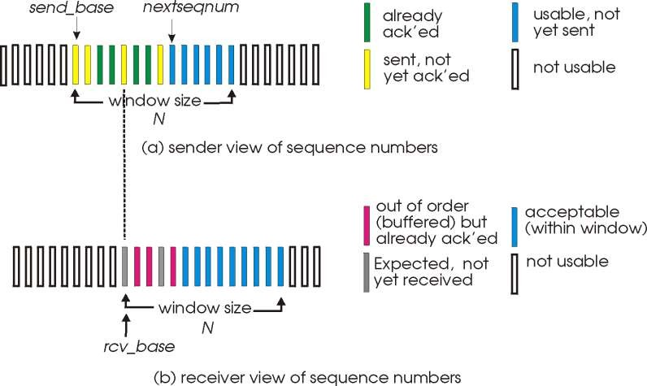

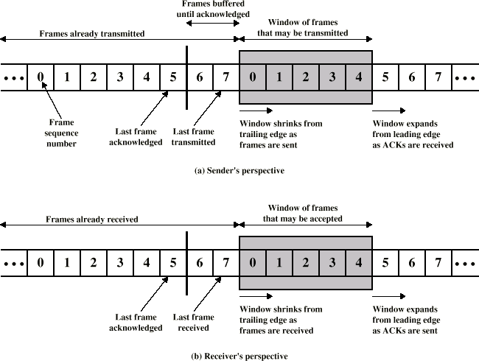

Communicati

on Networkss

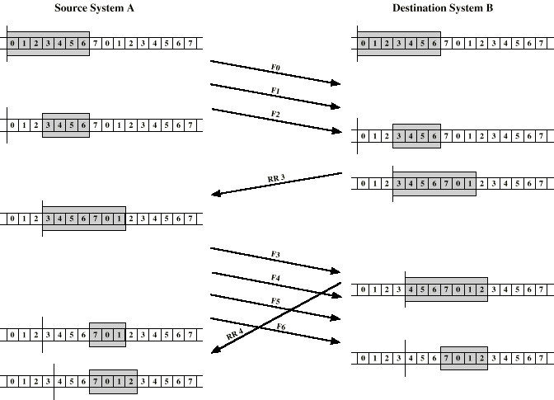

RR3 means the receiver has received all frames up to frame 2 and is ready to receive frame 3.

Have been delivered

to upper layer

More spaces for

future frames

* Sender:
  + Can transmit new packets as long as their number is within W (Window Size) of all un- ACKed packets
  + Retransmits un-ACKed packets after a timeout (Or upon a NAK if NAK is employed)
  + Must buffer all packets until they are ACKed (Up to W un-ACKed packets are possible)
* Receiver:
  + ACKs all correct packets
  + Stores correct packets until they can be delivered in order to the higher layer
  + Must buffer packets until they can be delivered in order i.e., until all lower numbered packets have been received. This is needed for orderly delivery of packets to the higher layer
  + Up to W packets may have to be buffered (in case the first packet of a window is lost)
* Implication of window size = N
  + Number of un-ACKed packets at sender =< N (window limit at sender)
  + Number of un-ACKed packets at sender cannot differ by more than N (window limit at

the receiver required to deliver packets in order)

* + Packets must be numbered modulo M >= 2N (using log2(M) bits)
* Example: Window Size N=4
* Case 1) Frame#0 has error, therefore B send NAK#0 and A sends frame#0 after frame#3
* Case 2) A sends frame#3, frame#4, frame#5, frame#6 and frame#7. All frames between frame#3 and frame#7 are lost. Therefore, B receives frame#3 followed by frame#7
* We should have a numbering system that allows differentiation between these two cases

A



|  |  |  |  |  |
| --- | --- | --- | --- | --- |
| 0 | 1 | 2 | 3 | 0 |

t

B

NAK 0

1 2 3 0 t

|  |  |  |  |  |
| --- | --- | --- | --- | --- |
| 3 | 4 | 5 | 6 | 7 |

A

t

* In general, the range of packets that may follow packet i at the receiver (Ex: N=4, Set i=3)
* Packet i may be followed by the first packet of the window (i -N+1) if it requires retransmission
* Packet i may be followed by the last packet of the window (i+N) if all Of the frames between i and i

+N are lost

* Receiver must differentiate between packets i -N+1 ... i +N
* These 2N packets can be differentiated using Mod 2N numbering
* In Selective Repeat, we should choose M2N

A



|  |  |  |  |  |
| --- | --- | --- | --- | --- |
| 0 | 1 | 2 | 3 | 0 |

t

B

NAK 0

1 2 3 0 t

|  |  |  |  |  |
| --- | --- | --- | --- | --- |
| 3 | 4 | 5 | 6 | 7 |

A

t

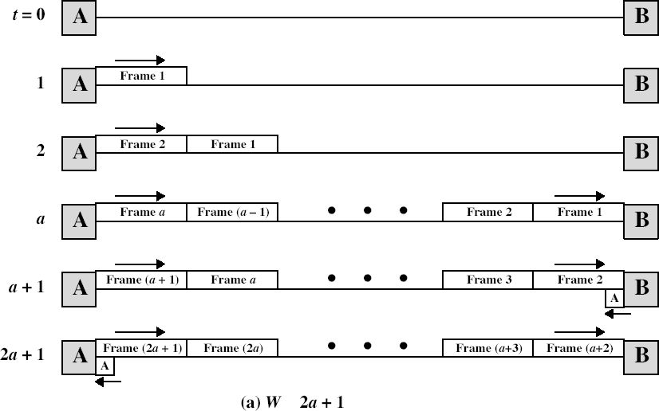

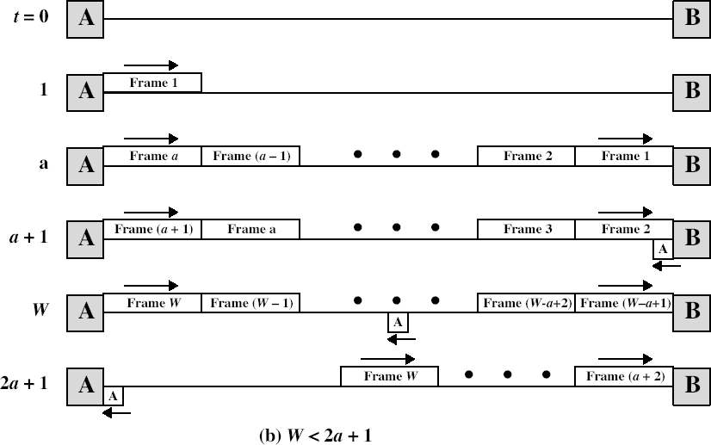

* Error Free Operation
  + Stop and Wait:

*U* 

1

2*a* 1

*a*  *Tprop*

*T*

* + Sliding Window

(W=window Size=2n-1):

*frame*

 1 *W*  2*a* 1

*U*   *W*

*W*  2*a* 1

2*a* 1

ata Networks 57

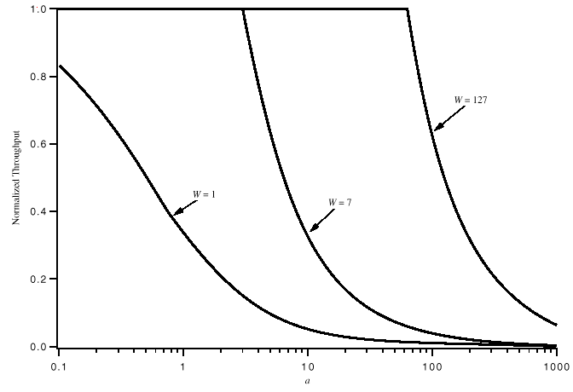

* Probability of frame error = *p*
* Stop and Wait Utilization
  + Probability of a frame requiring exactly k transmission = *pk-1*(*1-p*)
  + Expected Number of Transmission for a frame (*Nr*):

◎ 

 

*E* [ *N* ]  *N r*

 *k*  Prob(*k Transmission*)  *kpk* 1(1 *p*)  1

1  *p*

*k* 1

* + Utilization should be divided by *Nr* :
* Selective Reject Utilization
  + Exact same idea as stop and wait

*k* 1

*U*  1  *p*

1  2*a*

 1  *p W*  2*a*  1

*U*   *W* (1 *p*)



 1  2*a*

*W*  2*a*  1

* Go back N Utilization
  + Each frame error requires re-transmission of *L* packets where *L*1
  + Total number of frames that should be transmitted if the original frame

must be transmitted k times=*f*(*k*)=*1*+(*k-1*)*L*

◎ 

*E*[ *N* ]  *N r*   *f* ( *k* )  Prob(*k Transmission*) (1  *L*  *kL*) *pk* 1(1 *p*)

*L*)  

 (1 *L* )  *pkk*11(1 *p*)  *L* *kpk* 1(1 *p*)  (1

◎ 

*k* 1 *k* 1

*k* 1 *L* 1  *p*  *LP*

1  *p* 1  *p*

*L*  1 2*a W*  1  2*a*

 1  *p*

 1  2*ap*

*U* 



*W*  2*a* 1

 *W W*  1  2*a*



 *W* (1 *p*)

*W*  2*a* 1

(2*a* 1)(1 *p*  *Wp* )

Communicatio 23

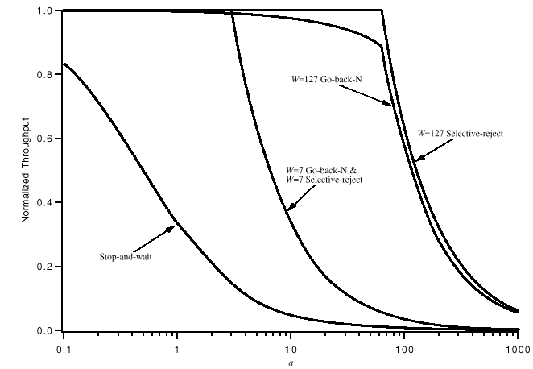

* HDLC: high-level data link control
  + Common in X.25 networks
  + Derived from IBM’s SNA
  + Bit-oriented, bit-stuffing
* Station Types:
  + Primary station
    - Controls operation of link
    - Frames issued are called commands
    - Maintains separate logical link to each secondary station

Commands

Unbalanced Point-to-point link

Unbalanced Multipoint link

Primary

|  |  |  |
| --- | --- | --- |
| Primary | Commands | Secondary |
| Responses |

Secondary

Responses

Secondary

Secondary

* + Secondary station
    - Under control of primary station
    - Frames issued called responses
  + Combined station
    - May issue commands and responses

Balanced Point-to-point link between Combined Stations

|  |  |  |
| --- | --- | --- |
| Primary | Commands Responses | Secondary |
| Secondary | Responses Commands | Primary |

* HDLC Link Configurations (Full duplex & Half duplex)
  + Unbalanced: One primary and one or more secondary stations
* Balanced: Two combined stations
* Normal Response Mode (NRM)

|  |  |  |
| --- | --- | --- |
| Primary | Commands | Secondary |
| Responses |

* + Unbalanced configuration
  + Primary initiates transfer to secondary. Secondary may only transmit data in

Primary

Unbalanced Point-to-point link

Unbalanced Multipoint link

response to command from primary

* + Used on multi-drop lines
  + Host computer as primary.
  + Terminals as secondary

Commands

Secondary

Responses

Secondary

Secondary

* Asynchronous Balanced Mode (ABM)
  + Balanced configuration (Most widely used)
  + Either station may initiate transmission

Balanced Point-to-point link between Combined Stations

|  |  |  |
| --- | --- | --- |
| Primary | Commands Responses | Secondary |
| Secondary | Responses Commands | Primary |

without receiving permission. No polling overhead

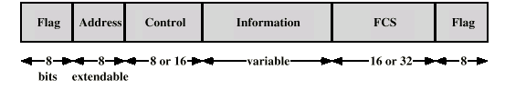

Communicatio

n Networkss

23

5

* Frame Structure
  + All transmissions in frames
  + Single frame format for all data and control exchanges
  + On idle point to point links, flag sequences are transmitted continuously
* Flag Fields
  + Delimit frame at both ends with 01111110
  + May close one frame and open another
  + Receiver hunts for flag sequence to synchronize
  + Bit stuffing used to avoid confusion with data containing 01111110
    - 0 inserted after every sequence of five 1s
    - If receiver detects five 1s it checks next bit
    - If 0, it is deleted
    - If 1 and seventh bit is 0, accept as flag
    - If sixth and seventh bits 1, sender is indicating abort
* Address Field
  + Identifies secondary station that sent or will receive frame
  + Usually 8 bits long
  + May be extended to multiples of 7 bits
    - LSB of each octet indicates that it is the last octet (1) or not (0)
  + All ones (11111111) is for broadcast

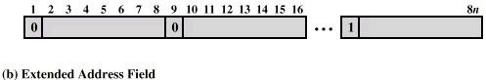

Communicatio 23

n Networkss 6

* Control frame varies for different frame types

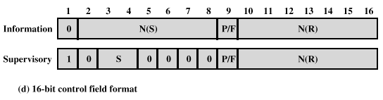

Communicatio

n Networkss

23

7

* + Information - data to be transmitted to user (next layer up)
    - Flow and error control piggybacked on information frames
  + Supervisory - ARQ when piggyback not used
  + Unnumbered - supplementary link control
* First one or two bits of control field: frame type identification

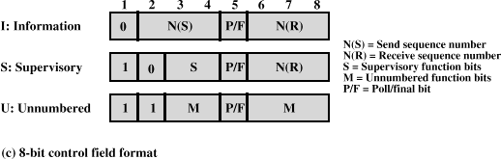

* Supervisory frames
  + Receive Ready Frame (SS=00)
    - Used when there are no information frames available to piggyback the ACK
  + Reject Frame (SS=01)
    - Receiver tells the sender to go back and start sending from the frame number N(R)
  + Receive Not Ready (SS=10)
    - All frames up to frame number N(R) have been received properly. But the receiver can not accept any frames at this time. (e.g. due to a full buffer)
  + Selective Reject (SS=11)
    - Receiver asks the sender to re-

send frame number N(R)

* Unnumbered frames
* Used to start up the link or tear it down
* Some examples:
  + SABM: Set ABM Mode
  + SNRM: Set NRM Mode
  + SABME: Set ABM Extended Mode
  + DISC: Disconnect
  + UA: Unnumbered Acknowledgment
  + FRMR: Frame Reject

Communicatio 23

n Networkss 8

* Provides a method for encapsulation of network layer packets over point to point links. It provides:
  + An HDLC-like Framing with error detection (Byte oriented)
  + LCP (link control protocol) for bringing up lines, testing, negotiating options
  + NCP (network control protocol) for each supported network layer
* PPP frame format
  + Flag byte: 0111.1110 / character stuffing
  + Address field (default = 1111.1111)
  + Control field (default = 0000.0011)
  + Unnumbered frames with unreliable transmission; no sequence numbers
  + Protocol field: indicates packet type
    - 0x indicates IP, IPX or XNS
    - 1x indicates LCP, NCP or others
  + Payload: 1500 bytes default length
  + Checksum of 2 (default) or 4 bytes

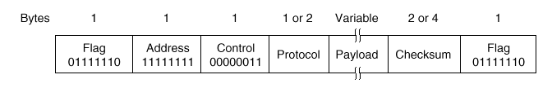

Communicatio

n Networkss

23

9

* 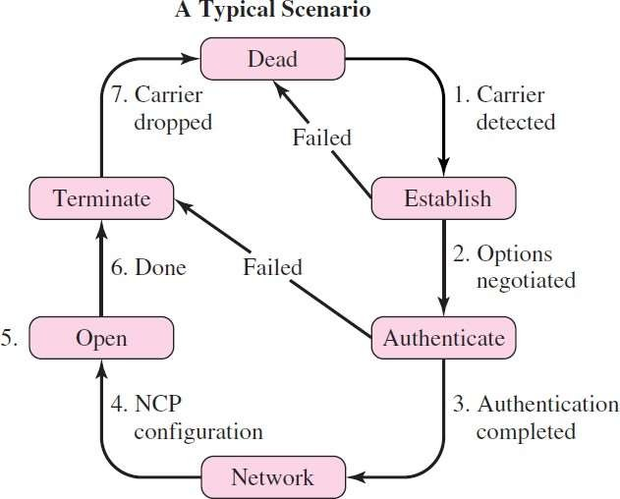Example 1: Home PC to Internet

Service Provider

* + PC calls router via modem.
  + PC and router exchange LCP packets to

negotiate PPP parameters.

* + Check on identities.
  + NCP packets exchanged to configure the network layer, e.g., TCP/IP (requires IP address assignment).
  + Data transport, e.g. send/receive IP packets.
  + NCP used to tear down the network layer connection (free up IP address); LCP used to shut down data link layer connection.
  + Modem hangs up.
* Example 2: PPP use for transmission of

packets over SONET SDH links

* There are no physical layer characteristics specific to ATM
  + ATM cells can be carried by various physical layer services such as SONET/SDH, ADSL or wireless links
* TC (transmission convergence) sub layer corresponds to DL layer
* Transmission: each cell of 53 byte includes 5 byte header
  + Add 4 bytes of identification and 1 byte of HEC (header checksum)
  + No checksum for payload. (BER<< 10-12 in fiber optic links)
  + Match speed to underlying physical transmission system by inserting empty or

maintenance (OAM) cells

* Reception of a cell
  + Locate cell boundaries
  + Verify header
  + Discard cells with invalid headers
  + Process maintenance cells
  + Pass data to ATM layer

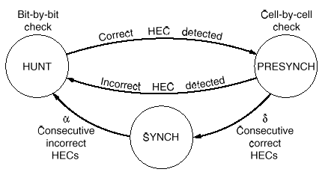

Communicatio

n Networkss

24

2

* How to detect cell boundaries (there are no marks !!)
  + Trick: constantly check HEC field after each incoming bit
  + Use 40-bits shift register to shift the incoming pattern bit-by-bit until the frame

header is found

* + After the first header match, jump 53 bytes (length of an ATM frame) and re-

check the HEC (is this the right HEC for the assumed cell?)

* + Repeat the header check d times in a row, If all correct, go to synch Mode
  + Change of accidental correct synchronization = 2-8d
  + ‘DeSynch’ after a incorrect headers
  + TC sub layer uses header of ATM field for synchronization: no proper separation of layers. E.g. changing header format for ATM affects TC layer

# Data Communication Networks Multiple Access Control Sublayer

DR.Eslami

Department of Electrical Engineering [Islamic Azad University،Science And Research Branch](https://srb.iau.ir/en)



* A number of systems are connected to share the medium: Who gets

access?

* + Used for LANs
  + Addressing
  + Broadcast



Shared Multiple

Access Medium



*M*

5

1

4

2

3





Static

* user gets a channel for the whole ‘conversation’.



Dynamic

* Channel capacity allocated for a user is not fixed; depends on usage.
* Using FDM or TDM to divide channel capacity among N users
* Inefficient bandwidth use: some users may be idle
* Users may be denied access even when other users do not use there allocated capacity
* Long time service delay T
* Delay in a single M/M/1 Queue
  + Channel can transfer C bits/sec
  + Frames arrive randomly with an average rate of  frames/sec and the inter-arrival

times are exponentially distributed

* + Frame length values has an exponential distribution with an average length of 1/

bits.

* + Mean delay of frames in the queue is given by:𝑇 = 1

𝜇𝐶−𝜆

* + Example: C=100 Mbps, 1/=10000 bits, =5000 frames/sec, T=200 sec

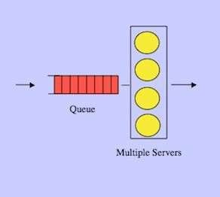

* Delay if we divide the channel into N sections
  + Assume we divide the same stream into N smaller streams and serve each of

them in a separate queue

* + There will be N channels with a capacity of C/N bits/sec for each
  + There will be N streams with an average rate of /N frames/sec each
  + Mean delay of each queue: 𝑇𝑁 =

~~𝐶 𝜆~~ =

𝑁 = 𝑁𝑇

𝜇 − 𝜇𝐶−𝜆

1

𝑁 𝑁

* + Example: If we divide the above queue into 4 sections, 𝑇𝑁 = 800 𝜇𝑠𝑒𝑐

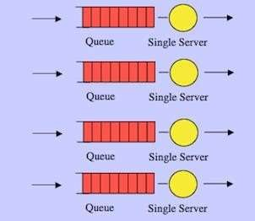

* In data communication, the peak to mean ratio of traffic can

be very high.

* In many applications, users require the channel in random times
* Static allocation will be a waste of channel resources
* It is best to assign the channel based on user demand
* Different protocols for coordination:
  + ALOHA : pure and slotted
  + CSMA : carrier sense multiple access protocols
  + Ethernet
  + Wireless LAN protocols
* Assumptions for analysis of dynamic channel allocation

algorithms:

* + Station model:
    - N independent stations generating frames within interval t with

probability =  t where  is frame rate (frames/second)

* + Single communication channel
  + Collision occurs when 2 frames are transmitted simultaneously
  + Time is
    - a) continuous, or
    - b) slotted (discrete intervals)
  + Stations may have the hardware to notice:
    - Collision of frames
    - The presence of another signal on the channel (carrier sense)
* ALOHA:
  + Station transmits as soon as it has a frame
  + If a collision is detected, it waits for a random time interval and then retransmits

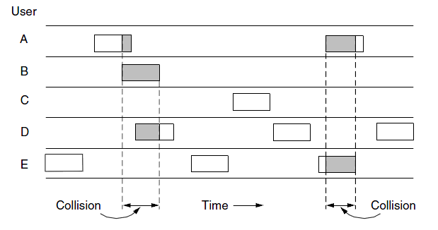

* Notes and assumptions:
  + Large number of stations
  + Frames of equal length
  + Transmit time for frame on the channel is normalized to unity
  + Stations can sense channel collision and re-try transmission if there is a collision
* Poisson distribution:
  + Poisson distribution is drived from the binomial distribution:
  + If event happens with probability p, the probability that the event happens exactly

X times in N trials is:

 *X* 

*P*( *X* )    *p X* (1 *p*)*N* *X*

 *N* 

* + If N is large and p is not close to 0 or 1 we get a Normal distribution
  + If N is large and p is small (rare event) we get a Poisson distribution
  + Probability of *k* events in a given time interval:

*Pr*[*k*] 

*Gke**G*

*k*!

* Frames are buffered at MAC
* MAC controls transmission of frames on the channel

Upper

Layer

Upper

Layer

Upper

Layer

Upper

Layer

MAC

MAC

MAC

MAC

PHY

PHY

PHY

PHY

Channel

* ***Analysis:***
  + All stations together, generate an average of S new frames per frame

time

* + - If S>1, every frame suffers a collision, so for reasonable operation, 0<S<1
    - A station does not send a new frame until the old frame has been transmitted

successfully. So, S can be seen as a measure of throughput as well.

* + Probability of k attempts per frame time by all stations, old and new

combined is Poisson with mean G per frame time.

* + Low load rare collision  SG
  + Increase the load  More collisions  G>S
  + Throughput is then the offered load, G, times the probability of no

collision, P0

⇒ S=GP0

* Probability of k frames generated

per frame-time (t) is (Poisson distribution)

*Pr*[*k*] 

*Gke**G*

*k*!

* Probability that there is no frame generated in a given interval t is

*Pr*[0]  *e**G*

* No collision if no other frame

generated in two frame-times.

* Mean number of frames generated during 2t sec is 2G so:

(2*G*)*k e*2*G*

Pr[*k*]   Pr[0]  *e k*!

2*G*

* ALOHA Efficiency:

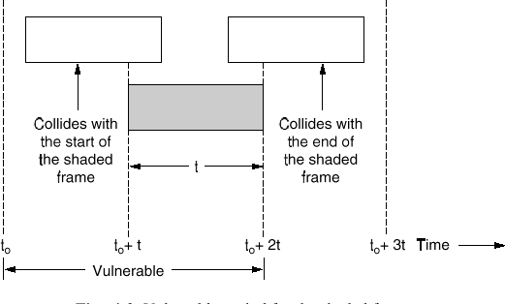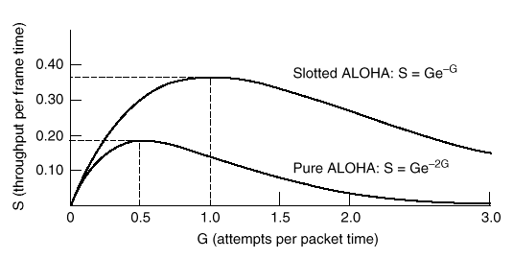

*S*  *Ge*2*G*

Slotted ALOHA Efficiency

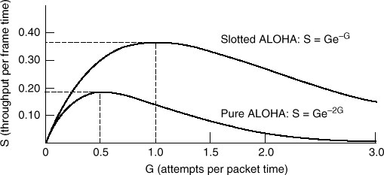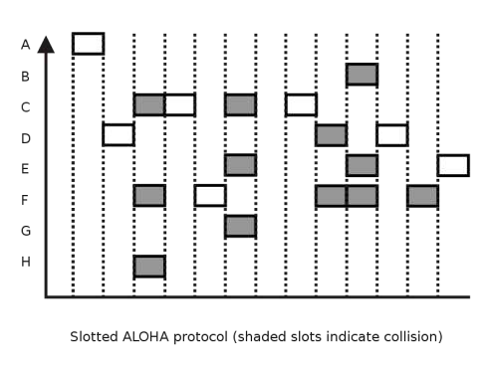

* Divide time in discrete intervals
* Users have to agree on slot

boundaries

* In each slot, one or more users

send their frames

* Probability of transmission success (no other frame is generated in a given interval) t is

(*G*)*k e**G*

*G*

Pr[*k*]   Pr[0]  *e k*!

* Slotted ALOHA Efficiency:

*S*  *Ge**G*

* Maximum channel utilization:
  + Pure Aloha : 18.4%
  + Slotted Aloha : 36.8% (37% empty

slots, 26% collisions)

* Probability of transmission failure for a single frame in slotted ALOHA:

*P*  (1*e**G* )

* Probability of a transmission requiring exactly k attempts:
* Expected Number of transmissions per frame is:

◎ 

*Pk*  *e**G* (1*e**G* )*k*1

*E*  *kPk*  *ke**G* (1 *e**G* )*k*1

 *eG*

* For ALOHA, with the same analysis, *E=e2G*

*k* 1 *k* 1

* A small increase in channel load, G can results in exponentially increase in transmissions (most of which cause collisions) resulting:
  + Reduced system throughput (S)
  + Longer queues in MAC layer for accumulated, waiting frames.
  + Increase in average frame delay
* Frame transmission duration: *X*
* Frame propagation time: *tprop*
* Average back-off time: *B*
* Average number of transmission attempts per frame (ALOHA): *G*/*S*=*e2G*
* Average number of unsuccessful attempts per frame: =*G*/*S*-1=*e2G*-1
* Successful transmission requires *X*+*tprop* seconds and each re-transmission requires *2tprop+X+B* seconds
* Therefore, average MAC delay in ALOHA is given by:

*E[TALOHA]=X+tprop+(e2G-1)(X+2tprop+B)*

* Normally, back-off time is uniformly distributed between 1 and K packet

transmission times and therefore, *B=(K+1)X/2*

* For Slotted ALOHA, the MAC delay is given by:

*E[TALOHA]=X+tprop+(eG-1)(X+2tprop+B)*

* **Normalized Transfer Delay** (NTD):

NTD 

*E*[*T* ]  (Average TransferDelay)

*E* [ *X* ]  (Average FrameTransmission Time)

* + A measure of delay caused

by access control algorithm (Collisions, reservations, etc).

* **Normalized Delay Bandwidth** (a):

*a*  One waydelay Bandwidth

Average FrameSize

* + Number of lost frames due to a collision is proportional to *a*
  + Example: 1000 bit frames, 2 Mbps channel, 40 msec. one-way delay 
* For ALOHA type MACs, the trend is:

s 17

*a*  2106  40103

1000

* When Load is low, NTD is near 1. NTD increases steadily as load is increased.
* Maximum achievable load is usually

much less than 1.

* Maximum achievable load decreases when *a* is increased ( Cost of MAC is higher for long distance or high speed links)

*E[T]/E[X]*

*a′ > a*

*a′*

*a*

1

Data Network

max

max

1

❒

Load

Normalized Transfer Delay

 80

Carrier Sense Multiple Access Protocols (CSMA)

* Idea: The number of collisions can be reduced by sensing the carrier

before transmission

* *1-persistent*
  + Listen to channel and transmit as soon as channel becomes idle
  + If collision, wait random time, and try again

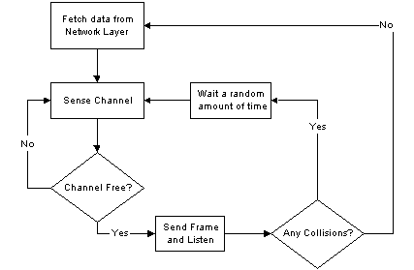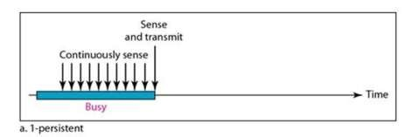

Communicatio

n Networkss

26

0

* *Non-persistent*:
  + Sense channel; if idle, transmit. If not idle, wait a random period before

sensing the channel

* + Better utilisation, however, longer delays

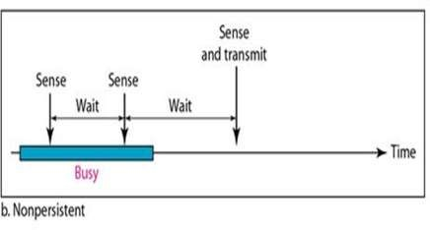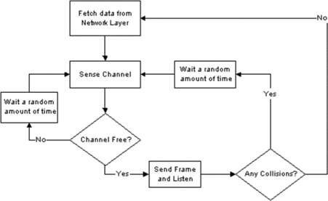

* *P-persistent:*
  + Sense channel, if idle, transmit with probability p, defer With probability

1-p to the next slot.

* + If next slot idle repeat the same algorithm
  + If busy the first time, wait till next time slot and try again

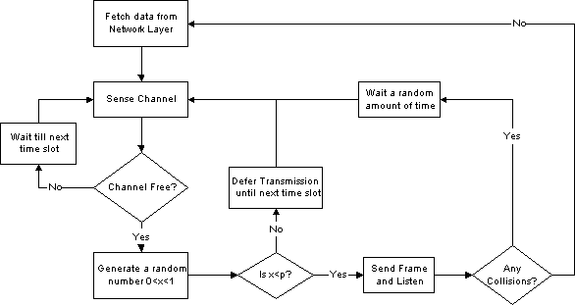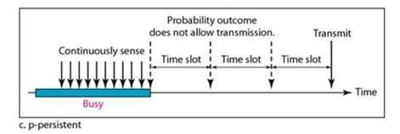

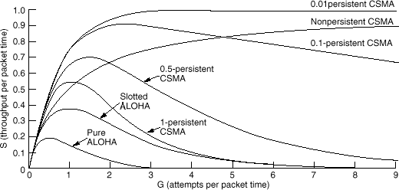

* 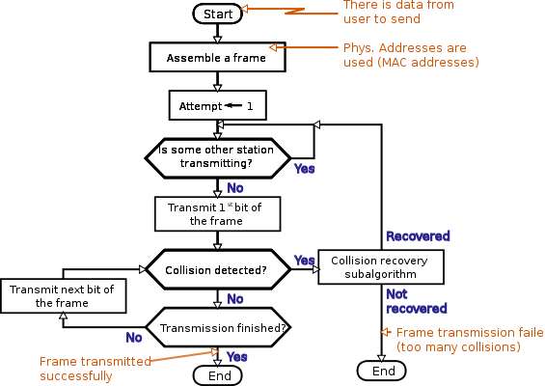Widely used on LANs in MAC sublayer (IEEE 802.3; Ethernet)
* Idea: *stop directly after detecting collision and wa*[*it for*](http://upload.wikimedia.org/wikipedia/commons/3/37/CSMACD-Algorithm.svg) *a random period*

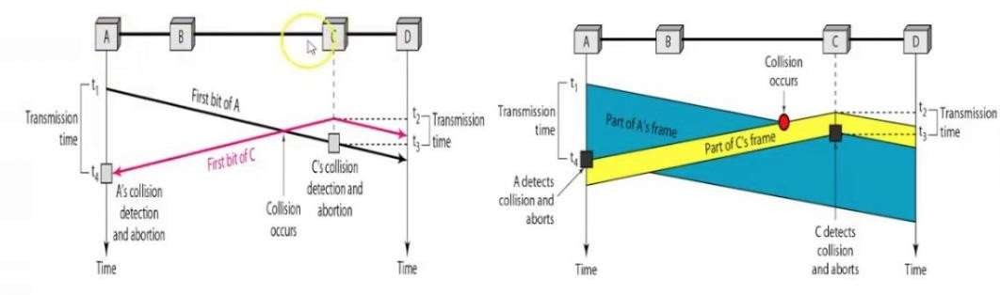

* How long does it take to detect collision?
  + Assuming a max travel time of *tprop*, it takes *2tprop* to be sure (contention period) (10 sec on 1 km cable)

A transmits at *t* = 0

A detects collision at *t* = 2 *tprop*



A

Distance *d* meters

*tprop = d / ν* seconds



A

B transmits before *t* = *tprop* and detects collision shortly thereafter

B



A

B

B

* Although CSMA/CD avoids collisions once a station has seized the channel;

collisions still occurs during the contention period

* Contention period may become large for long (fibre) cables

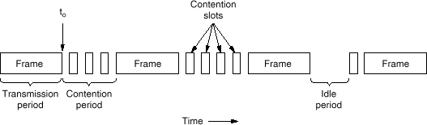

* Some MAC protocols rely on token.
* The token represents permission to send
* If a station has a frame queued for transmission when it receives the token,

it can send that frame before it passes the token to the next station.

* If it has no queued frame, it simply passes the token.
* In a token ring protocol, the topology of the network is used to define the

order in which stations send.

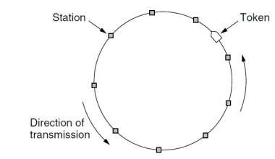

* Token passing can also be used in a bus mode where stations pass token

to each other in a predefined order.

* Examples:
  + Token Ring
  + Token Bus
  + FDDI
  + RPR
* IEEE 802 refers to a family of IEEE standards dealing with local area

networks and metropolitan area networks:

* + IEEE 802: Overview & Architecture
  + IEEE 802.1 Bridging & Management
  + IEEE 802.2: Logical Link Control
  + IEEE 802.3: CSMA/CD Access Method (Ethernet)
  + IEEE 802.5: Token Ring Access Method
  + IEEE 802.11: Wireless Local Area Networks (LAN)
  + IEEE 802.15: Wireless Personal Area Networks (PAN)
  + IEEE 802.16: Broadband Wireless Metropolitan Area Networks (MAN)
  + IEEE 802.17: Resilient Packet Rings (RPR)
  + IEEE 802.20: Mobile Broadband Wireless Access
  + IEEE 802.21: Media Independent Handoff
  + IEEE 802.22: Wireless Regional Area Network
  + IEEE 802.23: Emergency Services Working Group
* Original design for 1-10 Mbps
* Various media, first used on 50 ohm coaxial cable
* Started as ALOHA system on Hawaiian Islands
* Carrier sensing was added by Xerox

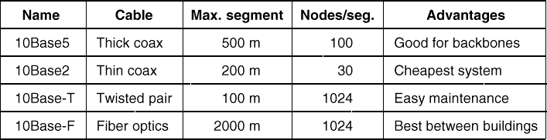

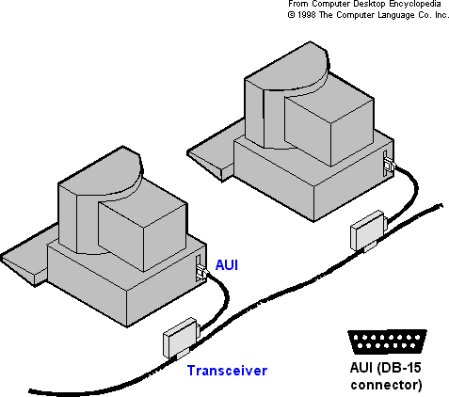 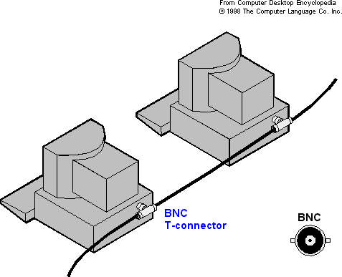

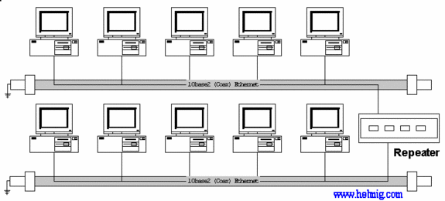

Communicatio

27

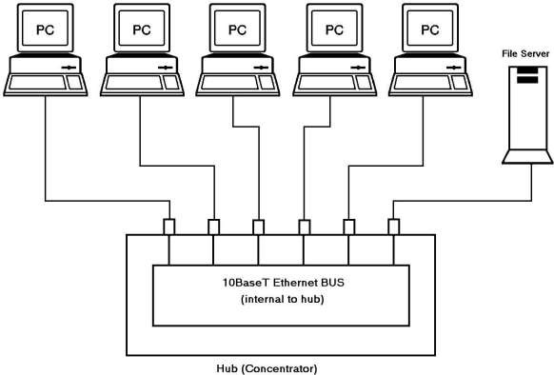

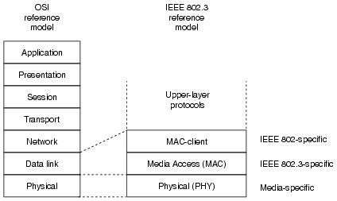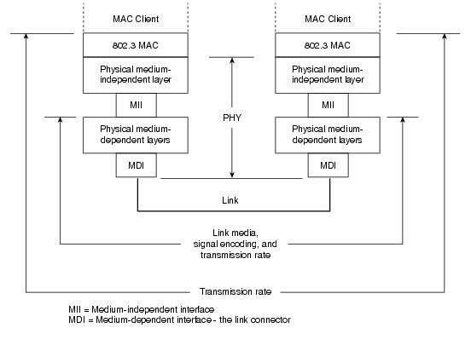

* Preamble: 7 x 1010.1010 pattern
  + Creates 10 MHz square wave of 5.6 microsecond for

synchronization

* Start field: 1010.1011 denotes start of frame

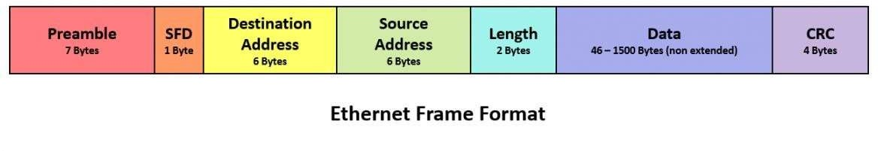

* Length field: 0-1500 bytes
* Data: payload
* Ethernet frames should be long enough to allow collision detection at the source. Therefore, a Pad field is defined to extend the length of short frames.
* Pad: ensure minimum frame length = 64 bytes.

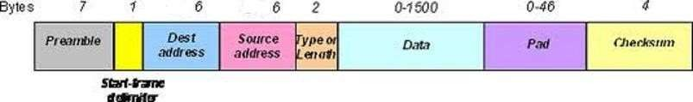

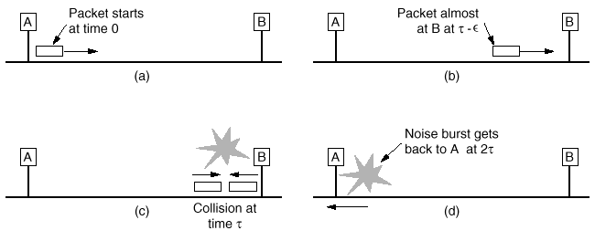

Communicatio

n Networkss

27

5

* LAN Length (L) = 500 m (per segment) x 5 segments = 2500 meters
* Velocity of propagation on the cable (V) = 2 * 108 meters/sec
* Delay added by repeater (D) = ~3uSec x 2 (Bi-Direction) x 4 Repeaters =

24uSec

* Round Trip Delay (RTD) = (Total Distance/V) + Repeater Delays (D) Total Distance/V = (2*2500/2 * 108) = 25 * 10-6 sec or 25usec Hence RTD = 25 + 24 = 49 usec
* Now, time to transmit 64 bytes = 512 bits / 10 * 106 = 51.2 10-6 sec or 51.2 usec (referred to as slot time in the 802.3) which is greater than the RTD of 49 usec.
* Hence the minimum frame size for the IEEE 802.3 (Ethernet) is 64 bytes.

Communicatio 27

n Networkss 6

* Jam Signal: When a collision is detected during a frame transmission, the transmission is not terminated immediately. A station noting a collision has occurred sends a 4 to 6 bytes long pattern composed of 16 1-0 bit combinations.

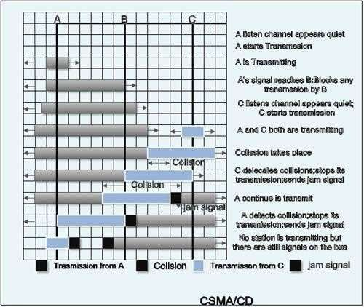

* The purpose of this is to ensure that any other nodes which may currently be receiving a frame will receive the jam signal in place of the correct 32-bit MAC CRC,

this causes the other receivers to discard the frame due to a CRC error.

Communicatio 27

n Networkss 7

* An Ethernet MAC address consists of a 6-digit hexadecimal vendor

OUI code followed by a 6-digit hexadecimal vendor-assigned value

* OUI address is managed by IEEE. It has two bits that specify:
  + Address is unicast or multicast
  + Address is locally administered or globally unique

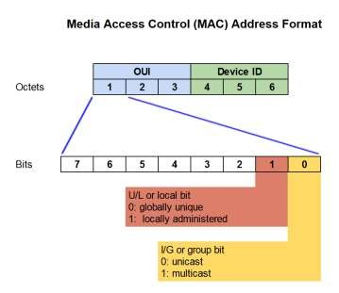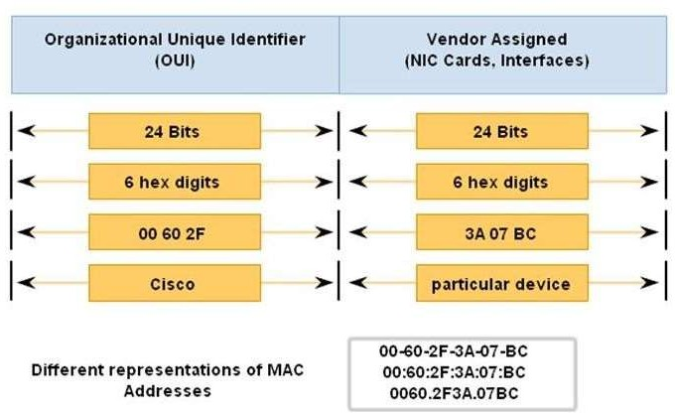

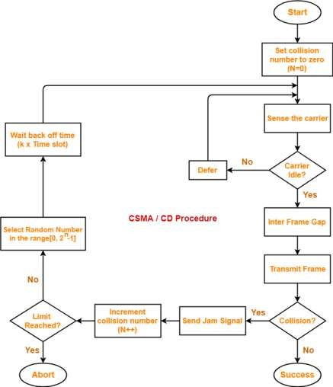

* 802.3 MAC uses CSMS/CD with binary exponential backoff
* Binary Exponential Back off
  + After collision wait 0 or more slots (of 51.2 msec)
  + First collision: wait 0 or 1 slot (choose randomly)
  + Second collision: wait 0, 1, 2 or 3 slots
  + N-th collision: wait 0 - 2N -1 slots
  + N max = 10 => wait between 0 - 1023 slots
  + Give up after 16 trials and leave

recovery to higher layers

* Algorithm ensures low latency at low load and fairly resolves collisions when the load is high.
* Assume constant transmission probability p (no exp back off)
* Probability A of acquiring a slot (by one of k stations):

*A*  *kp*(1 *p*)*k* 1

* Probability that contention interval, W, has precisely j slots:

*A*(1 *A*) *j*1

* Therefore, the average #slots per contention is given by

◎



*j* 0

*jA*(1 *A*) *j*1  1

*A*

* Each slot has a duration interval 2
* Mean contention interval is W = 2/A
* p optimal (= 1/k)  A = (1-1/k)k-1 =1/e (for k  heavy load) 

W=2e=5.4

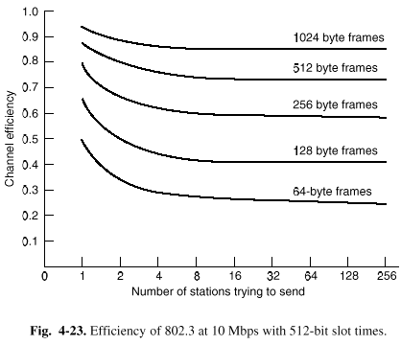

*U* 

*T*

*T*  2*τ* / *A*



1

1 2*BLe*/ *cF*

* F=frame length,
* L =cable length,
* B=network rate,
* c= propagation speed,
* e=contention slots per frame
* (Note: =L/c and T=F/B)

Communicatio

n Networkss

28

1

* Channel Utilization
  + Assume each frame takes T seconds to be transmitted.
  + When many stations have frames to send

(a)

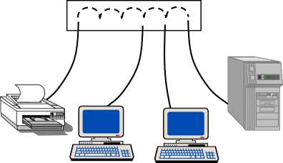

●     

Single collision domain

(b)



~~~~

●

●

●

High-Speed Backplane or

Interconnection fabric

Control Processor

Packet Classification Packet Scheduling Packet Switching

MAC

MAC

MAC

MAC

MAC

MAC

PHY



Egress Queue

Ingress Queue

Egress Queue

Ingress

Queue

Egress Queue

Ingress Queue

Egress Queue

Ingress

Queue

Egress Queue

Ingress Queue

Egress Queue

Ingress

Queue

Transceiver

PHY

Transceiver

PHY

Transceiver

PHY

Transceiver

PHY

Transceiver

PHY

Transceiver

* To improve the performance of the system, an Ethernet

switch can be used

* Each port of the system receives the frame of only one sender and stores it in the switch ingress buffers.
* Central switch fabric reads the frames from ingress buffers and forwards it to the egress output buffers.
* There will be no media collision
* Depending on the traffic pattern, buffers can be filled

which may results packet drop.

* Media Transmission Speed: 100 Mbps
* No multi-drop cables
* Two modes of operation
  + HUB Mode: a hub is a single collision domain. CSMA/CD is used
  + Switched Mode: frames are buffered and switched in the hub/switch. No

CSMA/CD. (100BaseFx works only in this mode)

* Types of Media
  + Twisted Pair: Most Common
    - 100 BaseTX: Operates in full duplex mode. Uses two UTP5 wires, one for transmission and one for reception. 4B/5B encoding at 125 MHz clock to send 100 Mbps.
  + Fiber Optics
    - 100BaseFX: Operates in full duplex mode. Uses two strands of multimode fibers to transmit and receive 100 Mbps in each directions up to 2km.
    - 100BASE-SX: 100 Mbit/s Ethernet over multi-mode fiber. Maximum

length is 300 meters.

* + - 100BASE-BX10: 100 Mbit/s Ethernet bidirectionally over a single

strand of single-mode optical fiber.

* + - 100BASE-LX10: 100 Mbit/s Ethernet up to 10 km over a pair of

single-mode fibers, using 1310 wavelength, full-duplex only.

* Media Transmission Speed: 1 Gbps
* Only Full duplex mode: send and receive independently to a switch and no media contention
* Physical interfaces
  + 1000 base-X:
    - Various standards for optical fiber-based transmission
    - Supports multimode and single mode fibers
    - Distance up to 120km
  + 1000base-T:
    - Various standards for copper-based media
    - Distance up to 100m
* Media Transmission Speed: 10 Gbps
* Physical interfaces
  + Copper based backplane:
    - Used in backplane for high-speed communication between cards
    - Distance up 1m
  + Copper based cables:
    - Coaxial cable, Twin-axial cables and twisted pairs
    - Distance up to 100m
  + Fiber-optic based cables:
    - Multi-mode and single-mode fibers
    - Distance up to 80km
* Media Transmission Speed: 25 Gbps
* Physical interfaces
  + Copper based backplane:
    - Used in backplane for high-speed communication between cards
    - Distance up 1m
  + Copper based cables:
    - Twin-axial cables up to 8m
    - Twisted pair cable up to 30m
  + Fiber-optic based cables:
    - Multi-mode fiber up to 100m
    - Single-mode fiber up to 30km using CWDM
* Media Transmission Speed: 40 Gbps
* Physical interfaces
  + Copper based backplane:
    - Used in backplane for high-speed communication between cards
    - Distance up 1m
  + Copper based cables:
    - Twin-axial cables up to 7m
    - Twisted pair cable up to 30m
  + Fiber-optic based cables:
    - Multi-mode fiber up to 150m
    - Single-mode fiber up to 40km
* Media Transmission Speed: 100 Gbps
* Physical interfaces
  + Copper based backplane:
    - Used in backplane for high-speed communication between cards
    - Distance up 1m
  + Copper based cables:
    - Twin-axial cable
    - Distance up to 7m
  + Fiber-optic based cables:
    - Distance of 125m over multi-mode fiber
    - Distance of 80km over single mode fiber
* Terabit Ethernet or TbE is Ethernet with speeds above 100 Gigabit

Ethernet.

* Media Transmission Speed: 200 Gbps and 400 Gbps
* Physical interfaces
  + Copper based backplane
  + Copper based cables: Twin-Axial
  + Fiber-optic based cables: Single Mode and Multi-Mode
  + Chip to Chip Communication
* Standards under development
  + 800 Gbps
  + 1.6 Tbps

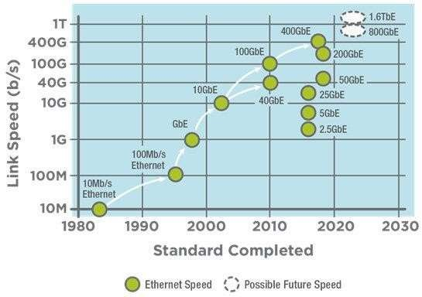

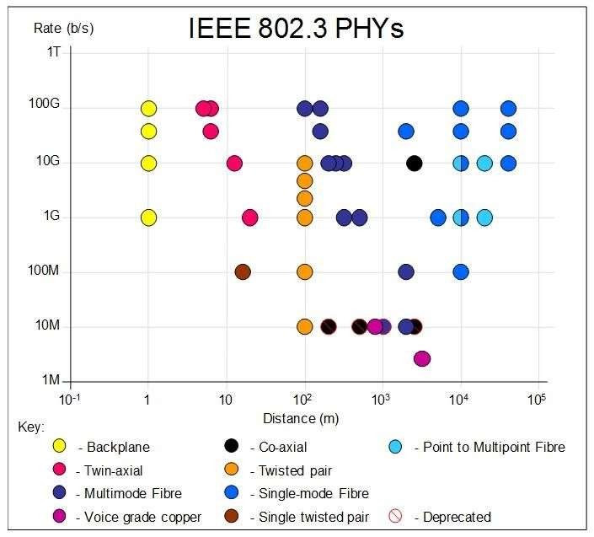

Communicatio 29

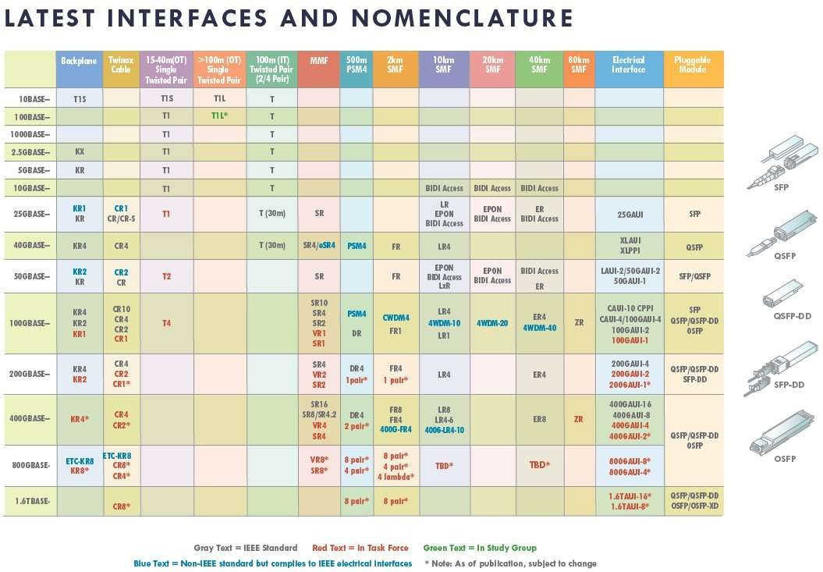

Communicatio 29

* For some applications, an error-controlled, flow controlled connection is desired
* Data link layer for 802 protocols consists of two parts:
  + LLC logical link control
  + MAC multiple access control
* LLC implements the functionality as discussed in the data link layer section like:

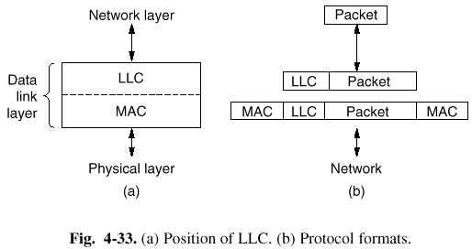

* + Error control
  + Flow control
* LLC offers three services:
  + Unreliable datagram service
  + Acknowledged datagram

service

* + Reliable connection-oriented

service

* LLC header is based on the

HDLC protocol

Communicatio 29

n Networkss 6

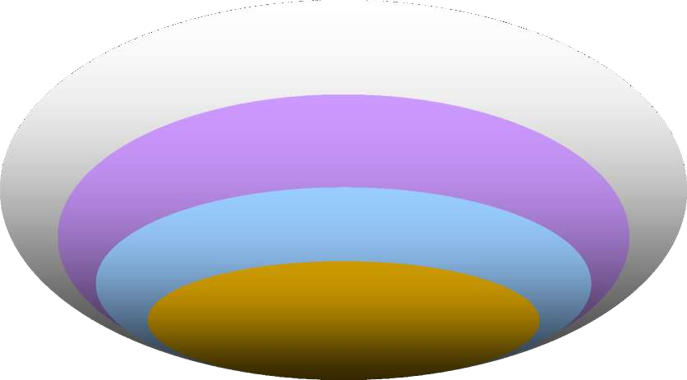**WAN**

**IEEE 802.20**

**(proposed)**

**IEEE 802.16**

**WirelessMAN**

**IEEE 802.11**

**WirelessLAN**

MAN

**LAN**

**3GPP, EDGE**

**(GSM)**

**ETSI HiperMAN &**

**HIPERACCESS**

**ETSI**

**HiperLAN**

**IEEE 802.15**

**Bluetooth**

**PAN ETSI**

**HiperPAN**

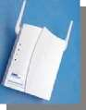 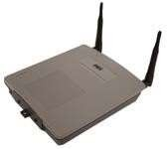 

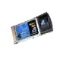

**Fixed**

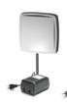

**Licensed and Unlicensed**

**E1/ T1 & DSL level service**

#### Portable Mobile

**Licensed and Unlicensed Licensed**

**Consumer DSL level service Wideband Data Rates**

**Enterprise**

**/ Backhaul**

**Residential**

**access**

**Destination**

**based**

**Nomadic**

**Cellular**

**Wideband**

**802.16**

**HiperMAN**

**802.16**

**HiperMAN**

**802.11 Hot**

**Spots**

**802.16e**

* 1. **G, 3G**
     + Wireless protocols are *inherently multiple access* !
     + Can we use ***sensing*** ?
       - What matters is collision at Rx
     + Hidden station problem:
       - C can not sense A. If both target B, there will be a collision
     + Exposed station problem:
       - B sends to A. C senses the medium and concludes that there is activity. So, it does not send to D. The link between C and D is not susceptible to the conversation of A and B.

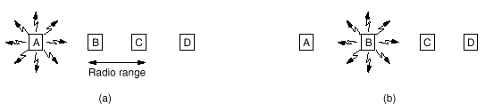

* + - MACA: ***Multiple Access with Collision Avoidance***
      * Sender: sends RTS (request to send)
      * Receiver: sends CTS (clear to send)
      * RTS and CTS contain length of message to be sent

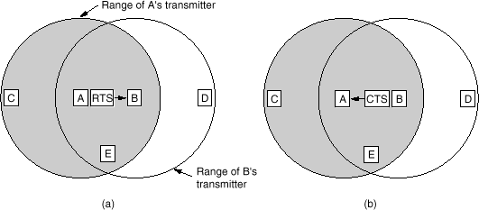

* + - Key observations:
      * Any station hearing RTS must keep silent during the next phase of data

transmission

* + - * Any station hearing CTS must keep silent during next message



* + - Wireless LANs are becoming increasingly popular due to:
      * Ease of installation
      * Support of mobility
      * Easy connection to back-bone networks in places like airports, shopping centers, conference rooms, etc

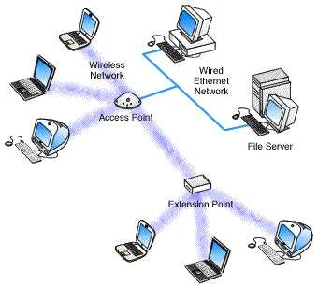

Communicatio

n Networkss

30

2

* + - Key Architectures
      * Infrastructure Mode: Require Access Point/Base Station
      * Ad-Hoc Mode: On demand networking without infrastructure

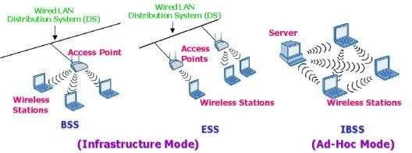

* + - Several standards have been developed in the last decade
    - One of the hottest areas of telecommunication
    - The list of standards keeps growing every year!

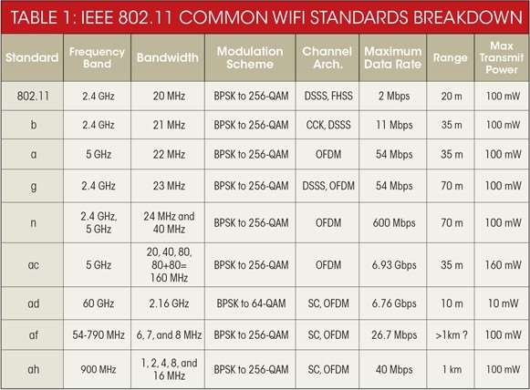

* + - 802.11a Orthogonal Frequency Division Multiplexing (OFDM)
      * Variable bit rates up to 54 Mbps
      * Uses 5 GHz ISM band
      * Much more immune to channel

variations

* + - * Short range, mostly used for indoor

LANs

* + - 802.11b High Rate Direct Sequence Spread Spectrum (HR-DSSS)
      * Variable bit rate up to 11 Mbps (1,2,5.5,11)
      * Uses 2.4 GHz ISM band
      * Longer range than 802.11a (Can be used for inter-office LAN connection)
    - 802.11g (OFDM)
      * Variable bit rate up to 54 Mbps
      * Uses 2.4 GHz band
    - 802.11n
      * OFDM/DSSS Modulation
      * Up to 540 Mbps
      * Uses 2.4 and 5 GHz bands
    - 802.11ac (5 GHz)
      * Uses MIMO and OFDM
      * Up to 860 Mbps per stream
      * Up to 8 MIMO streams

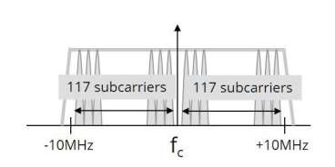

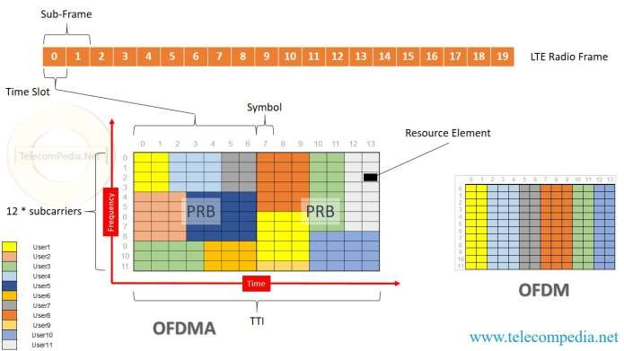

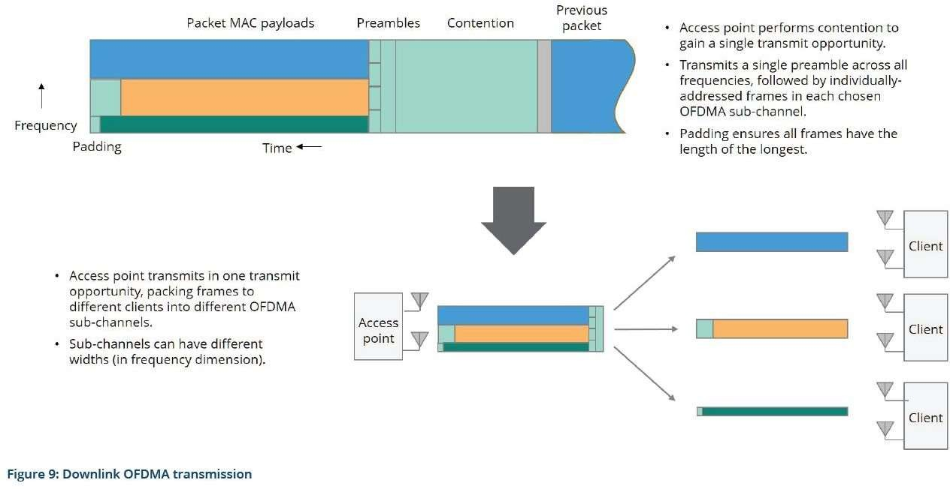

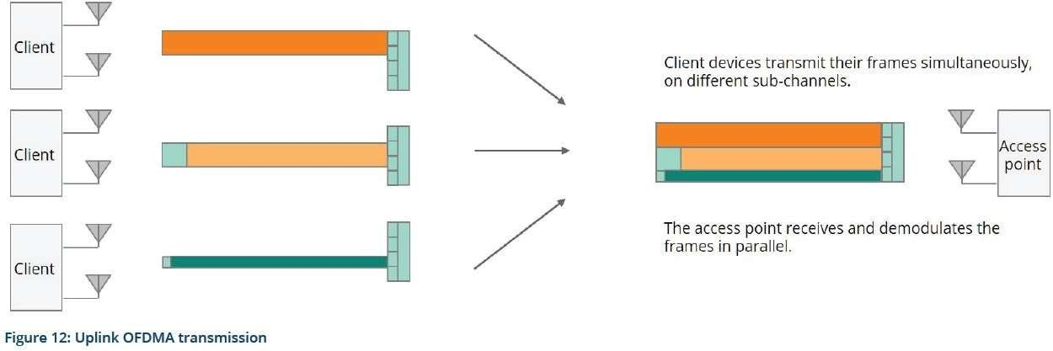

* + - All 802.11 (a,b,g) networks use the same MAC
    - MAC supports two modes of operation
      * Distributed Coordination Function: Used for Ad-Hoc connections
      * Point Coordination Function: Used when nodes are connected to an access point
    - PCF Mode:
      * Base station broadcasts a beacon frame that contains frequency hopping, synch

and some other information periodically

* + - * Stations can sign up to the base for receiving services
      * Once base station registers a user, it will assign the necessary resources.
      * Base station can manage the activity of users by putting them in sleep mode to save battery power. It wakes them up when needed.

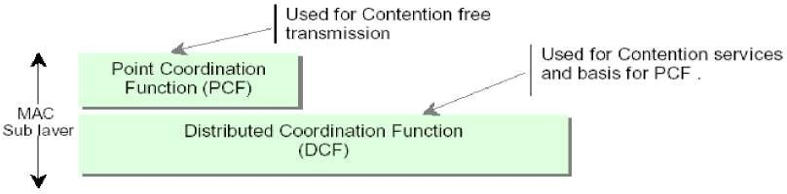

* + - DCF employs CSMA/Ca that has two access methods
      * Start transmitting as soon as channel is idle. If a collision, wait a random time (exponential back off) and try again
      * Use MACAW using RTC/CTS
      * Note: RTS and CTS contain data length thereby setting the waiting time (Not

Available Vector) in other stations.

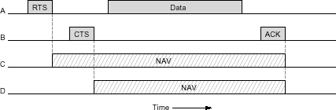

* + - A long frame has a much higher chance of error than a short frame
    - For BER=1e-4, Probability of frame error is more than 70% for a frame of length 12kbit.
    - Once channel is acquired, a burst of short frames can also be sent to

increase system throughput

* + - Uses Stop and Wait for each fragment

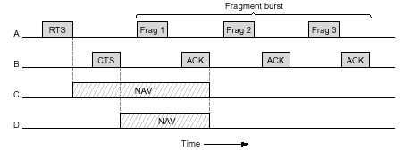

* + - All stations should remain quiet for a certain period after a

transmission has been completed (Inter Frame Space (IFS)) .

* + - * Short Interframe Spacing (SIFS):
        + High priority frames (ACK, CTS or fragment burst) only wait for SIFS duration
      * Arbitration Interframe Space (AIFS)
        + Base station can send high priority traffic during AIFS1 and low priority traffic

during AIFS4

* + - * DCF Interframe spacing (DIFS)
        + Any station may attempt to acquire the channel to send a new frame after the medium has been idle for DIFS
      * Extended Interframe spacing (EIFS)
        + A station can report a bad or unknown frame during this time

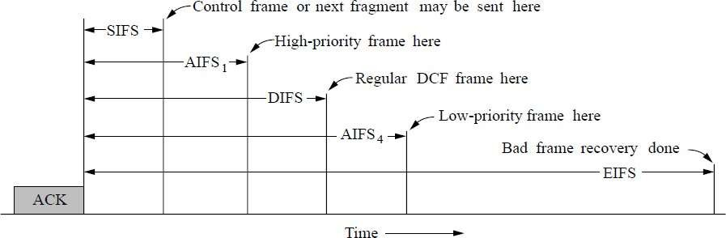

DIFS

Data

RTS

Source

Destination

SIFS

SIFS

SIFS

Ack

DIFS

NAV (RTS)

CTS

Other

NAV (Data)

NAV (CTS)

Defer access

* + - A station can send if channel is idle for a period of DIFS or longer
    - If medium is busy, node starts a random backoff timer
    - Station is allowed to transmit when its backoff timer expires during a contention period
    - If another station starts transmission during the contention period, the backoff timer is suspended and resumed next time a contention period takes place
    - When a station has successfully completed a frame transmission and has another frame to send, the station must first execute the backoff procedure
    - Waiting stations tend to have smaller remaining backoff time and can access channel sooner. Therefore, a degree of fairness is provided in the channel access process.
    - A wireless LAN can provide these services:
      * Distribution Services
        + Association: A mobile can connect to base station using this service.
        + Disassociation: Breaking the relationship between the base and mobile
        + Re-association: Change the preferred base station by moving from one cell to

another cell

* + - * + Distribution: A Service that determines how to route frames sent to a base
        + Integration: A service that handles the required translation of frame format for

sending a packet to a non-802.11 format

* + - * Station services
        + Authentication: prove the identity of the mobile
        + De-authentication: cancel the approved identification of a user
        + Privacy: Encryption of messages sent over PHY
        + Data Delivery: Transmission of data from one node to another
    - A standard for Inexpensive, compact , short range wireless communication.
    - 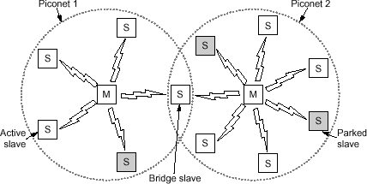Started by Ericsson, IBM, Nokia,

Intel and Toshiba in 1994, Version

1.0 finalized in 1999.

* + - Based on pico-nets connected

together by slave bridges

* + - Each piconet has one master node and seven slaves and up to 255 parked nodes (nodes in power stand-by)
    - Each piconet is a centralized TDM system managed by Master. All communications between slaves are done through the master. (No direct slave to slave comm.)

■ Standard specifies the entire protocol stack for various applications.

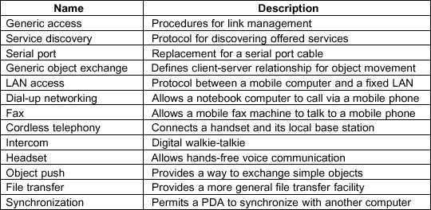 Important defined profiles (Important applications which are standardized by the standard):

❑ Serial port emulator

❑ LAN Access

❑ Dial up networking

❑ Cordless telephony

❑ Intercomm

❑ Headset

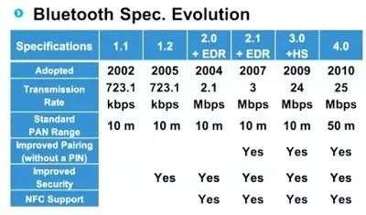

* Physical Radio:
  + Operates in 2.4 GHz ISM

frequency band

* Baseband Layer (MAC)
  + Turns raw bits to frames and

defines key formats

* + Each frame is transmitted

over a “Link”.

* + Two types of links:

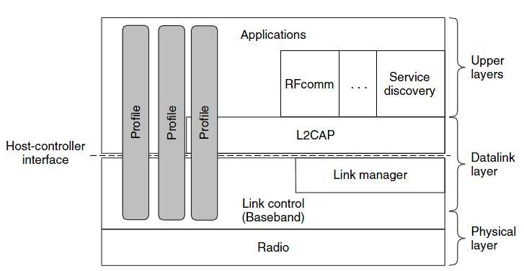

* + - Asynchronous Connectionless (ACL) used for packet data
    - Synchronous Connection Oriented (SCO) used for real time data such as voice
* L2CAP:
  + Frame segmentation and re-

assembly

* + Mux/Demux of multiple data

sources

* + Handles QoS requirements during link establishment and normal operation

Communicatio 32

* How to know where to forward frames in an Ethernet Switch?

Forwarding Table

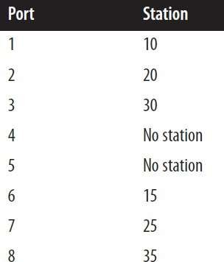

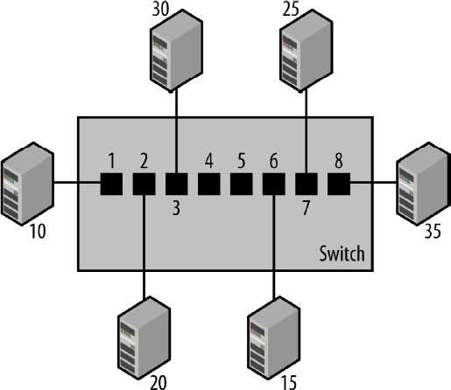Communicatio 32

* Switches use MAC address tables to determine how to forward traffic between ports.
  + MAC tables include dynamic and static addresses.
  + The MAC address table was also referred to as content addressable memory (CAM) table.
  + The maximum size of the MAC address table varies with different switches.
    - For example, the Catalyst 2960 series switch can store up to 8,192 MAC addresses

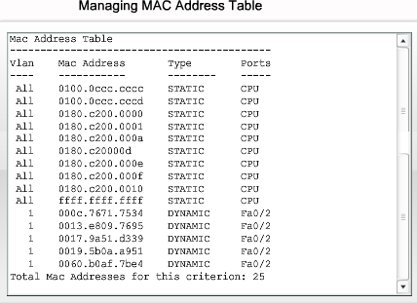

* Static MAC addresses:
  + A network administrator can specifically assign static MAC addresses to certain ports.
  + Static addresses are not aged out.
  + Only those devices that are known to the network administrator can connect to the network.



* Backward Learning is used to dynamically update the MAC address table:
  + If the port for the destination address is the same as the source port, discard the frame.
  + If the port for the destination address and the source port are different, forward the frame on

to the destination port.

* + If the destination port is unknown, use flooding and send the frame on all ports except the source port.
  + Remove very old entries (to trace systems going down and other topology changes)

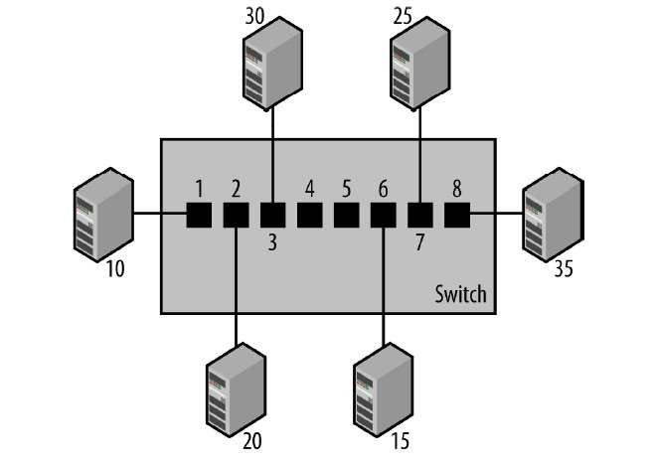

* Ethernet switches can be connected to expand the network
* Backward learning is used to learn addresses in all switches

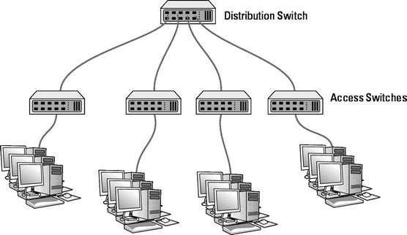

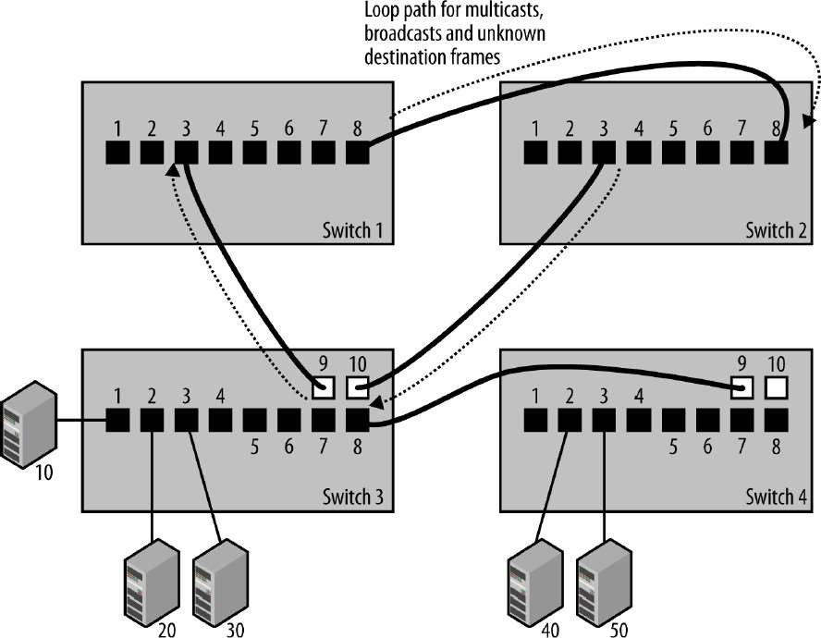

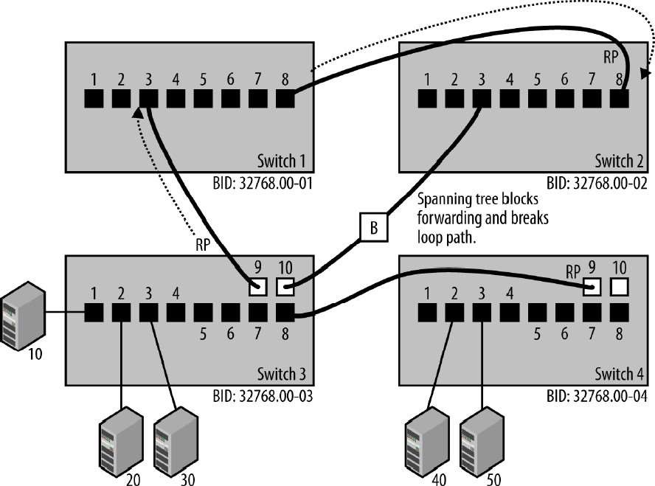

* Bridges need to route packets at layer 2 and also do some

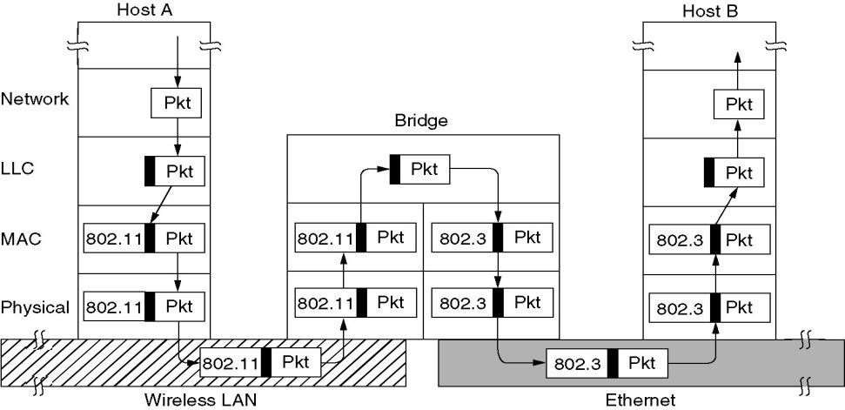frame conversions

* It is desirable to group users on LANs based on policy (For example based on organizational structure) rather than the physical layout of the building
  + Security and access control
  + Network Load Control
  + Broadcast Traffic (ARP)
  + Limiting scope of unwanted events such as broadcast storms
* Network partitioning in Layer 2 can be done by proper management

of switch learning process.

Communicatio 33

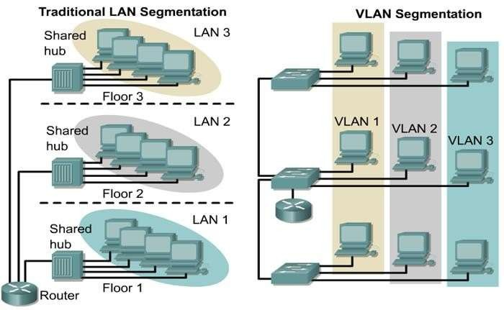

* Partition a switch into different switches
* Use tags to identify VLANs

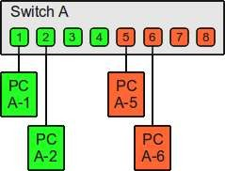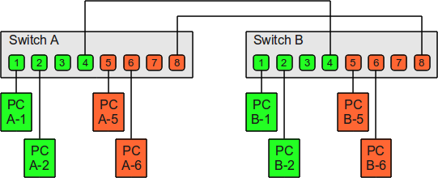

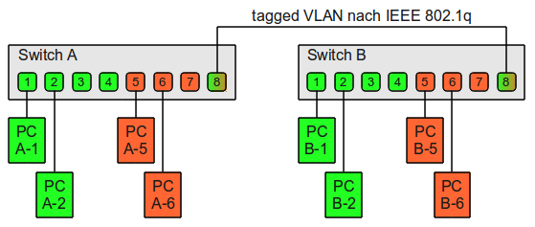

Communicatio 91

Pictures: https:/[/www.thomas-krenn.com/en/wiki/VLAN_BasnicNs](http://www.thomas-krenn.com/en/wiki/VLAN_Basics) etworkss

* Tag protocol identifier (TPID): a 16-bit field set to a value of 0x8100 in order to identify the frame as an IEEE 802.1Q-tagged frame. This field is located at the same position as the EtherType/length field in untagged frames, and is thus used to distinguish the frame from untagged frames.

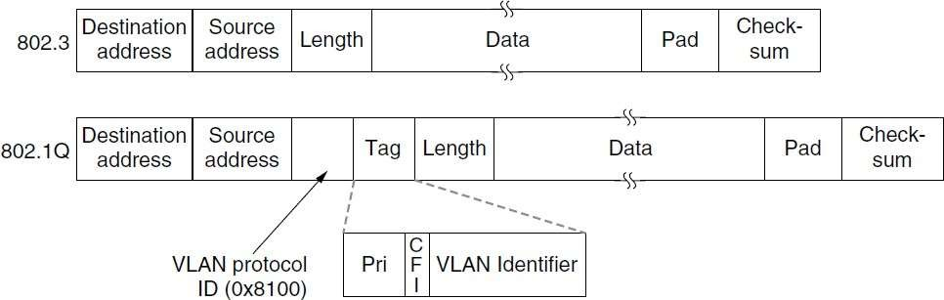

* Tag control information (TCI)
  + Priority code point (PCP): a 3-bit field which refers to the IEEE 802.1p class of service and

maps to the frame priority level.

* + Values in order of priority are: 1 (background), 0 (best effort), 2 (excellent effort), 3 (critical

application), ..., 7 (network control).

* + These values can be used to prioritize different classes of traffic (voice, video, data, etc.).
  + Drop eligible indicator (DEI): a 1-bit field. (formerly CFI) May be used separately or in conjunction with PCP to indicate frames eligible to be dropped in the presence of congestion.

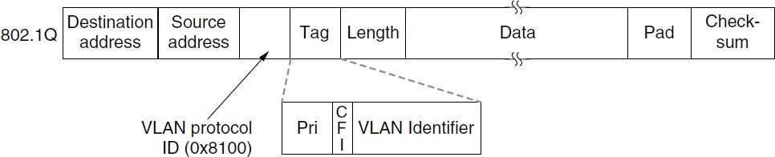

* Tag control information (TCI)
  + VLAN identifier (VID): a 12-bit field specifying the VLAN to which the frame belongs.
  + The hexadecimal values of 0x000 and 0xFFF are reserved.
  + All other values may be used as VLAN identifiers, allowing up to 4,094 VLANs.
  + The reserved value 0x000 indicates that the frame does not belong to any VLAN; in this case, the 802.1Q tag specifies only a priority and is referred to as a priority tag



* The VLAN fields are only actually used by the bridges and switches

and not by the user machines.

* There can be computers (and switches) that are not VLAN aware.
* The first VLAN-aware bridge to touch a frame adds VLAN fields and the last one down the road removes them.
* Frames can be tagged depending on the port on which they are received.

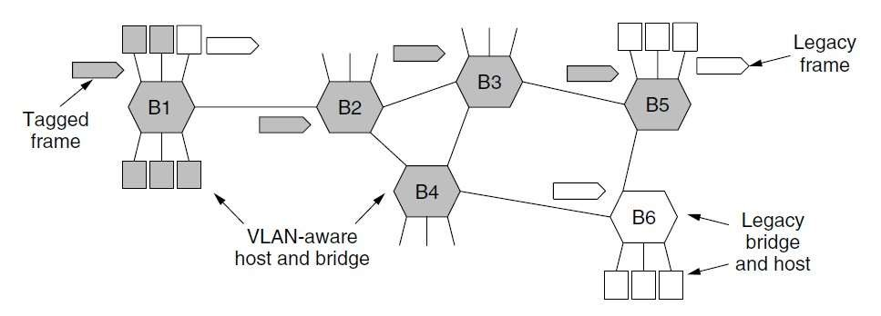

Communicatio

33

# Data Communication Networks Network Layer

DR.Eslami

Department of Electrical Engineering [Islamic Azad University،Science And Research Branch](https://srb.iau.ir/en)

Communicatio 1

Layer

* Role of network layer: ***routing packets***
  + Deals with end-to-end communication
  + 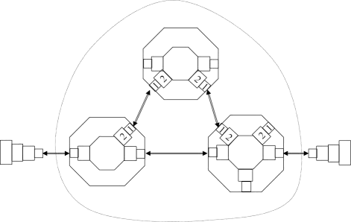Aware of network topology
  + Choose appropriate route
  + Communicates with transport and data

link layers

C

1 2 3 2 1

* Network layer topics
  + Design issues
  + Routing algorithms

End system



4 3 2 1

1 2 3 2 1

Medium

1 2 3 2 1

2

End system



1 2 3 4

* + Congestion control
  + Quality of Service
  + Internetworking
  + Network layer in the Internet: IP

1 Physical layer entity Data link layer entity

A B 1

Network

Network layer entity

2



3

4

Network layer entity

Transport layer entity

3

## Issues

* Services provided to the transport layer
  + Independent of chosen subnet technology
  + Shield transport layer from topology, type and number of subnets
  + Uniform numbering plan, across LANs and WANs

Messages Messages

Segments

Transport

layer

Transport layer

|  |
| --- |
| Network layer |
| Data link layer |
| Physical layer |

|  |
| --- |
| Network  layer |
| Data link  layer |
| Physical  layer |

Network service

|  |
| --- |
| Network layer |
| Data link  layer |
| Physical layer |

End system



Network service

End system

|  |
| --- |
| Network layer |
| Data link layer |
| Physical layer |







## issues

* **Connection-oriented or connectionless service?**
  + Where to put the complexity?
* Internet community: connectionless
  + Network will be unreliable anyway => handle this issue in higher layer (s)
  + Only SEND packet and

RECEIVE packet needed

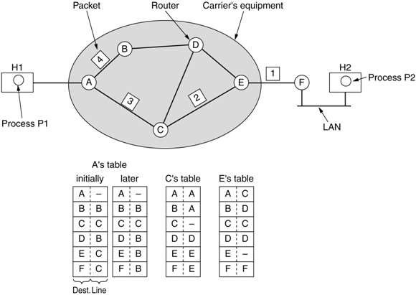

* + Hosts are getting powerful; so why not put the complexity there

(in the transport layer)

=> easy to adapt

* + Speed more

important than accuracy

Data 3

Communicatio 4

## Issues

* Telephone companies: NL should be connection-oriented
  + Set up connection first
  + Each connection has unique ID
  + Negotiate parameters (quality, cost)
  + Communication in both directions
  + Use of Acknowledge gives automatic flow control

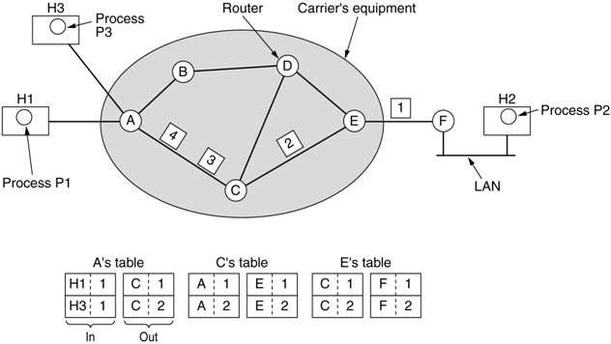

Data

Communicatio

3

4

* **Virtual circuits** :
  + Avoid routing every packet or cell independently
  + All packets/cells follow same route (= session routing)
  + Store # VC in routing tables (consuming some resources)
* 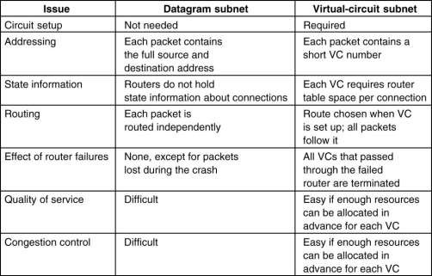**Datagrams**
  + Each packet contains destination and is independently routed
  + Also usable for

connection-oriented service

* Message / packet / cell has to pass multiple hops
* Routing algorithm : decide which outgoing link to use
* Routing algorithm requirements
  + Correctness
  + Simplicity
  + Robustness: cope with changing topology
  + Stability: converge quickly
  + Fairness: guarantee progression
* Non-adaptive (static) routing:
  + Do not use measurements or estimates of current traffic and topology
  + Static routing: calculate route off-line or use deterministic algorithm
* Adaptive (dynamic) routing:
  + Routing decision depends on network status
  + Update state information regularly
  + What type of network information do we base the decision on?
    - Hop count
    - Distance, estimated transit time
    - Traffic rate
    - Congestion metrics
* Static algorithm
* Idea: forward incoming packet on all other outgoing lines

Data 3

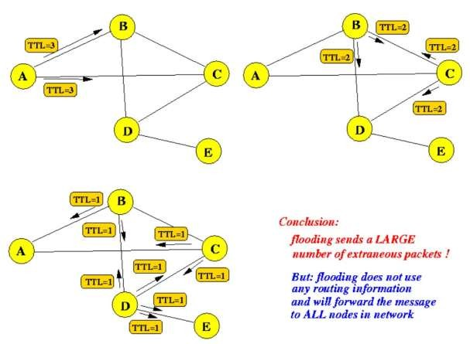

* Reducing the number of forwarded packets using sequence numbers

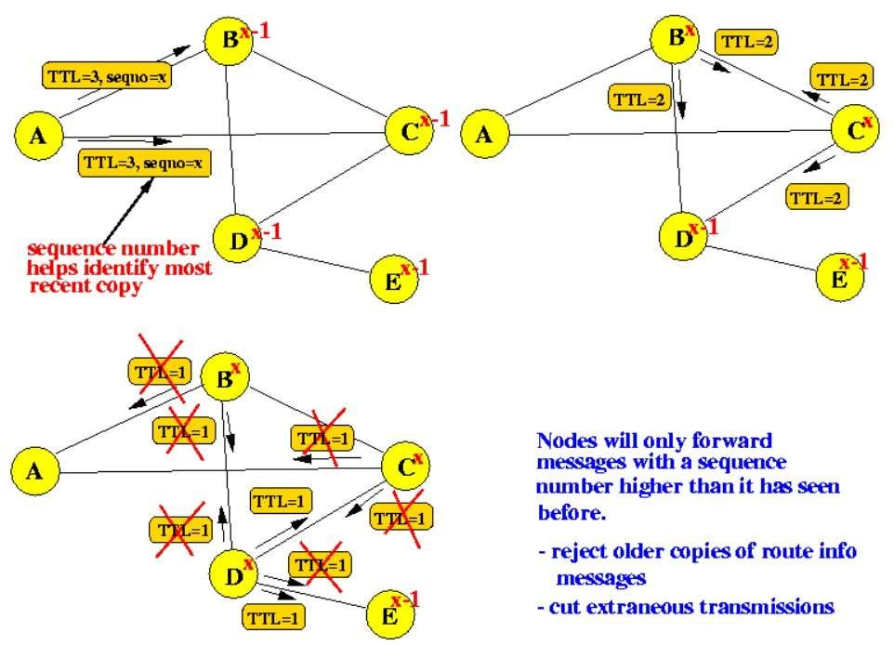

* Flooding Properties:
  + Not practical in most applications
  + Generates too much traffic
  + Useful for:
    - Extreme robustness (military purpose)
    - Broadcast
    - Reference algorithm
  + It always finds the shortest delay path !!
* Optimality principle:
  + If F is on optimal path of L  B then the whole path F  A  B is the best path between F and B

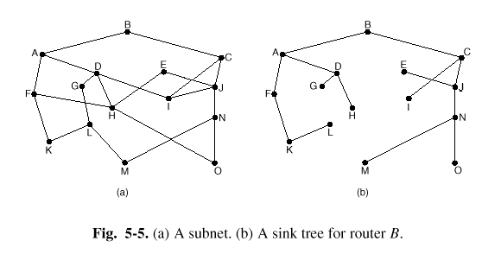

* Consequence: optimal routes from all sources to a given root ( = sink node ) form a *sink tree*  no loops.

Data

3

* Shortest Path Algorithm is used as part of many routing algorithms
* Build router graph G(N, L)
  + N is the set of nodes
  + L is the set of links (or edges)
* Choose path metric (weight of lines L)
  + # hops
  + Estimated delay ( using echo packets )
  + Physical distance
  + Queue length ( of outgoing lines )
* Dijkstra’s shortest path algorithm:
* Steps to find all shortest paths from A
* Initially: make A permanent: P = {A} : label all neighbors k of A with

Dk =dAk

* Repeat until P contains all nodes
  + find next closest node and add it to P:
  + P= P + {i} , with Di = min Dk (k not in P)
  + Updating labels of neighbours of P
  + Dk = min [ Dk , Dk + dik ] (k not in P)
* Key fact: the path to the next closest node i has to go through nodes from P only.

|  |  |  |  |  |  |  |  |  |
| --- | --- | --- | --- | --- | --- | --- | --- | --- |
|  | Base Set | B | C | D | E | F | G | H |
| 0 | A | 2,A | ◎ | ◎ | ◎ | ◎ | 6,A | ◎ |
| 1 | A,B |  | 9,B | ◎ | 4,B | ◎ | 6,A | ◎ |
| 2 | A,B,E |  | 9,B | ◎ |  | 6,E | 5,E | ◎ |
| 3 | A,B,E,G |  | 9,B | ◎ |  | 6,E |  | 9,G |
| 4 | A,B,E,G,F |  | 9,B | ◎ |  |  |  | 8,F |
| 5 | A,B,E,G,F,H |  | 9,B | 10,H |  |  |  |  |
| 6 | A,B,E,G,F,H,C |  |  | 10,H |  |  |  |  |

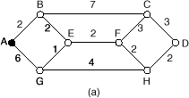

|  |  |  |  |  |  |  |  |  |
| --- | --- | --- | --- | --- | --- | --- | --- | --- |
|  | Base Set | B | C | D | E | F | G | H |
| 0 | A | 2,A | ◎ | ◎ | ◎ | ◎ | 6,A | ◎ |
| 1 | A,B |  | 9,B | ◎ | 4,B | ◎ | 6,A | ◎ |
| 2 | A,B,E |  | 9,B | ◎ |  | 6,E | 5,E | ◎ |
| 3 | A,B,E,G |  | 9,B | ◎ |  | 6,E |  | 9,G |
| 4 | A,B,E,G,F |  | 9,B | ◎ |  |  |  | 8,F |
| 5 | A,B,E,G,F,H |  | 9,B | 10,H |  |  |  |  |
| 6 | A,B,E,G,F,H,C |  |  | 10,H |  |  |  |  |

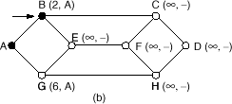

|  |  |  |  |  |  |  |  |  |
| --- | --- | --- | --- | --- | --- | --- | --- | --- |
|  | Base Set | B | C | D | E | F | G | H |
| 0 | A | 2,A | ◎ | ◎ | ◎ | ◎ | 6,A | ◎ |
| 1 | A,B |  | 9,B | ◎ | 4,B | ◎ | 6,A | ◎ |
| 2 | A,B,E |  | 9,B | ◎ |  | 6,E | 5,E | ◎ |
| 3 | A,B,E,G |  | 9,B | ◎ |  | 6,E |  | 9,G |
| 4 | A,B,E,G,F |  | 9,B | ◎ |  |  |  | 8,F |
| 5 | A,B,E,G,F,H |  | 9,B | 10,H |  |  |  |  |
| 6 | A,B,E,G,F,H,C |  |  | 10,H |  |  |  |  |

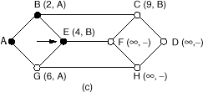

|  |  |  |  |  |  |  |  |  |
| --- | --- | --- | --- | --- | --- | --- | --- | --- |
|  | Base Set | B | C | D | E | F | G | H |
| 0 | A | 2,A | ◎ | ◎ | ◎ | ◎ | 6,A | ◎ |
| 1 | A,B |  | 9,B | ◎ | 4,B | ◎ | 6,A | ◎ |
| 2 | A,B,E |  | 9,B | ◎ |  | 6,E | 5,E | ◎ |
| 3 | A,B,E,G |  | 9,B | ◎ |  | 6,E |  | 9,G |
| 4 | A,B,E,G,F |  | 9,B | ◎ |  |  |  | 8,F |
| 5 | A,B,E,G,F,H |  | 9,B | 10,H |  |  |  |  |
| 6 | A,B,E,G,F,H,C |  |  | 10,H |  |  |  |  |

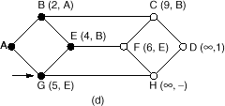

|  |  |  |  |  |  |  |  |  |
| --- | --- | --- | --- | --- | --- | --- | --- | --- |
|  | Base Set | B | C | D | E | F | G | H |
| 0 | A | 2,A | ◎ | ◎ | ◎ | ◎ | 6,A | ◎ |
| 1 | A,B |  | 9,B | ◎ | 4,B | ◎ | 6,A | ◎ |
| 2 | A,B,E |  | 9,B | ◎ |  | 6,E | 5,E | ◎ |
| 3 | A,B,E,G |  | 9,B | ◎ |  | 6,E |  | 9,G |
| 4 | A,B,E,G,F |  | 9,B | ◎ |  |  |  | 8,F |
| 5 | A,B,E,G,F,H |  | 9,B | 10,H |  |  |  |  |
| 6 | A,B,E,G,F,H,C |  |  | 10,H |  |  |  |  |

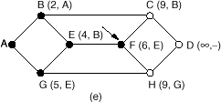

|  |  |  |  |  |  |  |  |  |
| --- | --- | --- | --- | --- | --- | --- | --- | --- |
|  | Base Set | B | C | D | E | F | G | H |
| 0 | A | 2,A | ◎ | ◎ | ◎ | ◎ | 6,A | ◎ |
| 1 | A,B |  | 9,B | ◎ | 4,B | ◎ | 6,A | ◎ |
| 2 | A,B,E |  | 9,B | ◎ |  | 6,E | 5,E | ◎ |
| 3 | A,B,E,G |  | 9,B | ◎ |  | 6,E |  | 9,G |
| 4 | A,B,E,G,F |  | 9,B | ◎ |  |  |  | 8,F |
| 5 | A,B,E,G,F,H |  | 9,B | 10,H |  |  |  |  |
| 6 | A,B,E,G,F,H,C |  |  | 10,H |  |  |  |  |

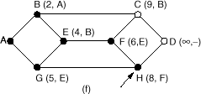

|  |  |  |  |  |  |  |  |  |
| --- | --- | --- | --- | --- | --- | --- | --- | --- |
|  | Base Set | B | C | D | E | F | G | H |
| 0 | A | 2,A | ◎ | ◎ | ◎ | ◎ | 6,A | ◎ |
| 1 | A,B |  | 9,B | ◎ | 4,B | ◎ | 6,A | ◎ |
| 2 | A,B,E |  | 9,B | ◎ |  | 6,E | 5,E | ◎ |
| 3 | A,B,E,G |  | 9,B | ◎ |  | 6,E |  | 9,G |
| 4 | A,B,E,G,F |  | 9,B | ◎ |  |  |  | 8,F |
| 5 | A,B,E,G,F,H |  | 9,B | 10,H |  |  |  |  |
| 6 | A,B,E,G,F,H,C |  |  | 10,H |  |  |  |  |

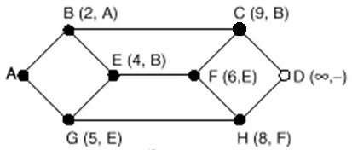

|  |  |  |  |  |  |  |  |  |
| --- | --- | --- | --- | --- | --- | --- | --- | --- |
|  | Base Set | B | C | D | E | F | G | H |
| 0 | A | 2,A | ◎ | ◎ | ◎ | ◎ | 6,A | ◎ |
| 1 | A,B |  | 9,B | ◎ | 4,B | ◎ | 6,A | ◎ |
| 2 | A,B,E |  | 9,B | ◎ |  | 6,E | 5,E | ◎ |
| 3 | A,B,E,G |  | 9,B | ◎ |  | 6,E |  | 9,G |
| 4 | A,B,E,G,F |  | 9,B | ◎ |  |  |  | 8,F |
| 5 | A,B,E,G,F,H |  | 9,B | 10,H |  |  |  |  |
| 6 | A,B,E,G,F,H,C |  |  | 10,H |  |  |  |  |
| 7 | A,B,E,G,F,H,C,D |  |  |  |  |  |  |  |

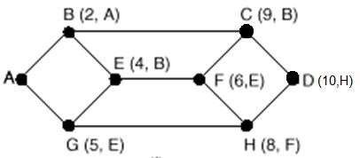

* Distance vector routing
  + Used in early ARPANET
  + Each router maintains distance table indexed by destination number
  + Entry contains : outgoing link + estimated distance
* How to know distance?
  + Send echo packet to all neighbors; this packet gets back with timestamp

therefore, distance to neighbor is determined

* Receive regularly updated tables from neighbors and update own

table

* + D (a,b) = min (D (a,x) + D (x,b) )

{for all neighbors x}

* Other metrics such as hop count

or cost could also be used

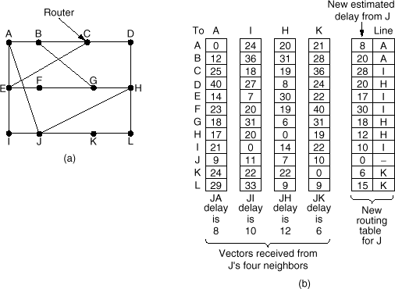

## routing

* Count-to-infinity problem:
  + Good news propagates much faster than bad news
* Split Horizon hack: (one of many efforts to reduce the impacts of this problem)
  + C does not report B the distance of node X for which packets have to flow through B
* C tells D the truth about the distance to A, but tells B that CA= 
* When AB fails, the bad news propagates as quickly as the good news
* Failure of Split Horizon
  + Init: CD=1, AD=2, BD=2, AB=1
  + CD fails, A and B tell C they can’t reach D, so C sets CD=
  + Unfortunately, A hears from B that BD=2, so it sets AD=3 => wrong!

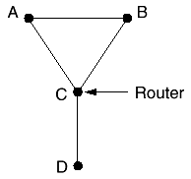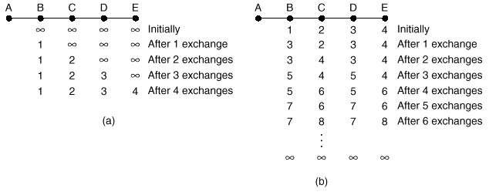

Data

Communicatio

3

6

* Solves slow convergence problem of the distance vector approach
* Idea:
  + Send all nearest neighbor information to all other routers
  + Each router uses this information to know the topology and determines

shortest path to all nodes

* Link State Routing: 4 steps
  + Discover neighbors (and their IDs)
  + Measure delay (or cost) to reach neighbours
  + Send link state packets to all other routers
  + Compute topology and shortest path to every router
* Perform last three steps at
  + Regular intervals
  + When major event happens (link / node going down or coming up )
* Discover neighbor:
  + After booting, send HELLO packet to all neighbors
  + Neighbor should respond telling its identity
* Measure delay:
  + Send ECHO packet; neighbors respond immediately
  + Calculate trip time = delay/2
  + Average of multiple measurements may be used
* Sending link state packets:
  + Make link state packet
  + Use flooding to distribute packets to all routers
  + Use sequence numbers to reduce traffic
  + Routers keep (source, seq#) pairs and discard lower sequence numbers
  + Use age fields to handle corrupted sequence numbers
  + Age is decremented in regular intervals
  + Information is discarded when age is zero

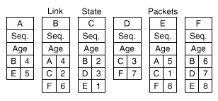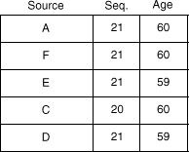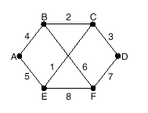

* Route Calculation
  + Compute new routes (when packets from all sources have been

received):

* + use shortest path algorithm on each node (e.g., Dijkstra’s algorithm)
* Link state routing used widely.
  + Example: OSPF (open shortest path first) routing which is used in the Internet
* Problem with Link State Routing:
  + large memory requirements ~ O (NK), where: N=number of routers

K=network node degree

* Purpose: Reduce routing table size and routing computation time
* Solution: use multi-level topology

3

Data Communication Networks

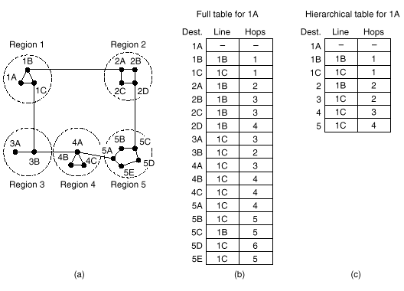

* Send lots of individual packets
  + Lots of traffic
  + Source needs to know all destination addresses
  + Generally, not used
* Flooding
  + Generates too many packets
* Multi-destination routing
  + Packet contains list of destinations
  + Router splits packet among output lines and updates destination list
  + Again, all destination addresses must be known!

Data 3

* Sink tree (= *spanning tree*)
  + Each packet is sent along the lines of the sink tree of the sender
  + Most efficient method for broadcast to all
  + Sink tree is not always known (e.g., not when distance vector routing is used; link state routing does have this knowledge!)



Data

3

Broadcast Routing: Reverse Path Forwarding

* Reverse path forwarding
  + Does not require network knowledge
  + Easy to implement
  + Transmission automatically finishes
  + Reasonably efficient
  + No list of destinations needed
  + No special mechanism needed to stop the forwarding
* Each router knows the normal line for sending packets to all other routers
* When a packet is received from a router, it is checked to see if it is coming from the

“normal” line.

* Send packet to all neighbours, but discard incoming packets from ‘wrong’ lines
* Packets from A arriving at B on line L is ‘wrong’ if B does not send to A at line L
* The idea is that if a packet arrives at the wrong line, it probably did not follow the shortest route
* The overall total generated traffic is slightly more than required, but efficiency is

reasonable

## Broadcast Routing: Reverse Path Forwarding

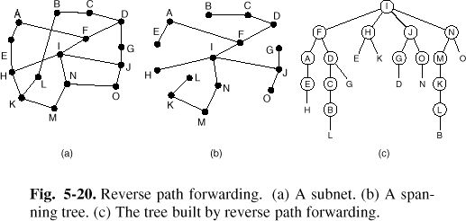

Routing

* Multicast: Sending packets to a group of nodes => Group

management required

* Routers must know to which groups their hosts belong
* Each router computes spanning tree for each supported group

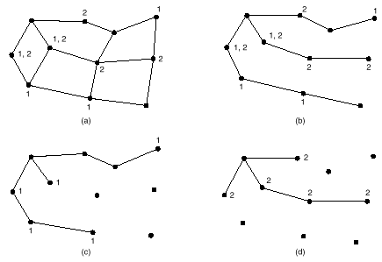

* Multicast packets are then forwarded to appropriate spanning trees

only

* When multiple spanning trees share some paths, trees need to be pruned to limit the packet forwarding only to the relevant routers

Data

3

* Ad Hoc Networks: Network of nodes that just happens to be near each other. Nodes can move and start/stop working arbitrarily. Examples:
  + Military vehicles on battlefield. (No infrastructure.)
  + A fleet of ships at sea. (All moving all the time)
  + A gathering of people with notebook computers.
* Fixed-wire Routing techniques can’t be used anymore
* Several methods have been proposed for ad hoc routing. Examples

are:

* + Dynamic Source Routing (DSR)
  + Ad hoc On-demand Distance Vector (AODV) Routing
* Key issue for Ad Hoc routing methods is that routes are calculated

on-demand to save bandwidth and battery life

* 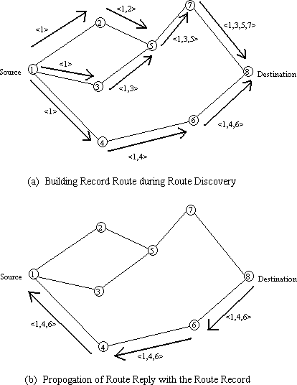On Demand routing protocol designed to restrict the routing overhead in ad hoc networks
* Route Request (RRQ) packets are generated by source and flooded in the network to inquire about a possible route to destination
* Each Route Request carries a sequence number generated by the source node and the path it has traversed.
* Each node, upon receiving a RRQ packet:
  + Checks the sequence number, records it and checks it to avoid forwarding duplicates
  + Checks time to live (TTL) of the packet to avoid forwarding old packets.
  + Adds its own ID to the packet
  + Rebroadcasts the packet to its neighbors
* Destination node replies to the source node using the trace ID of the first arrived RRQ packet.
* Source sends its data packets with a header containing the entire routing path. (That is why it is called source routing)

## Ad-hoc On-demand Distance Vector (AODV) Routing

* Node A constructs a ROUTE REQUEST (RRQ) packet and broadcasts it.
* RRQ Contains:
  + Request ID: a local counter maintained separately by each node, incremented for each RRQ

packet it sends

* + {Source Address, Request ID} uniquely identify the RRQ packet
  + Destination Sequence Number (Dest_Seq#): Number identifying the last known value of Route Reply (RRP) from the desired destination
* Each node that hears the RRQ discards it if it is a duplicate
* Then it looks in the route table. If there is a fresh route to the destination, it sends a RRP to the source with the info (Saying: Send the packet to me and I’ll route it!)
* Fresh route: Dest_Seq# of the RRQ is larger than the Dest_Seq# that exist in

its routing table

* If it does not know the route, it increments the Hop count and re-broadcasts it.
* It also extracts the source data and uses it for reverse routing (Everybody

knows where is A)

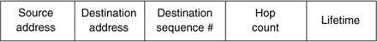

* The message goes up to the destination (In this example, node I)
* I builds an RRP, where the Hop count, source and destination address are

copied from RRQ,

* Dest_Seq# is copied from its current local counter value
* Life Time: Controls how long the route is valid
* Packet is sent back to the source address.
* In the reverse path, every node knows how to get back to the source.

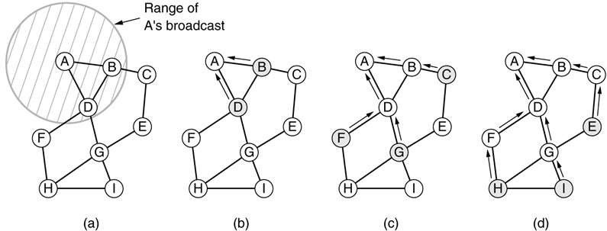

Data

Communicatio

3

7

* Routing info should be updated regularly because of node’s changing status
* Periodically, each node sends a Hello message to its neighbors
* If no response to Hello or no response to a data packet, assume the

neighbor is dead

* Active neighbors of node D: The neighbors that depend on D for routing

their packets.

* When a neighbor goes down, the affected active neighbors are informed of the event. Local routing table is modified to delete the route passing through the dead node.
* Each of those nodes in turn would notify their affected active neighbors of

the event.

* The routing tables are modified all over the nodes and invalid routes are purged.

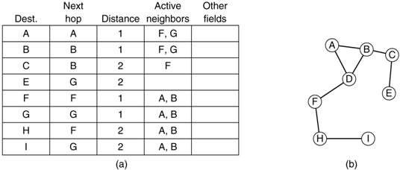

Data 3

Communicatio 7

* + Problem: Network performance severely degrades at high load
  + Examples of Reasons:
    - N to 1 communication: ***Hot-spot***
    - Sudden burst of traffic

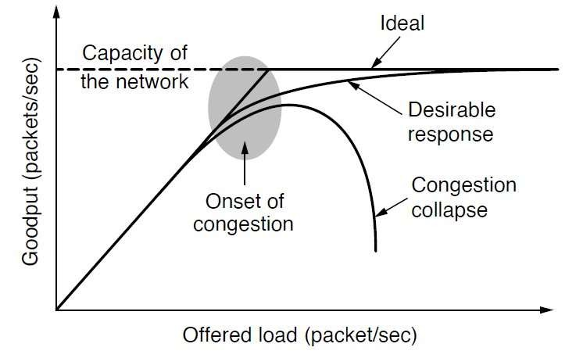

Data

3

* What is the difference between congestion control and flow control
* Congestion control
  + Global issue (network)
  + Indirect feedback
  + Sometimes slowdown messages are used
* Flow control
  + Local issue (line, point-to-point connection )
  + Direct feedback from neighbor
* Time Scale of applying congestion control techniques

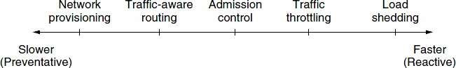

* Systems can be controlled by an open loop or a closed loop mechanism
* Open loop: no feedback; solve problems at design time (to make sure they

never occur; worst case design)

* Open loop issues:
* No regard to current state of network
* When to accept or discard new traffic? (Admission Control)
* Closed loop: Monitor the network on congestion
* Metrics: % discarded packets, queue length, # timed out packets, average delay
* Pass this information to right place
* Feedback packets: increase load
* Reserved bit field in header of every packet
* Probe packets can be sent periodically (ask about congestion)
* Adjust system operation
* Avoid oscillation (proper response time needed)
* Increase number of resources
* Decrease load
* Open loop policies can be applied at

different layers

* ***Data link layer policies***
  + Retransmission creates extra packets
    - Tune time out time
* ***Transport layer policies***:
  + Similar as previous policies
  + Choose proper time-out value for sender
    - Use selective repeat instead of go back n

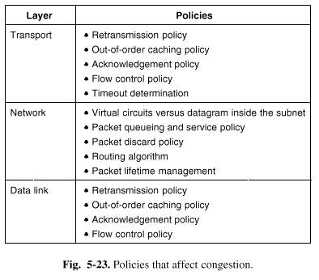

* Acknowledgement policy
  + Use piggyback
* Tight flow control (small window)
* ***Network layer policies***:
  + Any congestion control policies work only with virtual circuits, e.g.. reserving space
  + Routing
    - Spread traffic
    - Avoid hot spots
  + Discard policies
    - Remove long life-time packets

Data 3

Communicatio 8

* Congestion Control in Virtual Circuit subnets:
  + Use Admission Control to prevent congestion
    - If there is congestion, don’t accept new traffic.
    - Reserve the necessary resource along the data path to

prevent congestion

* + Negotiate a new VC that does not pass through the

congested area

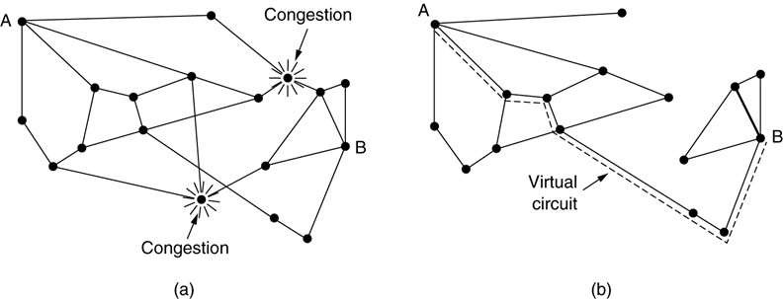

Data

Communicatio

3

8

## subnets

###### Estimate congestion u by sampling certain activity *f*

(e.g. Line utilization) on each outgoing line

###### Calculate u using:

*unew*  *auold*

###### Warning bit

 (1 *a*) *f*

* + Set a bit in the ip payload indicating that there is congestion along the data path. (Give warning when u > threshold)
  + The transport entity copies this bit in the acknowledge and

send it back to the source

* + The source can estimate the congestion by measuring the

fraction of ACKs it receive with a congestion bit indication

Data 3

Communicatio 8

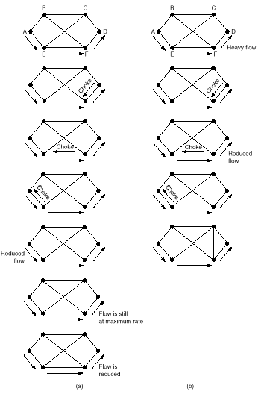

* Choke packets

subnets

* + Don’t wait for the destination to act. It may

be too late!

* + Each router sends a choke packet to source when in warning state.
  + Source reduces the load by %X. waits for a period of time and if there was no more choke packets, goes back to normal operation
* Hop-by-hop choke packets
  + Choke packets may take a long time to cause effect
  + Solution: Choke packets should not effect the source host only, but also intermediate routers
  + Routers reduce traffic in certain direction
  + More buffer space required at routers !!

Data Communication Networ

ks 50

* Load Shedding
  + Allow routers to discard packets
  + What‘s the selection criterion ?
  + Use packet priority
    - Use priority field to decide which packet to drop
    - Users should pay more for higher priority packets
* It is best to drop packets as soon as there is congestion
* If there is congestion in a particular port, it is difficult to know whose fault it is (Or who is the source that has caused the congestion)
* Don’t send choke packets as it can add to the congestion
* TCP would slow down if packets are dropped (Reduced traffic rate from the source). This is implicit feedback from the network about its status.
* This is a proactive buffer management approach in which the router discards one or more packets before the buffer becomes completely full
* Average Queue Length (*avg*): Moving average of the Queue length

in the past

𝑎𝑣𝑔 𝑡 + 1 = 𝑎𝑣𝑔𝑡  × 1 − 𝛼 + 𝐿(𝑡) × 𝛼

* Packets are marked with a probability P as a function of *avg*
* The probability that a packet is marked from a particular connection is roughly proportional to that connection’s share of the bandwidth at the router.
* The minimum and maximum thresholds minth and maxth are determined by the desired average queue size.
* The average queue size that makes the desired tradeoffs such as the tradeoff between maximizing throughput and minimizing delay depends on network characteristics

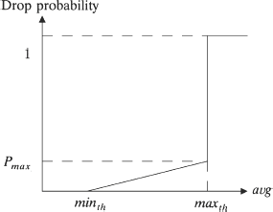

###### Traffic shaping is used to avoid bursty traffic

* + Regulate the average rate on server side
  + Negotiate a contract between sender and network. (Service

Level Agreement (SLA))

* + Specially important for real-time applications
* ***Traffic control***
  + Leaky bucket
  + Token bucket
  + Hybrid solution
* Leaky bucket algorithm
  + Sender puts packets or bytes in a queue
  + When queue is full the input is discarded
  + Queue output data at constant packet or byte rate
  + Equal to a single-server queuing system with constant service time

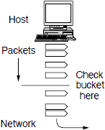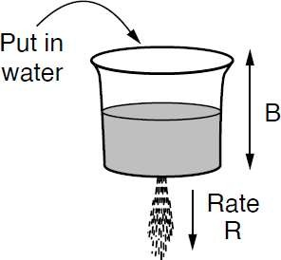

## Bucket

* Token bucket algorithm
  + Bucket holds tokens, generated 1 per T sec. up till certain max. value
  + Idle host time builds up ‘transmission rights’ (= tokens)

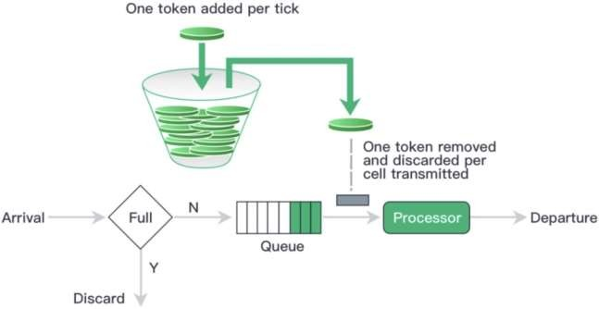

## Traffic Control

Example

* (a) Input to a leaky

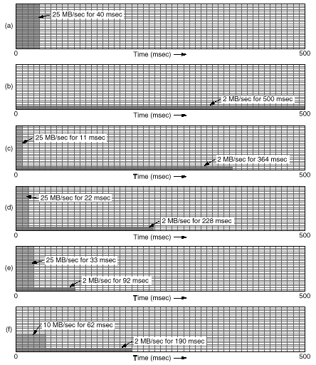

bucket.

* (b) Output from a leaky

bucket.

* Output from a token

bucket with capacities of

* + (c) 250 KB,
  + (d) 500 KB,
  + (e) 750 KB,
  + (f) Output from a 500KB token bucket feeding a 10-MB/sec leaky bucket.

Data 3

## Reservation

* Resource Reservation
  + To provide QoS, some sort of fixed path for the flow seems to be necessary
  + The idea: Reserve critical resources along the path of a flow
* Example for resource relation:
  + Mean processing capacity of the

processor, =106 packets/sec

* + Mean arrival rate of packets to the

processor (Poisson distribution),

=0.95 106 packets/sec

* + Mean delay experienced by a packet is:

● 1 1

* + Critical Resources:
    - Bandwidth

❒    *T*    1 

* + - Buffer space
    - CPU processing cycle (This can be tricky)

*T*  1 sec

1

1 0.95

 20 sec

* + - * So, the port bandwidth, buffer space

requirement and processing capacity all are related and impact QoS parameters.

* The flow can be specified in multiple ways.
* Sender generates the flow spec and sends it to the destination
* Routers along a flow-path will study the flow parameters, reserve enough resources and reduce the requested level of service if they can’t meet it.
* At the other end, a decision will be made on the provided QoS to the flow (control the flow admission by reservation of resources)
* An example of flow specification (RFC2210):
  + Token Bucket Rate (Bytes/sec) (Maximum sustained transmitter rate)
  + Token bucket size (Bytes) (Maximum burst size)
  + Peak data rate (Bytes/sec)
  + Minimum packet size (Bytes)
    - CPU cycles are used for each processed packet regardless of its size. This will help the router in its CPU allocation decision
  + Maximum packet size (Bytes)
    - Used for buffer allocation decision
* If there is a congested router, it marks the IP packets.
* Receiver sends a congestion notification on the reverse path to notify the sender so it can reduce its traffic rate temporarily.

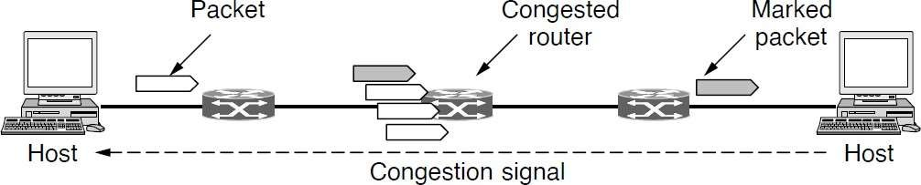

* If multiple sources compete for the same destination port of a router, then the most aggressive sender can block all others
* To remedy that, Fair Queuing algorithm was proposed:
  + Go round robin around among senders, send one packet of each source on the

destination port.

* What if packet sizes are different?
  + Go round robin, byte by byte on packets. When a packet got all its credits, send it

out

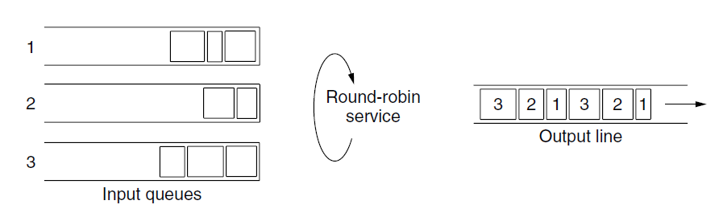

###### We can assign weight to queues and consider the length of packets to allow fair service.

* Priority of service is determined by calculating the virtual finish time of each packet.

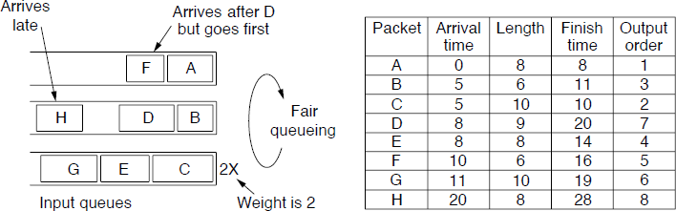

* For audio/video streaming applications, variance of delay (Jitter) should be controlled

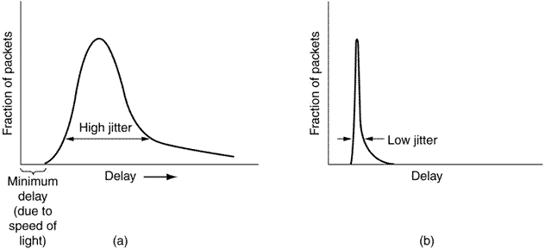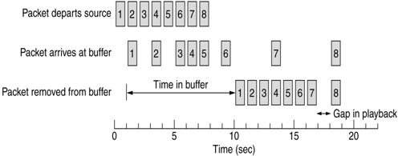

* Buffering at the destination can be used to reduce the effects of network-induced Jitter on the packet arrival time.

Data 4

Communicatio 0

* QoS parameters:
  + Reliability
  + Rate/Throughput
  + Delay/Jitter
* Applications require different types of QoS

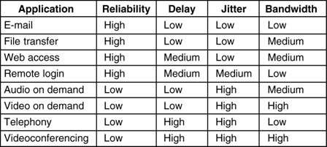

* How to connect and route on networks using different protocol

stacks

* + Different protocols will always exist (vendor policies)
  + Cheaper networks encourage variety (it becomes a departmental

decision)

* Interconnection of different networks is called an **internet**

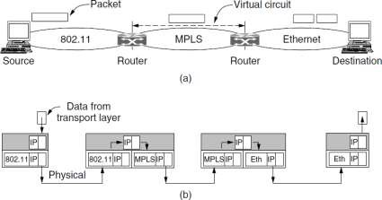

* Various boxes connecting networks or segments are used:
* Physical layer: Repeaters
  + Copy individual bits between cable segments
* Data link layer: Bridges, L2 Switches
  + Store and forward data link frames between LANs
* Network layer: Multi-protocol routers
  + Forward packets between dissimilar networks (often called gateways)
* Transport layer: Gateways
  + Connect byte streams in the transport layer e.g. TCP socket connection
* Application gateways:
  + Proxy servers
  + Firewall
* How networks differ?
  + Connectionless service may change the order of packets
  + Protocol conversion: e.g.. From IP to IPX
  + Address conversion (range, hierarchy)
  + Quality of service may or may not be provided

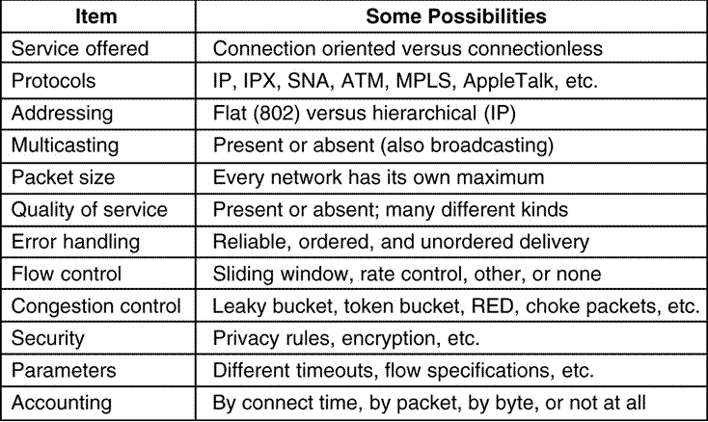

* Different packet length
* Different methods

(if at all) for flow control,

security, accounting, etc.

Data

4

## g

* Tunnelling
  + If source and destination hosts are on same type of network but there is

a different network in between, *tunnelling* can be used

* + Packet encapsulation performed by multi protocol router

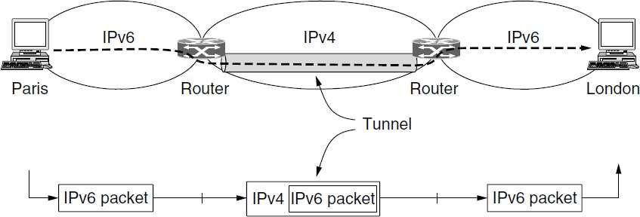

* All networks impose maximum packet payload size (Example: 65,515 bytes in IP)
* Multi protocol routers (gateways) may fragment packets. Two options:
  + Transparent :
    - Packet leaves network unfragmented and fragments have to use same route
  + Non-transparent
    - Fragments reassembled at destination host
    - All hosts must support this assemble feature
    - 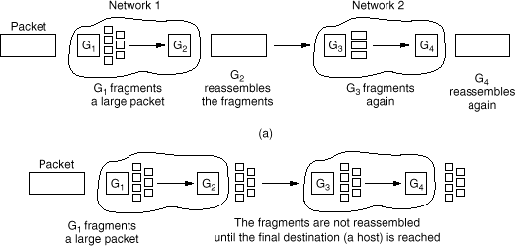Added overhead for all packets
* Problem: if one fragment lost, end-to-end retransmission required
* Another approach: choose smallest

unit which every network can handle

* Always chop large packets to this

size and follow the same procedure

* Internet: The Internet is an interconnected collection of many networks
* IP = Internet Protocol (provides datagram service)
* Transport layer breaks messages up in datagrams of about 1500 bytes
* Datagrams are reassembled at destination host (by Transport layer)

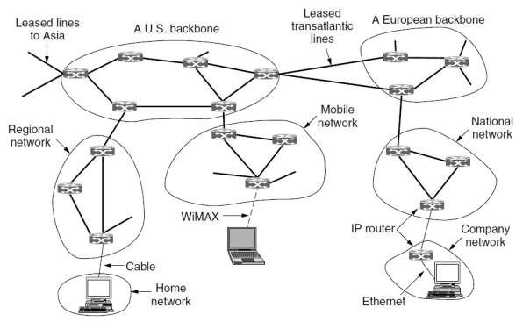

Data

4

* IP datagram contains a header of

minimal 20 bytes, containing fields for:

* + Version (= 4 for IPv4)
  + IHL: internet header length
  + Differentiated services
    - Distinguish between different classes of service.
* Total length
* Identification
  + Label fragments belonging to

same datagram

* DF (do not fragment) bit
  + Note: datagrams < 576 bytes should be supported

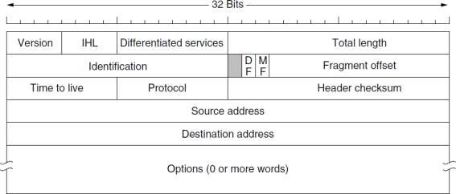

* MF (more fragments) bit: is this the

final fragment?

* Fragment offset: Location of the fragment within the datagram
* TTL (time to live)
  + Counter decremented at each hop
  + Discard datagram when zero: send

control message back to source

* Protocol field:
  + Indicate which transport layer protocol

to use: e.g.. UDP or TCP

* + Allows direct delivery to right TL protocol handler
* Header checksum
* Source and Destination IP addresses

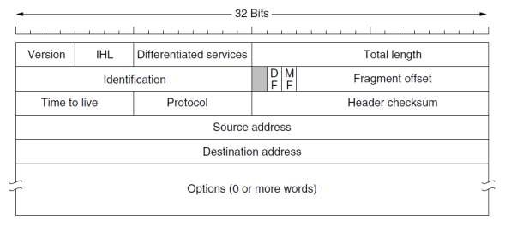

* Every IP-host (on the net) needs unique 32-bit address
* Assignment by ICANN (Internet Corporation for Assigned Names and

Numbers)

* Five classes: A - E
* Dotted decimal notation: Example: 129.245.96.122

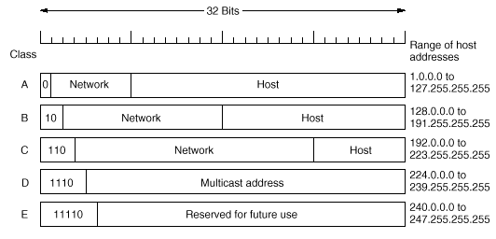

* A single class A, B or C address refers to one network.
* The network can be designed to contain subnets that can be used for internal routing.

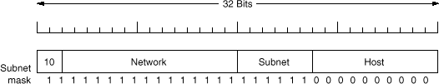

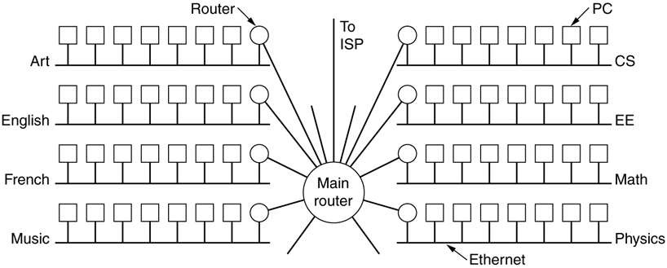

Data

4

## performed:

* Normally router contains table with the following type of addresses
  + (network#, 0)
  + (this network#, host#)
  + This is a 2-level hierarchy
  + If incoming network address not listed send packet to default router (with

more extensive table)

* With subnetting (for internal use only):
  + Router table contains additional entries:
    - (this network#, subnet#, 0)
    - (this network#, this subnet#, host#)
  + 3-level hierarchy
  + Use host masking to quickly determine subnet
* Decision on how many bits to use for subnet and how many bits for Host addresses is an internal design parameter for each company or university
* Idea: assign the addresses on a variable-sized blocks, without regard to classes
* Use Masking to quickly determine outgoing link
* Masking example:
  + Assume company needs 2k addresses, and gets: 194.24.0.0 - 194.24.7.255 (8 C blocks)
  + Mask = 255.255.248.0 (248 = 1111.1000b)
  + CIDR Notation: 194.24.0.0/21
* Routing tables contain (base address, mask) triples
* Incoming address is masked with each entry
* If: (address AND mask) = base address, send packet to appropriate output

port

* The router compares the destination IP address, bit-by-bit, with the

entries in the routing table.

* The entry that has the longest number of network bits that match the

IP destination address is always the best match (or best path)

* + Example: Packet has a destination address 192.168.1.33
  + Which path to choose?

|  |  |
| --- | --- |
| Address | Converted Binary Address |
| 192.168.1.33 (destination IP address) | **11000000.10101000.00000001.001**00001 |
| 192.168.1.32/28 | **11000000.10101000.00000001.001**00000  (<–Best match) |
| 192.168.1.0/24 | **11000000.10101000.00000001.**00000000 |
| 192.168.0.0/16 | **11000000.10101000.**00000000.00000000 |

* Allow each host in the internal network to maintain a permanent private IP address.
* Replace the {TCP Source, IP source} addresses with {virtual TCP source, Virtual IP

source} of each outgoing IP packet

* On the reply, use the combination of TCP and IP addresses to lookup the local host
* Reserved NAT addresses
  + IP packets with these addresses should not appear on internet
  + 10.0.0.0 – 10.255.255.255/8 (16,772,216 hosts)
  + 172.16.0.0 – 172.31.255.255/12 (1,0478,576 hosts)
  + 192.168.0.0 – 192.168.255.255/16 (65,636 hosts)

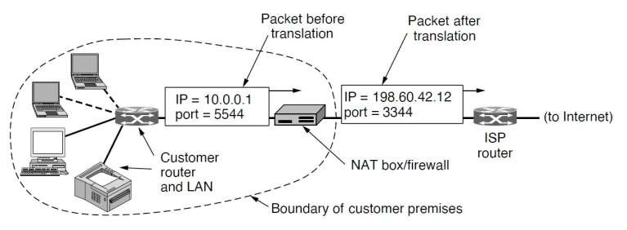

Data

4

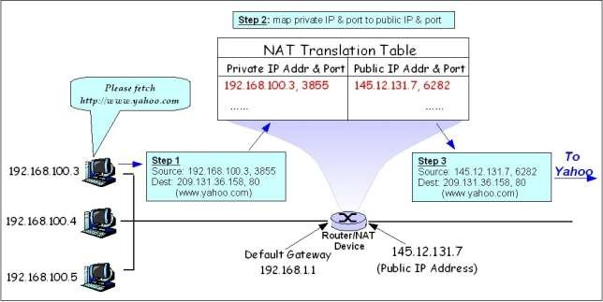

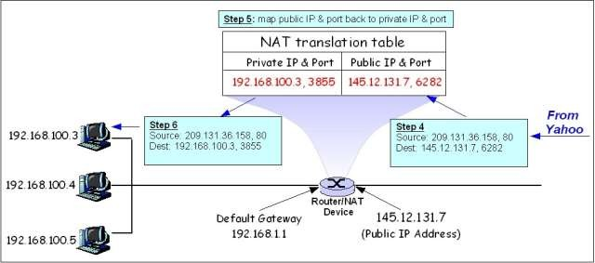

Data

4

## Planes

###### Network systems contain:

* + Data Plane
  + Control Plane
  + Management Plane

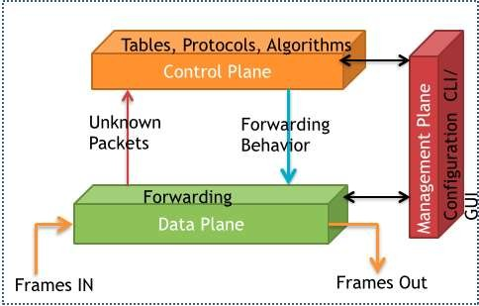

* Example of Internet Control protocols:
  + Internet Control Message Protocol (ICMP)
  + Address Resolution Protocol (ARP)
  + Dynamic Host Configuration Protocol (DHCP)
* A protocol to exchange messages between routers to allow

proper operation of the network

* Messages are embedded in IP packet

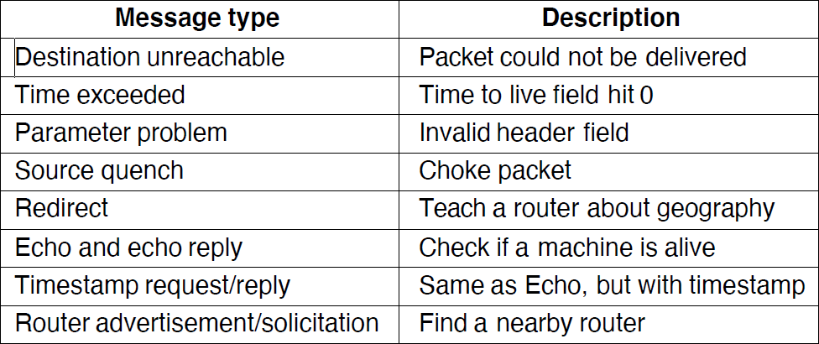

* The Address Resolution Protocol (ARP) is a communication protocol used for discovering the link layer address, such as a MAC address, associated with a given internet layer address, typically an IPv4 address
* Example:
  + System A broadcasts ARP Request message on LAN : give me the Ethernet address of 141.23.56.23
  + All LAN nodes receive the message, only the target unicasts the reply.
* Address mappings are cached temporarily

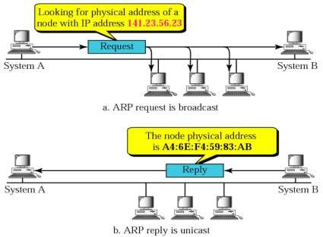

Data

Communicatio

4

2

* Remote Address Example: Host 1 wants to send information to Host 4
  + Host 1 uses ARP message; gateway responds
  + Host 1 Sends packet directly to gateway. (Host 1 must know the default (gateway)

Ethernet address)

* + Routers forward the packet to the destination LAN
  + On destination LAN ARP is used by the router again to get the destination

Ethernet address

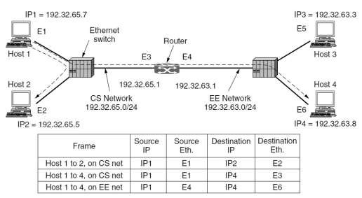

Data

4

Dynamic Host Configuration Protocol (DHCP)

* DHCP: Dynamic Host Configuration Protocol (RFC 2131, 2132)
  + A client-server architecture for configuration of host IP addresses
  + A newly booted workstation broadcasts a DHCP DISCOVER packet
  + The DHCP server replies by giving it an IP address
  + The IP address is leased for a period of time.
  + Host must ask for renewal of the lease before it expires.
  + If the lease expires, the IP is returned to the pool of available IP

addresses.

* + If DHCP server is not on the same LAN, a DHCP proxy can relay the DHCP messages over network to the DHCP server.
  + DHCP proxy should know the IP address of the DHCP server.

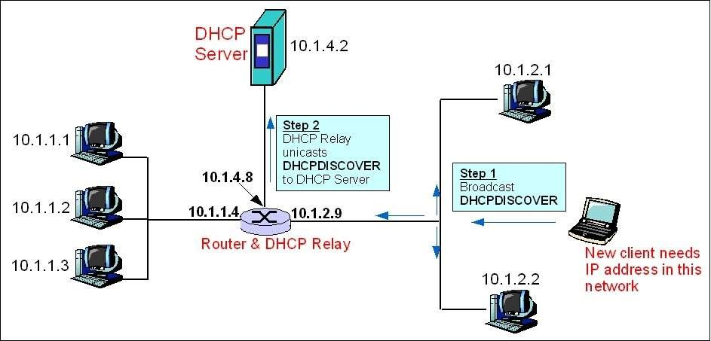

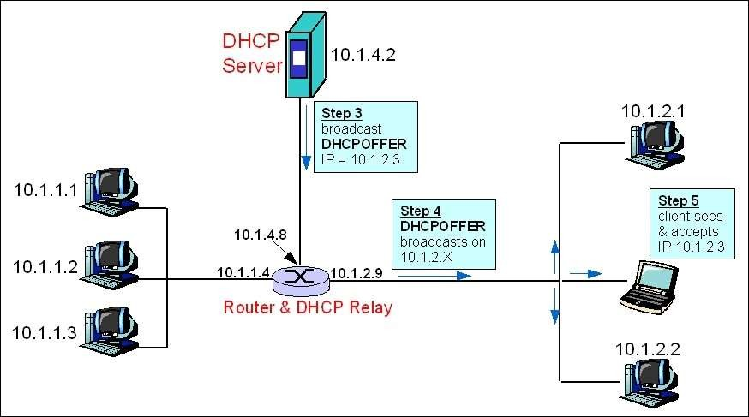

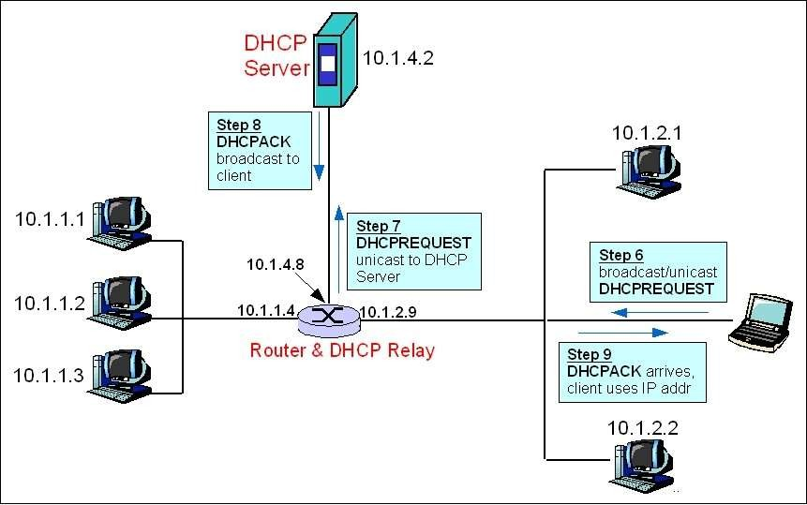

## Plane

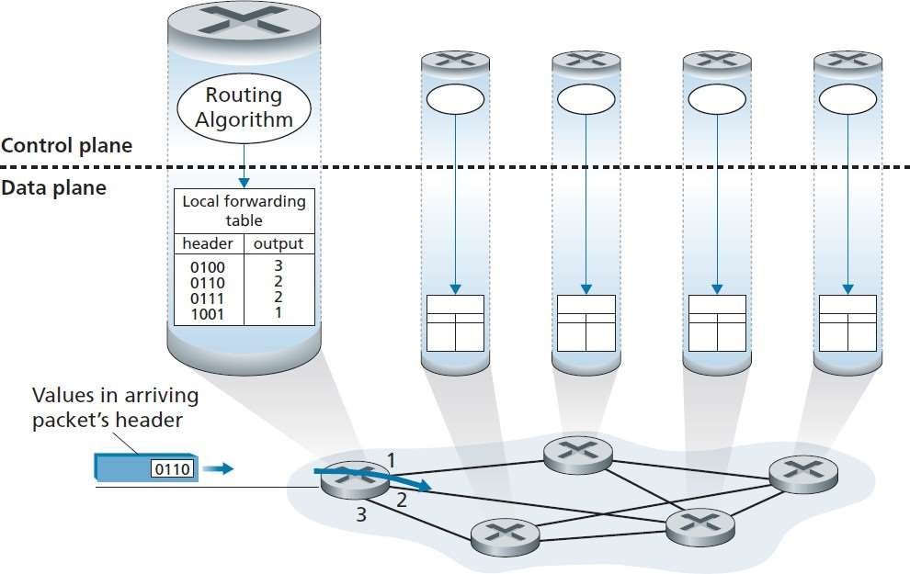

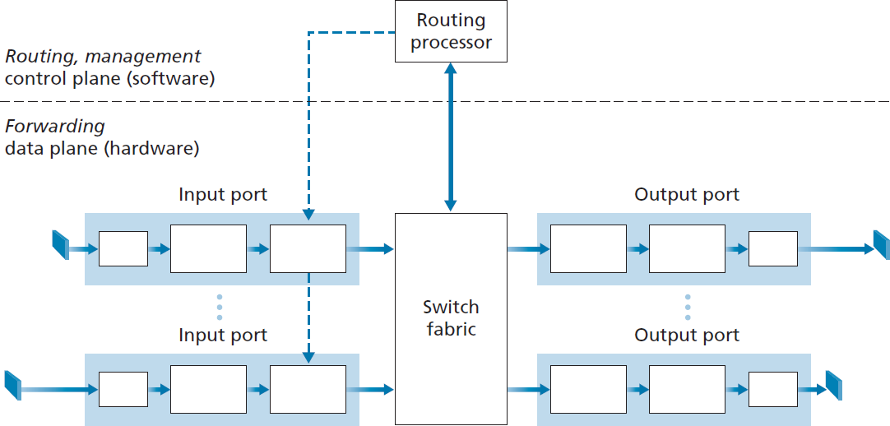

###### Line Termination

* Data Link Processing

###### Address Lookup

* Queuing

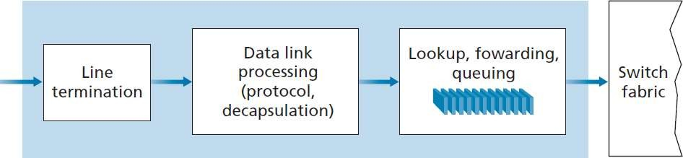

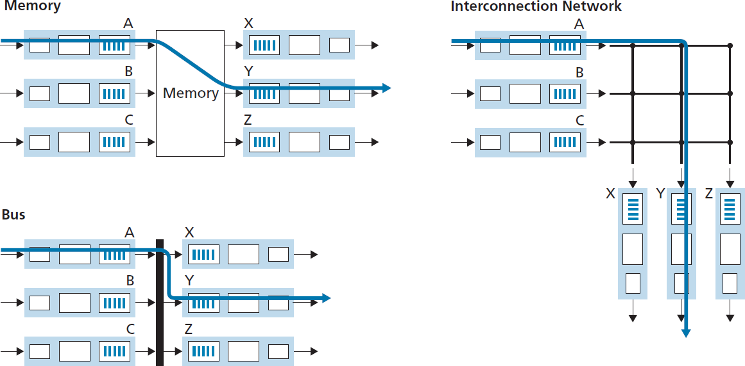

###### Queuing (Buffer management)

* Data Link Processing

###### Line Termination

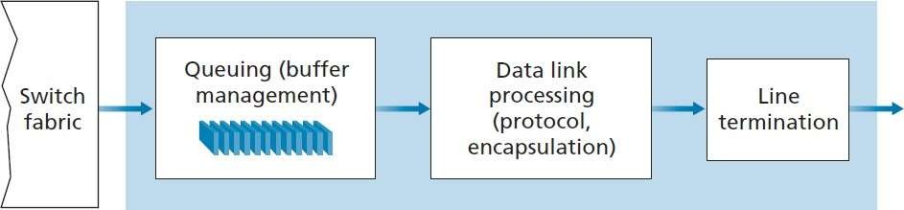

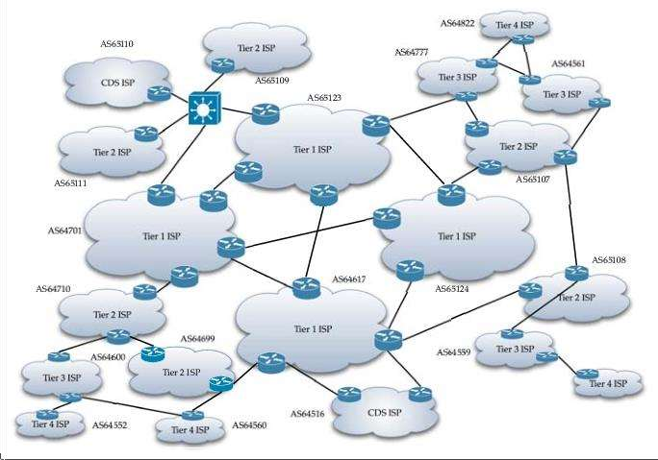

* Internet is made up of many independent networks or ASs (Autonomous Systems) that are connected.

Data 4

Communicatio 3

Intradomain Routing (Interior Gateway Protocol)

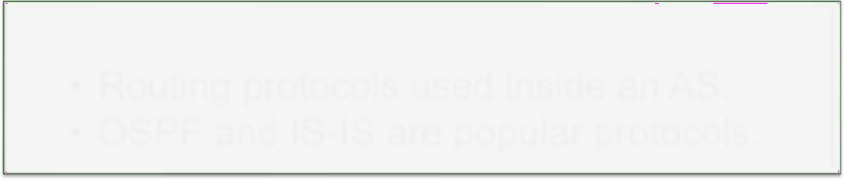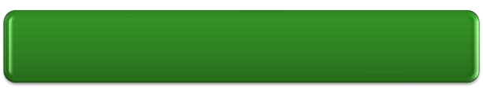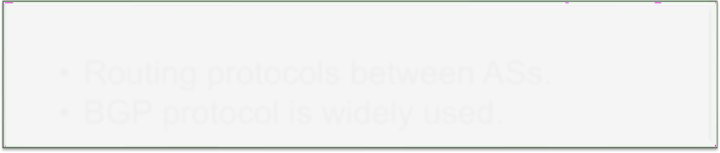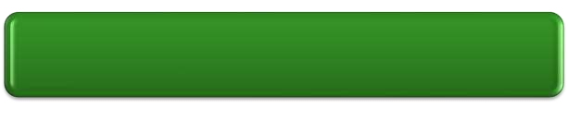

* Routing protocols used inside an AS.
* OSPF and IS-IS are popular protocols.

Interdomain Routing (Exterior Gateway Protocol)

* Routing protocols between ASs.
* BGP protocol is widely used.

## (OSPF)

* OSPF is a link-state protocol that uses flooding of link- state information and a Dijkstra’s least-cost path algorithm.
* With OSPF, each router constructs a complete topological map (that is, a graph) of the entire autonomous system.
* Each router then locally runs Dijkstra’s shortest-path algorithm to determine a shortest-path tree to all subnets, with itself as the root node.
* Security.
  + Exchanges between OSPF routers (for example, link-state updates) can be

authenticated.

* + With authentication, only trusted routers can participate in the OSPF protocol within an AS, thus preventing malicious intruders from injecting incorrect information into router tables.
* Multiple same-cost paths.
  + When multiple paths to a destination have the same cost, OSPF allows multiple paths to be used

## (OSPF)

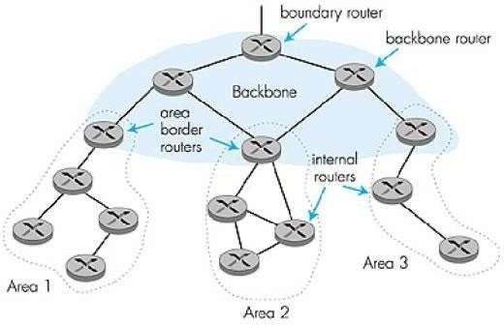

* An OSPF autonomous system can be configured hierarchically into areas.
* Each area runs its own OSPF link-state routing algorithm, with each router

in an area broadcasting its link state to all other routers in that area.

* Within each area, one or more area border routers are responsible for routing packets outside the area. Lastly, exactly one OSPF area in the AS is configured to be the backbone area.
* The primary role of the backbone area is to route traffic between the other

areas in the AS.

* The backbone always contains all area border routers in the AS and may

contain non-border routers as well.

* Inter-area routing within the AS requires that the packet be first routed to an area border router (intra-area routing), then routed through the backbone to the area border router that is in the destination area, and then routed to the final destination.

###### A decentralized protocol that is used to connect all ASs that are connected to form the internet.

* In BGP, packets are not routed to a specific destination address, but instead to CIDRized prefixes, with each prefix representing a subnet or a collection of subnets.
  + Router forwarding table entry example: (138.16.68/22,K)

where K is the interface number of the router.

###### BGP main objectives:

* + Obtain prefix reachability information from neighboring

ASs.

* + - BGP allows each subnet to advertise its existence to the rest

of the Internet.

* + Determine the “best” routes to the prefixes.
    - The best route will be determined based on policy as well as

the reachability information.

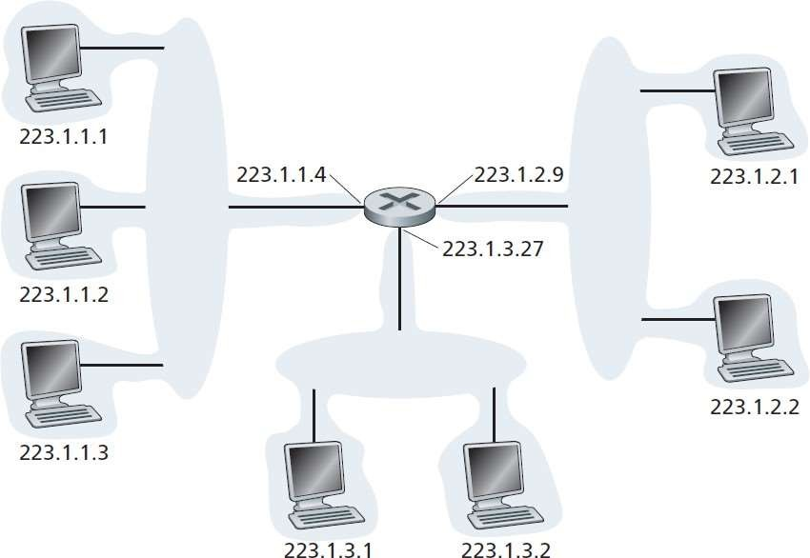

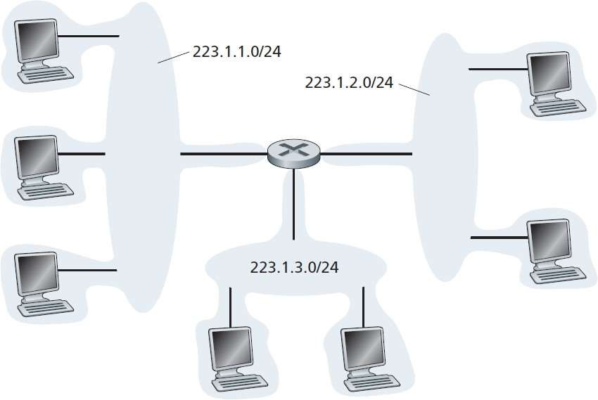

Hierarchical Addressing and Route Aggregation

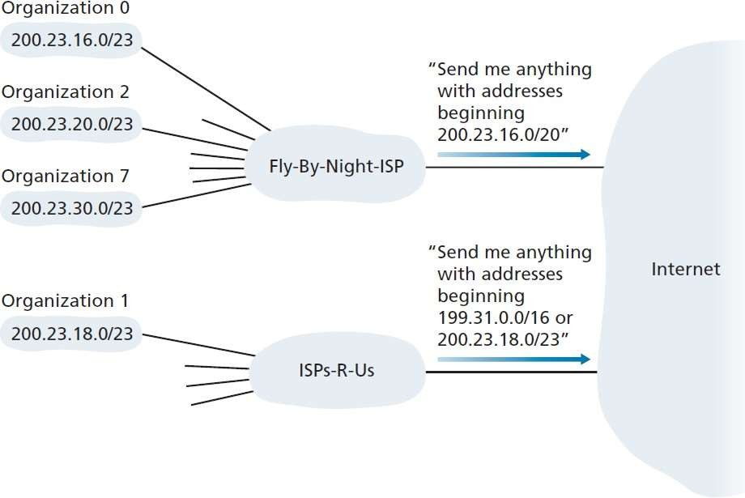

###### In BGP pairs of routers exchange routing information over semi-permanent TCP connections

* Each such TCP connection, along with all the BGP messages sent over the connection, is called a BGP connection.

###### Furthermore, a BGP connection that spans two ASs is called an external BGP (eBGP) connection

* A BGP session between routers in the same AS is called an internal BGP (iBGP) connection.

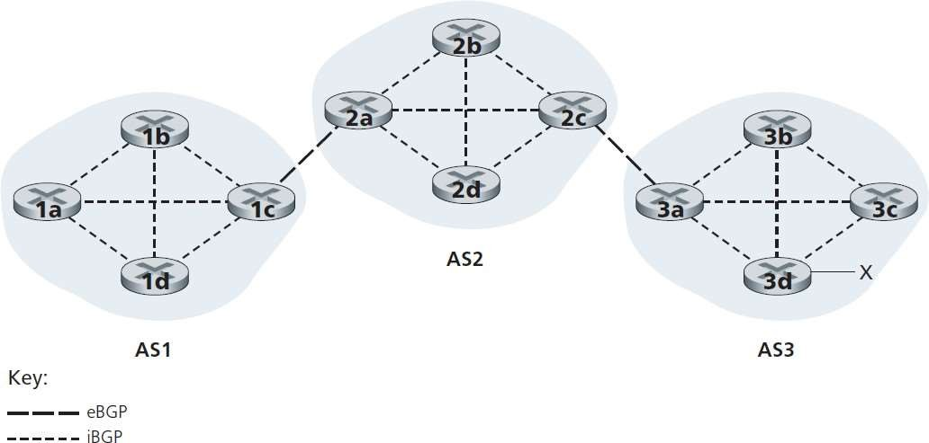

1. Gateway router 3a sends an eBGP message “AS3 x” to gateway router 2c.
2. Gateway router 2c then sends the iBGP message “AS3 x” to all the other routers in AS2, including to gateway router 2a.
3. Gateway router 2a then sends the eBGP message “AS2 AS3 x” to gateway router 1c.
4. Gateway router 1c uses iBGP to send the message “AS2 AS3 x” to all the routers in AS1.

* Now, all routers in AS1 know that the subnet x is

reachable via the path AS2-AS3-x

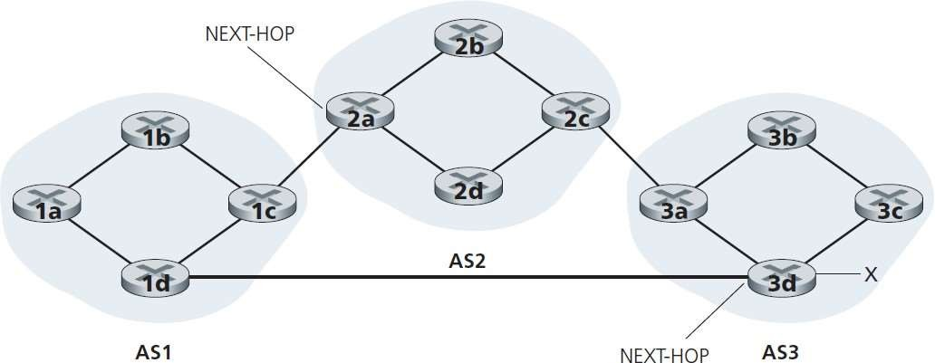

* When a router advertises a prefix across a BGP connection, it

includes with the prefix several BGP attributes.

* A prefix along with its attributes is called a route.
* Two of the more important attributes are AS-PATH and NEXT-HOP.
* The AS-PATH attribute contains the list of ASs through which the

eBGP advertisement has passed.

* The NEXT-HOP is the IP address of the router interface that begins

the AS-PATH.

* In this example, each router in AS1 becomes aware of two BGP

routes to prefix x:

* + IP address of leftmost interface for router 2a; AS2 AS3; x
  + IP address of leftmost interface of router 3d; AS3; x

###### A router learns all routes to a given prefix and performs route selection based on:

* + Local preference of the route which can be assigned based

on the policy of the network operator

* + Shortest AS path which is the lowest number of ASs in the

route

* + Shortest path from each router to the next-hop

###### One of the most important aspects of BGP is that it is designed so that network owners can apply their policy in routing.

* Examples of policy:
  + Any traffic flowing across an ISP’s backbone network must have either a source or a destination (or both) in a network that is a customer of that ISP.
  + Use AS1 instead of AS2 because it is cheaper.
  + Don’t use AT&T in Australia because performance is poor.
  + Traffic starting or ending at Apple should not transit Google
* To expand the feature set and capabilities of IP, in 1990 work on new protocol started with these requirements:
  + Support billions of hosts
  + Reduce routing table size
  + Simplify protocol (reduces processing power requirement in routers)
  + Better security (authentication

and privacy)

* + Multicasting
  + Mobile hosts
  + Allow protocol to evolve (room

for expansion)

* + Coexist with IPv4
* Important Features:
  + Longer addresses than IPv4: 16 byte addresses
  + Header simplification (fixed size of

40 bytes)

* + Better support for options
  + Improved Security capabilities
  + Support for packet priority
  + Support for pseudo connections

(using the flow label)

* + Support very long datagrams

## Features

ata Communication Networks 115

* Version: Always set to 6
* Priority: Handle packets with different classes of service
  + 0-7 non-real-time (flow controlled)
  + 8-15 real-time (no flow control)
* Flow: flow label which is used for flow-driven routing
* Payload Length: packets with size >64k are supported

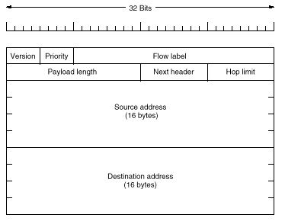

* Next Header: Headers can optionally be extended over multiple

packets.

D

* Multiprotocol Label Switching (MPLS) is a mechanism in high- performance telecommunications networks which directs and carries data from one network node to the next.
* MPLS makes it easy to create "virtual links" between distant nodes.

It can encapsulate packets of various network protocols.

* In an MPLS network, data packets are assigned labels. Packet- forwarding decisions are made solely on the contents of this label, without the need to examine the packet itself. This allows one to create end-to-end circuits across any type of transport medium, using any protocol
* MPLS requires a small overhead, while providing connection-

oriented services for variable-length frames.

Advanced

Communication

116

MPLS

**1a.** O**Exis**p**tin**e**g r**r**ou**a**ti**t**ng**io**pro**n**tocols (e.g. OSPF, IS-IS)**

**establish reachability to destination networks**

**1b. Label Distribution Protocol (LDP) establishes label to destination network mappings.**

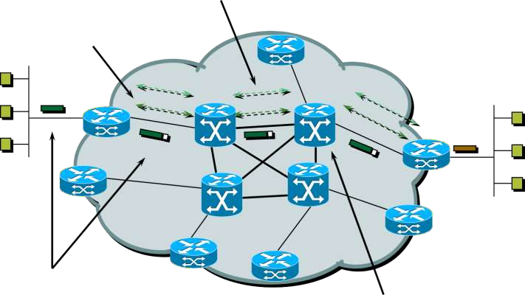

**4. Edge LSR at egress removes label and delivers packet**

1. **Ingress Edge LSR receives packet, performs Layer 3 value- added services, and “labels” packets**
2. **LSR switches**

**packets using label**

Advanced Data Netw**s**or**w**ks**apping** 117

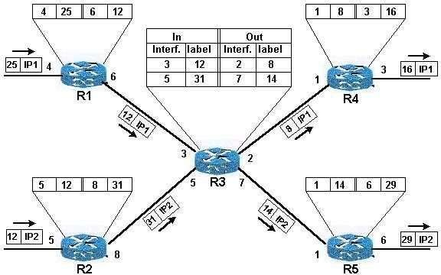

* Forwarding Equivalency Class (FEC)
  + The FEC is used to describe an association of discrete packets with a destination address and a class of traffic. It allows the grouping of packets into classes.
  + The matching of the FEC with a packet is achieved by using a label to identify each FEC. For different classes of service, different FECs and their associated labels are used.
* Label Switching Router (LSR)
  + Forwards MPLS packets using label switching
  + Capable of forwarding native IP packets
  + Executes one or more IP routing protocols
  + Participates in MPLS control protocols
  + A group of LSRs with the same MPLS level forms an MPLS domain.
* Label Switched Path (LSP)
  + The path through one or more LSRs followed by packets in a particular FEC is called a label-switched path
* Simplified header processing:
  + It is not necessary for MPLS routers to inspect the packet’s network layer headers.

Rather, they are only required to do a table lookup and label replacement.

* A network with a state
  + Packets that enter the network from different routers are distinguishable, so that

forwarding decisions that depend on the ingress router can be easily made.

* + This is not true of conventional forwarding, since packets are memoryless about their ingress routers.
* More flexible per packet operation
  + The label table of an MPLS switch may contain more information than just the next hop and the new label for a particular FEC.
  + For example, an entry may include the precedence or class of service predetermined

for the corresponding FEC.

* + On the contrary, conventional forwarding can only consider information encoded in the packet header.
* Create a Network Path for Traffic Engineering
  + To improve the performance it is sometimes desirable, rather than letting the route be chosen by dynamic routing algorithms from hop to hop in the network, to force a packet to follow a route that is explicitly chosen before the packet enters the network. This capability is necessary to support traffic engineering.

## Label

* Labels are assigned by downstream routers
* Labels are local to each path and change at each hop
* When there is a hierarchy in the MPLS network, labels can be stacked. Only top level labels are used to process the packet
* Label value contains:
  + Info for next hop
  + Operations to do on the label stack:
    - Swap label
    - Pop an entry off the label stack
    - Replace top label and then push another label

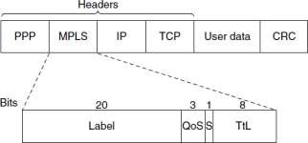

# Data Communication Networks Application Layer

DR.Eslami

Department of Electrical Engineering [Islamic Azad University،Science And Research Branch](https://srb.iau.ir/en)

* DNS is a hierarchical distributed database used to map host names

to IP addresses

* To map a name an application calls a (local) library procedure called

resolver

* The resolver sends a UDP packet to a local DNS server
* This server returns, possibly after consulting with other DNS

servers, the IP address to the application

* DNS Name Space
  + Naming scheme is hierarchical e.g. [www.sharif.ac.ir](http://www.sharif.ac.ir/)
    - ir is top level domain (TLD)
    - sharif is sub domain and represents all the nodes under it
  + Leaves of the tree represent domains which have no sub domain
  + Naming follows organizational boundaries, not physical (network) ones

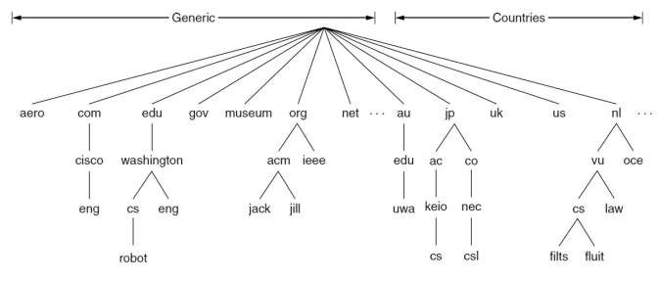

* Getting a name like sharif.ac.ir requires registration with the ac.ir

*domain manager*

* After that sub domains can be added freely: ee.sharif.ac.ir
* Names are case insensitive
* DNS Database
  + Every domain name has a set of corresponding ***resource records*** in the

database

* + For a single host: just record its IP address, but many other records exist
  + When a resolver gives name to DNS, it gets back the associated

resource records

* DNS resource record
  + Domain-name: search key
  + Time-to-live: indicates how stable the entry is in terms of seconds

(needed for caching) e.g. 86400 seconds (= 1 day)

* + Type: different types of resource records have been defined
  + Class: always IN for internet information
  + Value: Returned value
* Example:
  + relay1.bar.foo.com, static, A, IN, 145.37.93.126
  + This means: IP Address of relay1.bar.foo.com is 145.37.93.126

|  |  |  |  |  |
| --- | --- | --- | --- | --- |
| Domain name | Time to live | Type | Class | Value |

Root DNS servers

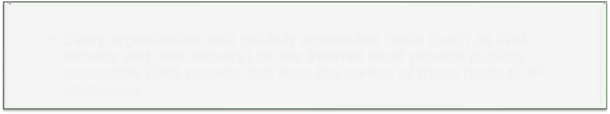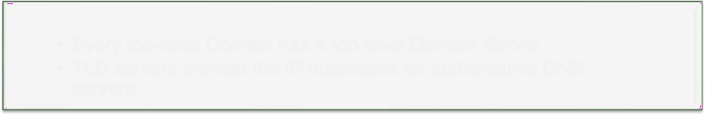

* Root name servers provide the IP addresses of the TLD servers.

Top-level domain (TLD) servers

* Every top-level Domain has a top-level Domain Server
* TLD servers provide the IP addresses for authoritative DNS servers.

Authoritative DNS servers

* Every organization with publicly accessible hosts (such as Web servers and mail servers) on the Internet must provide publicly accessible DNS records that map the names of those hosts to IP addresses.
* The DNS name space is split into non overlapping zones.
* A zone usually has 1 primary name server, and multiple secondary

ones, which get their information from the primary one.

* Note: cs.yale.edu and yale.edu have separate name servers

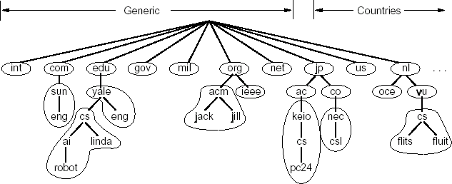

* The workstation *annie* asks its configured name server, *dakota,* for

[*www.nominum.com*](http://www.nominum.com/)*’s* address



dakota.west.sprockets.com

What’s the IP address of [www.nominum.com?](http://www.nominum.com/)

annie.west.sprockets.com



ping [www.nominum.com.](http://www.nominum.com/)

* The name server *dakota* asks a root name server, *m*, for [*www.nominum.com’*](http://www.nominum.com/)*s*

address



m.root-servers.net

dakota.west.sprockets.com



What’s the IP address of [www.nominum.com?](http://www.nominum.com/)

* The root server *m* refers *dakota* to the *com* name servers
* This type of response is called a “referral”



m.root-servers.net

dakota.west.sprockets.com Here’s a list of the com name servers. Ask one of them*.*



* The name server *dakota* asks a *com* name server, *f*, for

[*www.nominum.com*](http://www.nominum.com/)*’s* address

What’s the IP address of [www.nominum.com?](http://www.nominum.com/)



m.root-servers.net

dakota.west.sprockets.com



* The *com* name server *f* refers *dakota* to the *nominum.com* name servers

m.root-servers.net



Here’s a list of the nominum.com name servers.

Ask one of them*.*

dakota.west.sprockets.com



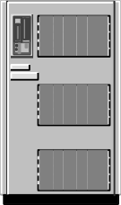dakota.west.sprockets.com

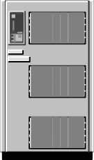m.root-servers.net

Here’s the address of [www.nominum.com](http://www.nominum.com/)

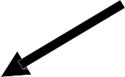

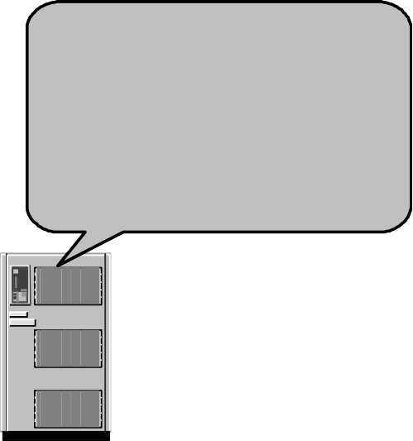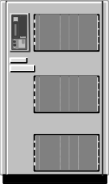f.gtld-servers.net

annie.west.sprockets.com

ping [www.nominum.com.](http://www.nominum.com/)

* The name server *dakota* asks a *nominum.com* name server, *ns1.sanjose*, for

[*www.nominum.com’*](http://www.nominum.com/)*s* address

What’s the IP address of [www.nominum.com?](http://www.nominum.com/)

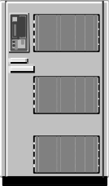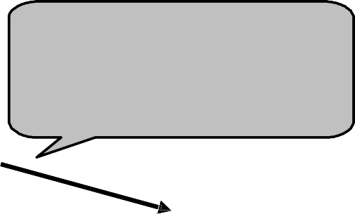

dakota.west.sprockets.com



m.root-servers.net

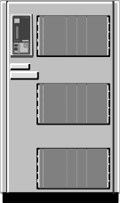ns1.sanjose.nominum.net

f.gtld-servers.net

annie.west.sprockets.com

ping [www.nominum.com.](http://www.nominum.com/)

* The *nominum.com* name server *ns1.sanjose* responds with

[*www.nominum.com*](http://www.nominum.com/)*’s* address



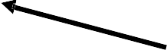 m.root-servers.net dakota.west.sprockets.com

ns1.sanjose.nominum.net

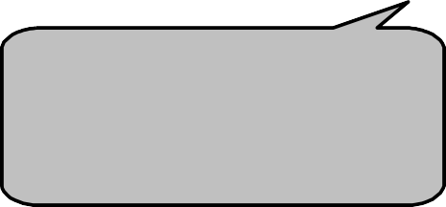

Here’s the IP address for [www.nominum.com](http://www.nominum.com/)

f.gtld-servers.net

annie.west.sprockets.com

ping [www.nominum.com.](http://www.nominum.com/)

* + The name server *dakota* responds to *annie* with [*www.nominum.com*](http://www.nominum.com/)*’s*

address



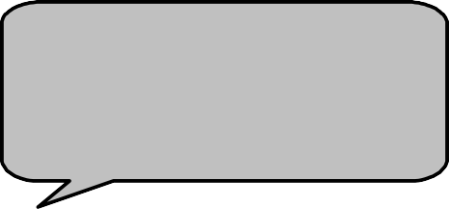

Here’s the IP address for [www.nominum.com](http://www.nominum.com/)

dakota.west.sprockets.com





ns1.sanjose.nominum.net

m.root-servers.net



f.gtld-servers.net

annie.west.sprockets.com

ping [www.nominum.com.](http://www.nominum.com/)

* DNS Records are cached in your computer as well as your ISP

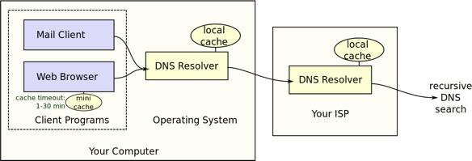

* Important E-mail components:
  + Simple Mail Transfer Protocol (SMTP).
  + Main Server

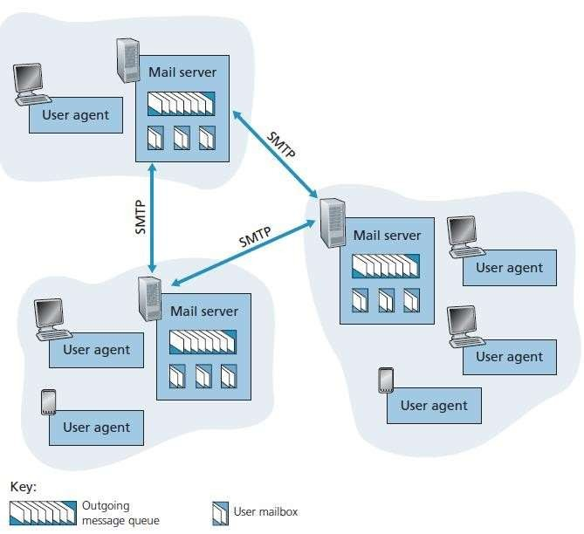

* + User agents

Communicatio 47

n Networkss 5

(SMTP)

* SMTP is the principal application-layer protocol for Internet

electronic mail.

* It uses the reliable data transfer service of TCP to transfer mail from

the sender’s mail server to the recipient’s mail server.

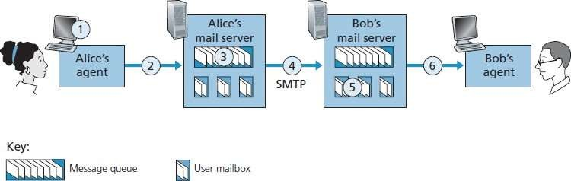

Post Office Protocol (POP)

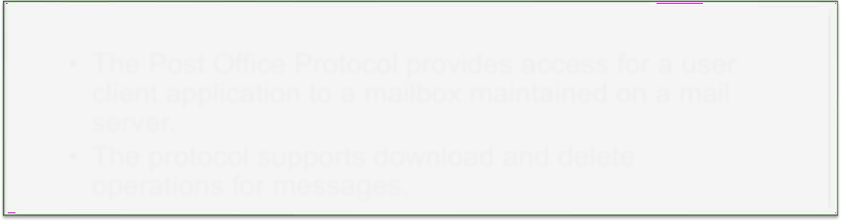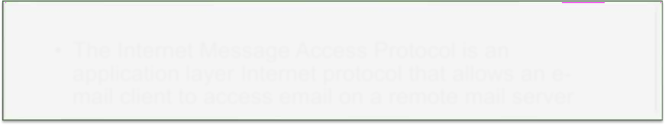

* The Post Office Protocol provides access for a user client application to a mailbox maintained on a mail server.
* The protocol supports download and delete

operations for messages.

Internet Message Access Protocol (IMAP)

* The Internet Message Access Protocol is an application layer Internet protocol that allows an e- mail client to access email on a remote mail server
* Web is framework for accessing linked documents
  + Web servers provide documents (pages)
  + Web browsers view the documents
  + Pages are linked using hypertext techniques
* Web idea comes from CERN, Geneva (1989)
* WWW consortium was set up by CERN and MIT (1994) to organize and standardize

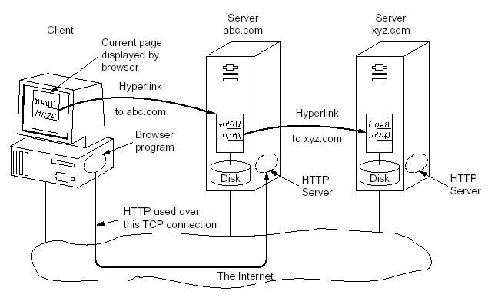

Communicatio 47

n Networkss 8

* Web pages are viewed by client-side programs called “browsers”

(Chrome, Firefox)

* Browsers key functions:
  + Interact with the web servers using Hyper Text Transfer Protocol (HTTP) to fetch the desired content and data
  + Display the content in a proper format to the user
  + Interact with the user to receive user data (click on the page, typed text, etc)
  + Interact with the helper applications on the user computer to handle the content properly

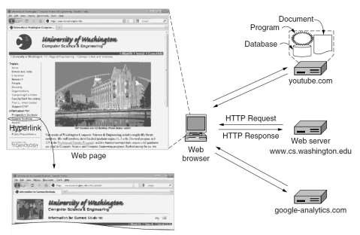

* + Caching of the contents

Communicatio 47

* Hypertext transfer Protocol : HTTP
  + HTTP is ASCII based protocol
* Two types of requests:
  + without or with protocol version
  + e.g.: *GET /hypertext/WWW/pages.html HTTP/1.0*
* Several built-in HTTP request methods

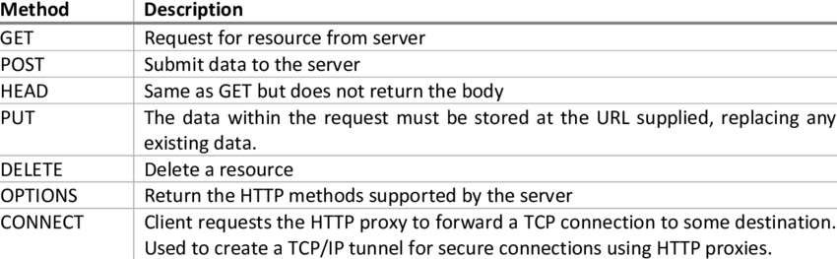

Communicatio 48

* WWW Pages
  + Pages are written in HTML: HyperText Markup Language
  + Markup commands are not hidden
  + HTML editors are usually used to create and edit HTML pages

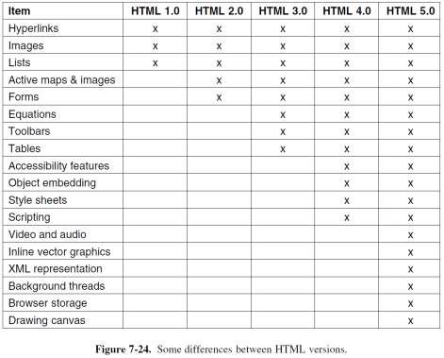

* Multiple versions of HTML have been developed with new features added on over

time.

Communicatio

n Networkss

48

1



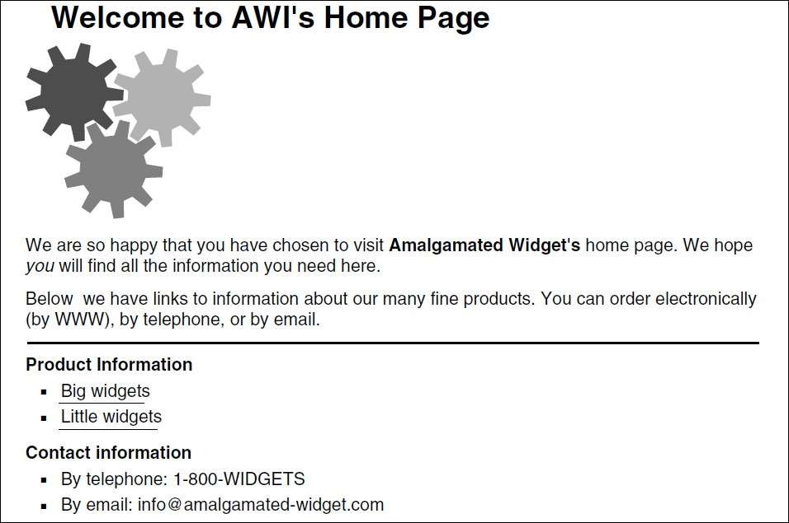

* WWW uses ULRs to locate pages
* Example: <http://sina.sharif.ac.ir/index.html>
* URL contains 3 parts:
  + protocol name:
    - HTTP, FTP, news, mailto, or file
  + server name: sina.sharif.ac.ir
  + page (file) name: Index.html

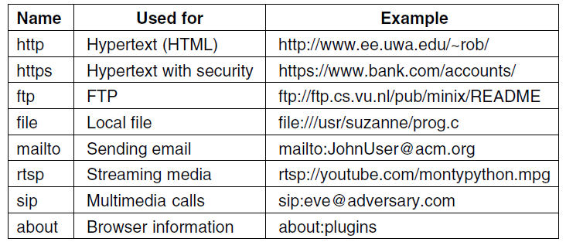

* Protocol steps:
  + Browser determines URL
  + Browser asks DNS to map server name to IP address
  + Browser makes TCP connection to server IP address, port 80
  + Browser sends GET ‘URL’ command
  + Server sends page (file) index.html

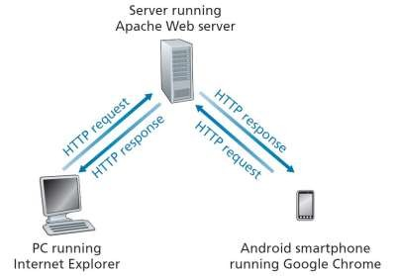

Communicatio

48

* Functions of the web server:
  + Resolve the name of the Web page requested.
  + Perform access control on the Web page.
  + Check the cache.
  + Fetch the requested page from disk or run a program to build it.
  + Determine the rest of the response (e.g., the MIME type to send).
  + Return the response to the client.
  + Make an entry in the server log.

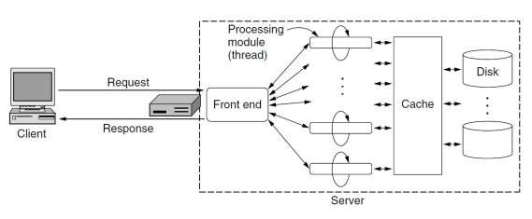

* Key challenges:
  + Speed
  + Scalability
* Solutions:
  + Cache
  + Load Balancing
* Many web interactions such as web search requires a program to generate the content based on user data.
* A program should run on the server side that interacts with user generated data.
* Example: Search Engines such as google.com

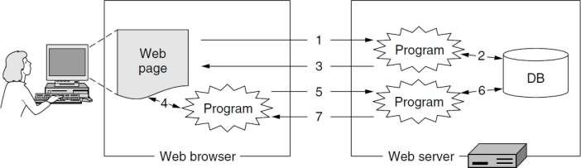

## Languages

* Programming languages oriented toward interfacing between the web and the server database
* Run on the server and generates dynamic web pages on the request of the client
* Examples:
  + PHP
  + Python
  + Java Script
* Idea: Download a code that runs on the client side and interacts with user

locally

* Java Script
  + A scripting language with some similarities to Java
* Java applets:
  + Applets are downloaded and then run locally
  + Applets are written in JAVA bytecode and interpreted by a Java Virtual Machine

(JVM)

* + Interpreter has to guarantee security
  + The objective has been to allow JAVA bytecodes to run on all machines that have a

JVM

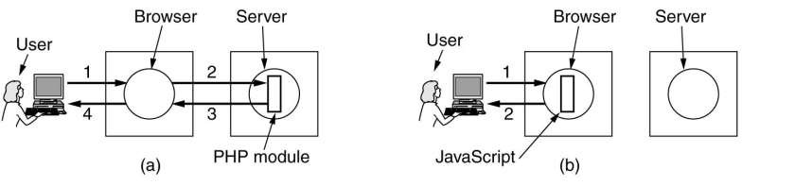

Communicatio

48